
FPT- ADCADEMY INTERNATIONAL
FPT – APTECH COMPUTER EDUCATION

Supervisor: Hoàng Đức Quang
Batch: T3.2508.E1 Group: FPT BitForge

Serial No. | Student ID | Student Name | Role & Responsibilities in MarketLink
1 | T3.2508.E1-01 | Nguyễn Đức Long | Team Leader, Lead Backend Architect (DB 3NF, FSM Engine, Shared Services)
2 | T3.2508.E1-02 | Trần Lê Minh Anh | Backend Administrator, DevOps & QA Lead (Cloud Deploy, Security, Excel, Test)
3 | T3.2508.E1-03 | Tăng Huỳnh Tuấn Tú | Backend Customer & AI Specialist (Customer APIs, Gemini Chatbot, Auth JWT)
4 | T3.2508.E1-04 | Nguyễn Khánh Danh | Lead Frontend Engineer (Complete 63 UI/UX Screens, React 19, Leaflet Map)
5 | T3.2508.E1-05 | Phạm Kim Nghi | Lead Technical Writer & Documentation Specialist (Full Docs, SRS, Diagrams)

Centre Name: ACE-HCMC-2-FPT.
Address: 21 Bis Hau Giang, Tan Son Nhat ward, HCMC.

MARKETLINK
FARM FRESH JUST A CLICK AWAY
TECHWIZ 7 - THE WORLD TECH CHAMPIONSHIP
Theme: eGreen Basket | Category: End-to-End Web Solutions
TP.HCM - 2026

Contents
PHASE 1: OVERVIEW & SYSTEM REQUIREMENTS 3
1. PROBLEM STATEMENT 3
1.1 MarketLink Project Introduction (Vietnamese Agricultural Supply Chain Context) 3
1.2 Target Users & System Roles 3
1.3 System Scope & Business Value 4
2. FUNCTIONAL & NON-FUNCTIONAL REQUIREMENTS 4
2.1 Requirement Classification & SRS Traceability 4
2.2 Mandatory Functional Requirements (SRS-Required) 5
2.3 Additional Functional Requirements (Team Value-Added) 11
2.4 Enhancements Beyond the SRS Baseline 14
2.5 Mandatory Non-Functional Requirements (SRS-Required) 17
2.6 Additional Non-Functional Requirements (Team Value-Added) 18
3. SYSTEM REQUIREMENTS (INFRASTRUCTURE CONFIGURATION) 19
3.1 Server Environment 19
3.2 Client / End-User Environment 19
3.3 Software Stack 20
4. TASKSHEET 1 (PHASE 1 WORK ALLOCATION: 24/09/2026 – 25/09/2026) 20
PHASE 2: ANALYSIS, DESIGN & DATABASE 21
1. USE CASE SPECIFICATIONS 21
1.1 Overview Use Case Architecture & Actor Profiles 21
1.2 Detailed Specifications of 12 Key Use Cases 22
2. SEQUENCE DIAGRAM SPECIFICATIONS (13 CORE WORKFLOWS) 25
3. ORDER LIFECYCLE STATE MACHINE 38
4. DFD (DATA FLOW DIAGRAMS) 39
4.1 DFD Level 0 (Context Diagram) 39
4.2 DFD Level 1 (Overall System Decomposition) 40
5. ERD (ENTITY RELATIONSHIP DIAGRAM) 42
5.1 Overview Entity Relationship Architecture 42
5.2 Entity and Attribute Summary (35 Relational Tables across 8 Apps) 42
6. DATABASE DATA DICTIONARY (35 RELATIONAL TABLES) 55
7. SOFTWARE ARCHITECTURE 80
7.1 Overall Multi-Tier System Architecture 80
7.2 Frontend Architecture (React 19 Framework) 81
7.3 Backend Architecture (Django REST Framework) 81
7.4 Real-time WebSockets & AI Subsystem (ASGI & Redis) 81
7.5 Security Hardening & Maintenance Operations 82
8. TASKSHEET 2 (PHASE 2 WORK ALLOCATION: 26/09/2026 – 27/09/2026) 82
PHASE 3: UI SCREEN PREVIEW & FINALIZATION 83
1. SNAPSHOT SCREEN SPECIFICATIONS 83
1.1 Public & Guest Screen Specifications (G-01 to G-15) 83
1.2 Customer Portal Screen Specifications (C-00 to C-11) 86
1.3 Farmer Portal Screen Specifications (F-01 to F-11) 88
1.4 Administrator Console Screen Specifications (A-00 to A-21) 90
1.5 Embedded Components Without a Route (N-01, N-03, N-04) 94
2. TASKSHEET 3 (PHASE 3 WORK ALLOCATION: 28/09/2026 – 29/09/2026) 95
2.3 Overall Project Workload & Contribution Summary (24/09/2026 – 29/09/2026) 95

Page numbers are field codes. If they look stale, select the list and press F9, or choose Update Field, and Word will recompute them.

PHASE 1: OVERVIEW & SYSTEM REQUIREMENTS

1. PROBLEM STATEMENT

1.1 MarketLink Project Introduction (Vietnamese Agricultural Supply Chain Context)
In Vietnam’s rapidly growing cities, especially major economic centers such as Ho Chi Minh City and Hanoi, demand for clean, safe, traceable, and certified agricultural products has increased significantly. Consumers are becoming more interested in products that meet standards such as VietGAP, GlobalGAP, and USDA Organic. To meet this demand, community-based weekend farmers’ markets, green produce fairs such as “Chợ Phiên Nông Sản An Toàn” and “Chợ Phiên Xanh,” as well as direct sales from agricultural cooperatives, have become important channels connecting smallholder farmers with urban consumers. These farmers and cooperatives mainly come from agricultural areas such as Da Lat – Lam Dong, Dong Nai, Cu Chi, and the Mekong Delta.
However, many weekend farmers’ markets in Vietnam still depend heavily on fragmented and manual communication methods, including Zalo groups, personal Facebook posts, phone calls, and handwritten price boards at physical stalls. Without a centralized system, both farmers and consumers face several problems.
Urban consumers face an unpredictable shopping experience. Weekend markets usually operate only in the early morning, often from around 5:00 AM to 9:00 AM on Saturdays and Sundays. Consumers therefore have to arrive early to find the products they want before they sell out. In many cases, they may travel a long distance only to find that their preferred farmer is not attending that week or that popular products have already sold out. This results in wasted time, unnecessary travel, and frustration.
Smallholder farmers and cooperatives also face significant post-harvest losses. Farmers often harvest perishable products the afternoon before the market and transport them long distances to the city during the night. Without knowing the actual demand in advance, they have to make difficult decisions about how much to bring. Bringing too little means losing potential sales, while bringing too much can lead to unsold products. In Vietnam’s hot and humid climate, fresh vegetables and fruits can quickly lose quality, become damaged, or spoil. By the end of the market, farmers may have to sell the remaining products at heavily reduced prices (“bán đổ bán tháo”) or dispose of them completely.
MarketLink is designed to address these challenges under the Techwiz 7 theme “eGreen Basket – End-to-End Web Solutions.” The platform introduces a simple “Pre-Order Online & Physical Weekend Market Pickup” model, allowing consumers to reserve fresh products before going to the market while giving farmers better visibility into expected demand.
MarketLink combines features such as interactive location mapping using OpenStreetMap and Leaflet, recurring weekly inventory management, a two-stage order acceptance process, and multi-farmer basket checkout. By connecting online pre-orders with physical weekend market pickup, the platform aims to reduce the morning rush, help farmers better prepare their inventory, maintain product freshness, and reduce unnecessary food waste.
Ultimately, MarketLink’s goal is simple: “Farm Fresh Just a Click Away.” It aims to make fresh and traceable agricultural products easier for urban consumers to access while creating a more predictable and efficient way for Vietnamese farmers and cooperatives to sell their products directly to the community.

1.2 Target Users & System Roles
The platform recognises exactly FOUR actors, each possessing distinct operational privileges, workflow contexts and business objectives:
▪ 1. Customer (End Consumer): Consumers seeking trusted local farm produce. Customers explore markets via digital maps, filter produce by category, price, market and operating day, place multi-farmer pre-orders with a designated pickup window, submit order modifications and change requests, collect their produce at the weekend market stall, and post reviews tied to a completed order.
▪ 2. Farmer (Stall Owner / Vendor): Independent growers and agricultural cooperatives operating market stalls. Farmers register their digital stall, set weekly operating schedules, configure recurring weekly stock templates, review and approve customer pre-orders (triggering accurate inventory deduction), package produce ahead of market hours, handle customer pickup handover, and respond to consumer reviews.
▪ 3. Platform Administrator: Central system governance authorities. Administrators verify and approve new farmer registrations, manage market locations and operating timetables, oversee platform-wide product categories, enforce content integrity (moderating abusive reviews or fraudulent stalls), monitor customer 'At-risk' spam markers, and export platform reports.
▪ 4. Guest / Public Visitor: Non-authenticated public visitors who explore the landing page, view active farmers’ markets on OpenStreetMap, browse the produce catalog and existing reviews, check stall operating days and market opening hours, and initiate registration.
Note on the “System” label used later in this document: the automated lazy sweep (expire_overdue_orders) that expires overdue PLACED orders and voids stale change requests is not a fifth actor and not a login role. It appears only on the single transition where the system expires an overdue PLACED order, and is recorded in order_status_history as actor_role = SYSTEM with an empty actor. The weekly stock template is never refreshed automatically - the Farmer applies it manually with “Apply to this week”.

1.3 System Scope & Business Value
The scope below is fixed: what the system does, what it intentionally leaves out, and why that matters.
▪ In scope: Customers pre-order from several farmers in one cart and collect at the stall; farmers publish their weekly stock and accept or decline each order. Section 2 lists all 54 functional requirements in full, separated into the 43 the SRS requires and the 11 the team added on top of them.
▪ Out of scope: Three boundaries are intentional and fixed. No online payment — customers pay cash at the stall on collection. No delivery and no courier service, so tracking an order here means tracking its status, never a shipment. Further, no verification of farmer certifications such as VietGAP or Organic.
▪ Business value: Farmers harvest against orders already accepted, so far less produce is left unsold. Customers see what is in stock before they travel, instead of losing a morning to a sold-out stall. Every order leaves a record, which gives both sides something to rely on.

2. FUNCTIONAL & NON-FUNCTIONAL REQUIREMENTS

2.1 Requirement Classification & SRS Traceability
MarketLink is specified as 54 functional requirements and 14 non-functional requirements. This section separates them into two tiers, because the two tiers are judged differently. The first tier shows that the brief was met, and the second tier shows what the team built on top of it. The numbering is intentionally non-contiguous. FR-07 to FR-09 and FR-33 to FR-39 are reserved and unused.
Tier 1 - Mandatory. A requirement belongs here only when it can be traced to a specific bullet of the SRS (sections 1.4 and 1.6 for functional, 1.7 for non-functional). Every mandatory requirement carries an SRS Source line quoting the clause it answers, so the mapping can be checked one requirement at a time.
Tier 2 - Additional. A requirement belongs here when the SRS either marks it optional or does not mention it at all. The SRS closes section 1.7 with “these are the bare minimum expectations … once they are complete, you can use your own creativity and imagination to add more features”, and section 1.9 with “over and above the given specifications, you can apply your creativity and logic to improve the system”. Tier 2 is that work. Every additional requirement carries a Why Added line stating the problem it solves.
A third category lies between the two and is documented separately in section 2.4. It covers a mandatory requirement on which the system intentionally delivers more than was asked. For example, the SRS asks for a cart, while MarketLink provides a multi-farmer basket, and the SRS lists four order statuses, while MarketLink runs eight. These are not new requirements, so they keep their original FR number, but the additional engineering is described separately.
Tier | Functional | Non-Functional | Basis
Mandatory (SRS baseline) | 43 FRs, 13 modules | 10 NFRs | Traceable to SRS §1.4, §1.6, §1.7
Additional (team value-added) | 11 FRs | 4 NFRs | SRS marks optional, or absent from the SRS
Total | 54 FRs | 14 NFRs | Sections 2.2, 2.3, 2.5, 2.6
Coverage of the SRS is complete. Every functional bullet in SRS §1.6 and every non-functional bullet in SRS §1.7 maps to at least one requirement in section 2.2 or 2.5, so nothing in the brief is left unaccounted for.

2.2 Mandatory Functional Requirements (SRS-Required)
The 43 requirements below form the brief itself, grouped into 13 modules. Each entry names its actor, states what the system does, and quotes the SRS clause that it answers.

Module 1: Registration, Authentication & Access Control
▪ FR-01: Customer Registration
Actor: Guest
Description: Allows a visitor to register a customer account with full name, phone number, email and address.
SRS Source: §1.6 Customer Features - User Registration and Login: “Name, contact number, e-mail ID, and address must be supplied during registration.”
▪ FR-02: Farmer Registration
Actor: Guest
Description: Allows a grower to register a stall with stall name, contact person, phone, email, address and weekly operating days; the account then waits for administrator approval.
SRS Source: §1.6 Farmer Features - Farmer Registration: “Farmers must provide stall/business name, contact person, contact number, e-mail ID, and address”, together with §1.6 Admin Features: “approve, or suspend Farmer registrations before they can list products.”
▪ FR-03: Secure Login & Logout
Actor: All Users
Description: Allows users to sign in with email and password and land on the dashboard for their role; administrators sign in through a separate page.
SRS Source: §1.6 Customer Features: “Customers must be able to register, log in, and securely access their dashboard”, and §1.6 Admin Features: “Admin can securely log in to a dedicated dashboard separate from the Customer and Farmer views.”
▪ FR-04: Role-Based Access Control
Actor: All Users
Description: Allows the system to enforce permission boundaries so each role (CUSTOMER, FARMER, ADMIN) uses only its own features, while guests see public pages only.
SRS Source: §1.6 Other Features - Role-Based Access Control: “Users can access only those features relevant to their role.” Extended beyond the two roles named in the SRS; see section 2.4.

Module 2: Public Information Pages
▪ FR-05: About Us Page
Actor: Guest, All Users
Description: Displays information about the team and the platform, including the FAQ on sharing one account within a household.
SRS Source: §1.6 Other Features - About Us: “Information about the team and the platform should be displayed.”
▪ FR-06: Contact Us Page
Actor: Guest, All Users
Description: Displays static contact details together with an embedded map of the location.
SRS Source: §1.6 Other Features - Contact Us: “Display static team contact information with Google Maps showing location.”

Module 3: Market & Farmer Discovery
▪ FR-10: Browse Nearby Markets
Actor: Guest, Customer
Description: Allows users to browse farmers' markets by location and operating day, with the nearest markets listed first.
SRS Source: §1.6 Browse Markets and Farmers: “Customers can browse nearby farmers markets by location and day.”
▪ FR-11: Participating Farmers per Market
Actor: Guest, Customer
Description: Displays the list of farmers trading at each market.
SRS Source: §1.6 Browse Markets and Farmers: “… and view the list of Farmers present at each market.”
▪ FR-12: Public Farmer Stall Profile
Actor: Guest, Customer
Description: Displays a stall profile with stall name, location, operating days and the produce offered that week.
SRS Source: §1.6 Browse Markets and Farmers: “view a Farmer’s profile including stall name, location, operating days, and current weekly stock.”
▪ FR-13: Map Markers & Directions
Actor: Guest, Customer
Description: Displays markets and stalls as markers on an OpenStreetMap map, with directions to the chosen collection point.
SRS Source: §1.6 Browse Markets and Farmers: “view markets and Farmer stalls on an embedded map powered by Google Maps API or OpenStreetMap, with location markers and directions to the selected pickup point.”

Module 4: Product Catalog, Search & Filter
▪ FR-14: Browse Product Catalog
Actor: Guest, Customer
Description: Allows users to browse the produce catalog and filter it by price, category, market and operating day.
SRS Source: §1.6 Search, Browse, and Filter Products: “browse product categories … with filters for price, category, market, and day.”
▪ FR-15: Product Detail
Actor: Guest, Customer
Description: Displays a product's price, unit of measure, quantity remaining and the farmer who sells it.
SRS Source: §1.6 Search, Browse, and Filter Products: “view product details including price, unit, quantity available, and Farmer.”
▪ FR-16: Search, Sort & Filter
Actor: Guest, Customer
Description: Allows users to search and sort markets, farmers and products, showing results on the map whenever the search is about location.
SRS Source: §1.6 Other Features - Search, Sort, Filter: “search markets, Farmers, or products based on filters like location, category, price, and market day, with map-based results … wherever location discovery is required.”

Module 5: Cart & Pre-Order Checkout
▪ FR-17: Multi-Farmer Shopping Cart
Actor: Customer
Description: Allows a customer to collect produce from several farmers in a single cart held on their own device.
SRS Source: §1.6 Place Pre-Orders for Pickup: “Customers can add products to a cart and place a pre-order against the Farmer’s available stock.” The multi-farmer basket goes beyond the single cart the SRS describes; see section 2.4.
▪ FR-18: Pickup Date & Time Window
Actor: Customer
Description: Allows a customer to choose a collection date and time window that is both a market day and a farmer trading day.
SRS Source: §1.6 Place Pre-Orders for Pickup: “select a pickup date and time slot within the Farmer’s available windows.”
▪ FR-19: Place Pre-Orders
Actor: Customer
Description: Allows a customer to place the cart as separate orders, one per farmer, all of them or none; stock is checked but not deducted until the farmer accepts.
SRS Source: §1.6 Place Pre-Orders for Pickup: “place a pre-order against the Farmer’s available stock”, with §1.5: “payment for pre-orders is settled in person at pickup.” The two-stage stock deduction is an engineering decision explained in section 2.4.

Module 6: Order Lifecycle & Change Management
▪ FR-20: Track Pre-Order Status
Actor: Customer
Description: Allows a customer to follow an order through its eight states: PLACED, ACCEPTED, READY_FOR_PICKUP and COMPLETED, plus the closing states CANCELLED, DECLINED, NO_SHOW and EXPIRED.
SRS Source: §1.6 Place Pre-Orders for Pickup: “view order status (placed, accepted, ready for pickup, completed).” The four extra closing states are additional; see section 2.4.
▪ FR-21: Modify an Order
Actor: Customer
Description: Allows a customer to edit a placed order directly, or to send a change request on an accepted order that the farmer must approve first.
SRS Source: §1.6 Place Pre-Orders for Pickup: “cancel or modify an order before the Farmer’s cutoff time”, and §1.6 Manage Orders: “Modify Orders.”
▪ FR-22: Cancel an Order
Actor: Customer
Description: Allows a customer to cancel a placed or accepted order before the cutoff time, returning any stock already deducted.
SRS Source: §1.6 Manage Orders: “Cancel Orders”, and §1.4: “place or cancel pre-orders for pickup.”

Module 7: Order History, Favorites & Dashboard
▪ FR-23: Order History & Reorder
Actor: Customer
Description: Allows a customer to review past orders and reload one into the cart at current prices, skipping items no longer sold.
SRS Source: §1.6 Order History and Favorites: “view their past orders and quickly reorder previously purchased items.”
▪ FR-24: Favorites & Restock Alerts
Actor: Customer
Description: Allows a customer to bookmark farmers and products, and receive an in-app alert when a bookmarked product is back in stock.
SRS Source: §1.6 Order History and Favorites: “mark Farmers and products as favorites for quick access and restock alerts.”
▪ FR-25: Saved Markets & Directions
Actor: Customer
Description: Allows a customer to save preferred markets together with their collection details and a directions shortcut.
SRS Source: §1.6 Order History and Favorites: “save preferred market locations and receive route-friendly pickup details through … OpenStreetMap integration.”
▪ FR-32: Customer Dashboard
Actor: Customer
Description: Displays open orders, the next collection with a countdown to its cutoff, and shortcuts into favorites.
SRS Source: §1.4 Scope: “interactive dashboards for both Farmers and customers”, and §1.6: “securely access their dashboard.”

Module 8: Reviews & Ratings
▪ FR-26: Rate & Review
Actor: Customer
Description: Allows a customer to rate and comment on the farmer and on each purchased product once the order is completed.
SRS Source: §1.6 Reviews and Ratings: “rate and review Farmers and individual products after an order is completed.”
▪ FR-27: Read Reviews
Actor: Guest, Customer
Description: Allows anyone to read existing reviews before placing an order.
SRS Source: §1.6 Reviews and Ratings: “view reviews left by other customers before ordering.”

Module 9: Customer Notifications
▪ FR-28: Customer Notifications
Actor: Customer
Description: Sends in-app and email alerts when an order is accepted, ready for collection, declined or expired.
SRS Source: §1.6 Other Features - Notifications: “Customers should receive e-mail or in-app alerts for order confirmations and orders ready for pickup.” The declined and expired alerts, and the real-time delivery channel, are additional; see section 2.4.

Module 10: Stall Profile, Operating Days & Pickup Windows
▪ FR-40: Stall Profile & Location
Actor: Farmer
Description: Allows a farmer to maintain the stall profile, the markets attended, the operating days and the address, with map coordinates resolved automatically.
SRS Source: §1.6 Farmer Registration and Profile Management: “Farmers can enhance their profile including the markets they sell at, operating days, pickup time windows, and location details such as address, map pin, latitude, and longitude.”
▪ FR-45: Cutoff, Windows & Closures
Actor: Farmer
Description: Allows a farmer to set the cutoff lead time between 1 and 72 hours, manage weekly collection windows, and declare closure periods.
SRS Source: §1.6 Manage pre-orders: “Farmers can set order cut-off times and manage available pickup slots.”

Module 11: Product Catalog & Weekly Stock
▪ FR-41: Product Management
Actor: Farmer
Description: Allows a farmer to create, edit, view and remove products with name, category, price, unit, quantity, description and image.
SRS Source: §1.6 Manage Weekly Stock and Pricing: “add, edit, view, or delete products including name, category, price, unit, quantity available, description, and image.”
▪ FR-42: Weekly Stock Template
Actor: Farmer
Description: Allows a farmer to keep a weekly default quantity for each product and apply it in one action, never dropping below the quantity already committed to accepted orders.
SRS Source: §1.6 Manage Weekly Stock and Pricing: “set up a recurring weekly stock template and adjust it as availability changes.”
▪ FR-43: Sold Out & Pause Selling
Actor: Farmer
Description: Allows a farmer to mark produce sold out or withdraw it from sale temporarily.
SRS Source: §1.6 Manage Weekly Stock and Pricing: “mark items as sold out or temporarily unavailable.”

Module 12: Order Fulfilment, Reviews & Insights
▪ FR-44: Pre-Order Fulfilment
Actor: Farmer
Description: Allows a farmer to accept an order, which is the intention where stock is deducted, decline it with a reason, mark a single item sold out, mark the order ready for collection, and resolve customer change requests.
SRS Source: §1.6 Manage pre-orders: “view incoming pre-orders, accept or decline them, and mark orders as ready for pickup.”
▪ FR-46: Sales History & Insights
Actor: Farmer
Description: Displays sales history, best-selling produce, total orders, pending orders and revenue over a chosen date range.
SRS Source: §1.6 View Order History and Insights: “view past sales, order history, and their best-selling products. Also, Farmers should be able to see Total Orders, Pending Orders, Revenue Summary.”
▪ FR-47: Respond to Reviews
Actor: Farmer
Description: Allows a farmer to publish one public reply to each customer review.
SRS Source: §1.6 Respond to Reviews: “Farmers can view and optionally respond to customer reviews left on their products.”
▪ FR-49: Handover & No-Show
Actor: Farmer
Description: Allows a farmer to confirm the physical handover as completed, or to record a no-show once the collection window has closed.
SRS Source: §1.6 Place Pre-Orders for Pickup, which lists “completed” as an order status; someone has to set it, and the handover at the stall is that moment. The no-show branch is additional; see section 2.4.

Module 13: Administration, Moderation & Reporting
▪ FR-50: Platform Dashboard
Actor: Administrator
Description: Displays platform totals for farmers, customers, markets and orders.
SRS Source: §1.6 Admin Login and Dashboard: “The dashboard should summarize key platform metrics such as total Farmers, total customers, total markets, and total orders.”
▪ FR-51: Farmer Vetting & Suspension
Actor: Administrator
Description: Allows an administrator to approve, reject, suspend and restore farmer accounts; suspending a stall hides it publicly and declines its open orders, returning the stock.
SRS Source: §1.6 Manage Farmers and Customers: “view, approve, or suspend Farmer registrations before they can list products.” The cascade onto open orders is additional; see section 2.4.
▪ FR-52: Customer Moderation
Actor: Administrator
Description: Allows an administrator to lock or reactivate a customer account with a recorded reason; locking cancels that customer's open orders and returns the stock.
SRS Source: §1.6 Manage Farmers and Customers: “view, activate, or deactivate customer accounts in case of policy violations.” The cascade onto open orders is additional; see section 2.4.
▪ FR-53: Market Directory
Actor: Administrator
Description: Allows an administrator to add, edit and withdraw markets with name, address, operating days, opening hours, coordinates and closure periods.
SRS Source: §1.6 Manage Markets: “add, edit, or remove farmers markets, including name, address, operating days, timings, and map coordinates or embedded map links.”
▪ FR-54: Content Moderation
Actor: Administrator
Description: Allows an administrator to take down violating produce listings and hide abusive reviews instead of deleting them.
SRS Source: §1.6 Content Moderation: “view and remove inappropriate product listings or customer reviews that violate platform guidelines.” Pre-publication approval (FR-61) and the AI-assisted check that feeds it (FR-60) are separate additional requirements: the SRS asks only for removal after the fact.
▪ FR-55: Reports & Excel Export
Actor: Administrator
Description: Displays total orders, revenue by market and the most active farmers over a date range, exportable as an Excel file, with every export recorded in the security audit log.
SRS Source: §1.6 Reports and Analytics: “view platform-wide reports covering total orders, revenue summary across markets, and the most active Farmers.” The export itself is additional; see section 2.4.
▪ FR-56: Master Categories
Actor: Administrator
Description: Allows an administrator to maintain the master produce categories.
SRS Source: §1.6 System Configuration: “manage master data such as product categories.”
▪ FR-57: Platform Announcements
Actor: Administrator
Description: Allows an administrator to publish announcements aimed at all users, at customers only or at farmers only, over a chosen date range.
SRS Source: §1.6 System Configuration: “publish platform-wide notifications or announcements.”

2.3 Additional Functional Requirements (Team Value-Added)
The eleven requirements below are not part of the mandatory baseline. Two of them are marked optional in the SRS and were implemented in any case. The remaining nine are absent from the SRS. They were added either because building the mandatory features exposed a gap that would have affected the platform in daily use, or because a review of the system asked for them.

Group A: Optional in the SRS, Implemented in Full
▪ FR-29: AI Assistant
Actor: Guest, Customer
Description: Allows users to ask about produce, market hours, farmers and collection windows; looking up an order requires signing in.
Why Added: The SRS marks this feature as optional in two places. §1.2 states “Along with an optional basic AI feature”, and the §1.6 heading reads “AI Assistant (Optional)”. The team implemented it because the questions it answers are the same questions that cause a shopper to abandon an order. Is this stall trading on Saturday, is this product still in stock, and when does the collection window close. If the answer is given in one sentence, the reason to abandon the order is removed. The design was kept narrow on purpose, with four read-only tools and no write tool at all. This is also the main protection against prompt injection. The full design is given in Phase 2, section 7.4.
▪ FR-30: Family Account Sharing
Actor: Customer
Description: Allows household members to share one account across devices, where signing out on one device leaves the others signed in.
Why Added: The SRS states “Sharing of accounts among family members can be permitted (optional)”. The team implemented it because weekend market shopping is a household activity. One member places the order and another member collects it. If separate accounts were required, the order history of a single household would be split into two. The feature is implemented as per-device sessions instead of a shared password, so each device can be signed out on its own.

Group B: Not Required by the SRS, Added by the Team
▪ FR-31: Profile & Password Management
Actor: All Users
Description: Allows users to update their own profile and change their password after confirming the current one.
Why Added: The SRS requires registration and login, but it does not mention changing a password. On a platform that allows one account per household (FR-30), a password that can never be changed becomes a liability, because anyone who once had the credentials continues to hold them. The current password is also required before a change is accepted. This prevents the obvious attack on a device that has been left signed in.
▪ FR-48: Farmer Notifications
Actor: Farmer
Description: Sends alerts for a new order and for a customer modification, and email as well when a customer cancels or when an order is cancelled because the customer was locked.
Why Added: The SRS asks for notifications in one direction only, stating “Customers should receive e-mail or in-app alerts.” However, the farmer is the party who must act. An order remains in PLACED until the farmer accepts it, and a farmer who is not informed does not accept. The order then expires under FR-59, and the sale is lost although the customer did nothing wrong. A late cancellation is even more serious, because the farmer may already have harvested against that order.
▪ FR-58: Security Audit Log
Actor: Administrator
Description: Allows an administrator to monitor the platform through the append-only security audit log and the per-record change histories.
Why Added: This is not in the SRS. It was added because several of the mandatory features have effects that cannot be reversed. Suspending a stall declines its open orders (FR-51), locking a customer cancels theirs (FR-52), and a report export takes platform data off the platform (FR-55). Without a record of who performed which action and when, none of these can be reviewed or disputed afterwards. The log is append-only by design, so it cannot be tidied up after the event. Each row also carries the request id that appears in the application logs, which allows one action to be traced across both.
▪ FR-59: Automatic Expiry of Overdue Orders
Actor: System
Description: Expires a placed order that the farmer never approved once its collection window has started, leaving stock untouched, recording no fault against the customer, and notifying them.
Why Added: This is not in the SRS. It exists because of the two-stage stock model described in section 2.4. An order that the farmer never answers would otherwise remain open indefinitely. The customer cannot tell whether to travel to the market, and the order continues to appear on the dashboard as though it were live. Expiry closes such an order once the collection window has started. No stock is returned, because none was ever deducted, and nothing is recorded against the customer, who has done nothing wrong. The distinction between this and NO_SHOW (FR-49) is intentional.
▪ FR-60: AI-Assisted Listing Review & Automatic Approval
Actor: Administrator, Farmer
Description: Reviews every new or edited produce listing before it reaches the public catalog and records a verdict, a risk score and a list of findings. A listing the check clears is approved automatically and goes on sale without waiting for an administrator; a listing it suspects is held off sale and placed in the follow-up queue. Either way the administrator can open the decision afterwards on the AI Decisions page, and the system tracks which automatic decisions no one has looked at yet. Also re-checks product photographs on a scheduled sweep, and reports how often the administrator agreed with the advice.
Why Added: This is not in the SRS, which asks only for manual content moderation (FR-54). It was added because manual review does not scale. Without it there are only two possibilities, and neither is acceptable. Either every listing waits for an administrator, in which case a stall that must wait a day to publish a vegetable will stop using the platform, or nothing is checked at all. Two layers run over each listing. The first is a set of deterministic rules covering price against an administrator-tuned band per category and unit, peer prices, quantity limits and text checks. The second is a vision-capable model that reads both the wording and the photograph. Content that has already been reviewed is recognised by its hash and is not reviewed again. The agreement rate between the advice and the administrator's eventual decision is reported, so the rules can be tuned against evidence rather than opinion. Two properties keep the automation accountable. Automatic approval is a setting (AI_AUTO_APPROVE) that can be switched off to return the system to advisory-only mode, and every automatic decision remains visible as an automatic decision until an administrator has reviewed it.
▪ FR-61: Produce Listing Approval Queue
Actor: Administrator, Farmer
Description: Holds a new or edited listing off the public catalog until it has been approved, and shows the administrator a queue of everything still waiting, oldest first, with an approve or reject decision and a written reason. A listing is sent back to the queue only when the farmer changes what it claims to be - its name, description, photograph or category - while the approved version stays on sale in the meantime.
Why Added: This is not in the SRS. It was added after a review of the system found that a listing went live the moment a farmer saved it, and that the only control available to an administrator was to take it down afterwards, in front of an audience that had already seen it. Two design choices here are intentional and are the ones most open to question. First, a change of price or stock never sends a listing back to the queue. A stall that has to wait for an administrator before it can correct its own stock level will stop correcting it, and the stock figure is the single number on which the whole booking flow depends. Second, while a re-review is pending, the previously approved version stays on sale. Hiding a listing because of a corrected spelling would cost the stall a market day and would give no gain in safety.
▪ FR-62: Automatic Account Lock After Repeated No-Shows
Actor: System, Administrator
Description: Locks a customer account automatically once the customer has failed to collect three orders within the at-risk window of thirty days, cancels that customer's open orders and returns the stock, records the evidence in the security audit log, and notifies the customer. Only no-shows recorded after the account was last unlocked are counted, and the administrator's customer page shows which orders triggered the lock.
Why Added: This is not in the SRS. It was added after a review of the system asked that the no-show history already being collected should carry a consequence, rather than only a warning flag. This requirement intentionally changes an earlier project decision, D-028 clause 3, “the administrator decides a lock; the system does not lock by itself”. The change is recorded here rather than left implicit, because it moves an irreversible action from a person to a rule. Three safeguards were added in exchange. The count restarts after any unlock, so an administrator who gives a fresh start is not overruled by the old history. The lock writes the specific order numbers it relied on into the audit log, so the decision can be reviewed and reversed. The threshold and window are the same values the at-risk flag already used, so “at risk” and “locked” cannot drift apart. The residual risk is stated plainly. A lock cancels open orders belonging to stalls that did nothing wrong, so a single mistaken no-show marking has consequences beyond the account it touches.
▪ FR-63: System-Raised Moderation Flags
Actor: System, Administrator
Description: Raises a follow-up flag by itself when a pattern appears that an administrator would want to look at - several low ratings on one product within a short window, or a review whose text contains abusive language or contact details - and places it in the same follow-up queue an administrator uses. One open flag per subject: a second occurrence on something already queued adds nothing.
Why Added: This is not in the SRS. It was added because the moderation queue was previously only as good as whatever someone happened to notice, while the patterns that matter are the ones that build up silently over weeks. The stance is the same as for the held listings of FR-60, and that stance is the important part. The system only asks for a decision. Nothing is hidden, locked or refused by a flag. A failure while writing the queue is logged and swallowed, so a review or a no-show can never fail because the queue could not be written.
▪ FR-64: Pickup Reschedule After a Schedule Change
Actor: Customer, Farmer, System
Description: Marks an order as needing a new collection time when an administrator changes or closes the market it was placed against, invites the customer to choose a new date and window, and suspends the original cutoff so the change does not lock them out. Only the collection time may change on such an order. If the old collection time passes with no new one chosen, the order is closed, the stock is returned and both the customer and the farmer are told why in plain terms.
Why Added: This is not in the SRS, which does not consider the case of a market schedule changing under an order that has already been placed. It was added because the alternative is silent breakage. The order still names a collection window that no longer exists, and neither side discovers this until someone is standing at a closed market. Suspending the cutoff is important here. The customer is being asked to change the order because of a decision that was not theirs, so the deadline that normally protects the farmer's planning would be penalising the wrong party. The order is closed rather than left open when no new time is chosen, because an order pointing at a collection window that has already passed is not a live order.
Operating recommendation on the two automatic decisions. FR-60 and FR-62 are the only requirements in this system where a rule acts without a person, and both act on something a person owns - a public catalogue entry and a user's account. Each therefore ships behind a switch and each writes its evidence to the audit log. For an evaluated demonstration the team's recommendation is to run with AI_AUTO_APPROVE turned off, so listings queue for a visible human decision: a wrongly published listing costs a stall its market day, the reviewer cannot see from the catalogue which entries a person actually approved, and “the model approved it” is a poor answer to the question of who is accountable. Automatic approval becomes justified once the agreement figures in FR-60 show the check and the administrators reaching the same conclusion often enough to be trusted with the easy cases.

2.4 Enhancements Beyond the SRS Baseline
The requirements below are mandatory and keep their original FR numbers, but the system does more than the SRS asks for. Each row states the minimum that the brief would have accepted, what MarketLink does instead, and the reason. These are the decisions on which the team expects to be questioned.
FR | SRS minimum | What MarketLink does instead | Why it matters
FR-19, FR-44 | “Place a pre-order against the Farmer’s available stock.” | Stock is checked at checkout but deducted only when the farmer accepts the order; row locks are taken in ascending product id inside the transaction. | A customer cannot reserve produce that the farmer has not agreed to sell. If stock were deducted at checkout, an unanswered order would hold produce that a serious buyer wanted. Locking the rows in a fixed order prevents the deadlock that two simultaneous multi-product orders would otherwise cause.
FR-17 | “Add products to a cart.” | One basket spanning several farmers, split at checkout into one order per farmer, placed all together or not at all. | A shopper walks through one market and visits several stalls. One cart per stall would mean repeating checkout three times. Splitting the basket per farmer keeps each order answerable by the farmer who owns it, and the all-or-none rule ensures that a shopper is never left holding half of a shopping trip.
FR-20 | Four statuses: placed, accepted, ready for pickup, completed. | Eight statuses - the four above plus CANCELLED, DECLINED, NO_SHOW and EXPIRED - with every transition written to an append-only history recording who caused it. | The four states in the brief describe only the path where everything goes right. The four added states describe the ways a real order actually ends. Telling them apart is what makes the record trustworthy, because a customer who was declined is not the same as a customer who failed to turn up.
FR-21 | “Cancel or modify an order before the Farmer’s cutoff time.” | A PLACED order is edited directly. Once ACCEPTED, the edit becomes a change request the farmer must approve, held as a pending change on the order until they answer. | After acceptance the farmer has committed stock and may have planned the harvest around it. If the customer could rewrite that order silently, the commitment would be broken. The change request keeps the customer's ability to change their mind without removing the farmer's ability to refuse.
FR-28, FR-48 | “E-mail or in-app alerts for order confirmations and orders ready for pickup.” | Alerts for decline, expiry and cancellation as well, delivered over a WebSocket push as well as by email, with email sent asynchronously so it never delays the response. | The events a user most needs to hear about are the ones that go wrong. A push notification arrives while the page is open, which matters on a market morning when a farmer is accepting orders only minutes before the window opens.
FR-42 | “Set up a recurring weekly stock template and adjust it as availability changes.” | Applying the template never lowers a product below the quantity already committed to accepted orders, and it is applied by the farmer by design rather than on a timer. | An automatic refresh would silently overwrite quantities that the farmer had already promised to customers. Because the action is taken on purpose and is floored at the amount already owed, the template can never oversell an accepted order.
FR-49, FR-59 | “Completed” as an order status. | The farmer confirms handover, or records NO_SHOW after the window closes; separately, an order the farmer never answered is EXPIRED with nothing recorded against the customer. | Fault is recorded where it belongs. A customer who did not collect is a no-show. A customer whose order was never answered is not at fault at all. If both were collapsed into one status, the failure would be attributed to the wrong party.
FR-51, FR-52 | “Approve, or suspend Farmer registrations”; “activate, or deactivate customer accounts.” | Suspending a stall also hides it publicly and declines its open orders; locking a customer also cancels theirs. Either way the stock is returned and both sides are notified. | An account that can no longer trade must not leave live orders behind it. Without the cascade, customers would continue waiting at a stall that will never open, and the stock held by those orders would remain unsellable.
FR-55 | “View platform-wide reports.” | The same figures export as .xlsx; every export is written to the audit log, and every cell is written as text so a value beginning with = is never evaluated. | A report that cannot leave the screen cannot be taken to a meeting. Recording the export is important because it is the one action that takes platform data off the platform, and writing cells as text closes the formula-injection route into whoever opens the file.
FR-04 | “Users can access only those features relevant to their role.” | Four access levels rather than the two named in the SRS, and every business endpoint checks both the caller's role and their ownership of the specific record. | The role by itself is not sufficient. One farmer holding a valid farmer token must still not be able to read another farmer's orders, and that is a question about the record rather than about the role.
FR-53, FR-64 | “Add, edit, or remove farmers markets, including … operating days, timings.” | Changing or closing a market reaches the orders already placed against it: each is marked for rescheduling, its cutoff is suspended, the customer is asked for a new time, and an order left without one is closed with the stock returned. | The brief treats the market directory as reference data, but an operating day is a commitment that other people have already planned around. Editing a row must therefore reach the orders that depend on that row, otherwise the schedule and the orders silently disagree until someone is standing at a closed market.
FR-52, FR-62 | “View, activate, or deactivate customer accounts in case of policy violations.” | Repeated no-shows lock the account without waiting for an administrator, with the triggering order numbers written to the audit log and the count restarting after any unlock. | This is the only place where the system takes an irreversible action by itself, and it is the decision in this document most open to challenge, because a lock cancels open orders belonging to stalls that did nothing wrong. It is documented here, rather than hidden, precisely because it reverses an earlier project decision. See FR-62.
FR-13, FR-53 | “Google Maps API or OpenStreetMap.” | OpenStreetMap with Leaflet throughout, with coordinates resolved automatically from the address the farmer types. | OpenStreetMap needs no API key and no billing account, so the deployed application continues to work for judges without a paid key. Resolving the coordinates automatically also removes the step most likely to be entered incorrectly, which is a farmer typing latitude and longitude by hand.
FR-54, FR-60, FR-61 | “View and remove inappropriate product listings.” | A listing is checked before it is published rather than taken down afterwards (FR-61). The AI-assisted check approves a clear listing automatically and holds a suspect one for the queue (FR-60); an administrator can review any automatic decision afterwards, and automatic approval can be switched off entirely. | Removing a listing after publication is a decision taken too late, and in front of an audience. Checking first corrects that, but checking everything by hand would hold up the stalls. Hence the system clears the obvious cases and a person sees the rest. The asymmetry is intentional, because the system may publish, which is reversible, and may not reject, which is not.

2.5 Mandatory Non-Functional Requirements (SRS-Required)
SRS section 1.7 lists nine non-functional requirements and closes by calling them “the bare minimum expectations from the project”. NFR-01 to NFR-09 answer those nine one for one. NFR-10 is the tenth mandatory item: the SRS states it under §1.6 Other Features rather than in the non-functional list, but it is a quality attribute, so it is specified here. Each entry gives the criterion that decides whether it passes and the technique that gets it there.
▪ NFR-01: Safe to Use
Measurement Criteria: No unexpected downloads; one download format platform-wide, the .xlsx admin report.
Technical Solution: Uploads checked by extension, MIME type and magic bytes, then re-saved under a UUID name.
SRS Source: §1.7: “The application should not result in any malicious downloads or unnecessary file downloads.”
▪ NFR-02: Accessibility
Measurement Criteria: 16px body text, contrast at least 4.5:1, every input labelled, Lighthouse Accessibility 90 or above.
Technical Solution: Design tokens, visible focus states, Radix ARIA primitives, alt text, reduced-motion support.
SRS Source: §1.7: “The application should have clear and legible fonts, user-interface elements, and navigation elements.”
▪ NFR-03: User-Friendliness
Measurement Criteria: Menus not more than two levels deep; a pre-order from a product page takes not more than four steps.
Technical Solution: One layout per role, breadcrumbs, English status labels, validation shown inline.
SRS Source: §1.7: “The application should be easy to navigate with clear menus and other elements and easy to understand.”
▪ NFR-04: Operability
Measurement Criteria: No uncaught console errors; every list has a loading, empty and error state.
Technical Solution: React error boundaries, one error envelope shared by all endpoints, a request id carried end to end.
SRS Source: §1.7: “The application should be reliable and efficient.”
▪ NFR-05: Performance
Measurement Criteria: 95% of read requests under 500ms with 1,000+ seeded products; home page LCP under 2.5s.
Technical Solution: Pagination of 20, indexes on filtered columns, eager loading against N+1 queries, lazy images, client caching.
SRS Source: §1.7: “minimal load time and smooth page redirection, even when browsing large product catalogues.”
▪ NFR-06: Scalability
Measurement Criteria: Stock never goes negative under concurrent ordering; no session state held on the server.
Technical Solution: Row locks taken in ascending product id when an order is accepted; throttles of 10 orders/hour and 20 chat messages/minute.
SRS Source: §1.7: “designed to handle increasing numbers of Farmers, customers, and product listings, especially during peak market days.”
▪ NFR-07: Security
Measurement Criteria: Every business endpoint checks the caller's role and their ownership of the record.
Technical Solution: Safe defaults (debug off, no start without a secret key, HTTPS and secure cookies), brute-force limits per IP and per email, uploaded images re-encoded to strip metadata, report cells written as text.
SRS Source: §1.7: “adequate security measures such as authentication. For example, only registered users can access certain features.”
▪ NFR-08: Availability
Measurement Criteria: Public URL reachable; the health endpoint returns 200.
Technical Solution: Frontend, backend and database hosted externally, with a periodic ping so the free tier stays awake.
SRS Source: §1.7: “available 24/7 with minimum downtime, so customers can browse and pre-order at any time before pickup.”
▪ NFR-09: Compatibility
Measurement Criteria: Current Chrome, Edge, Firefox and Safari, at any width from 360px to 1920px.
Technical Solution: Mobile-first CSS3 with no browser-specific code paths.
SRS Source: §1.7: “compatible with latest browsers and various devices.”
▪ NFR-10: Responsive Design
Measurement Criteria: No horizontal scrolling at 360px.
Technical Solution: Breakpoints at 640, 768 and 1024px; tables become cards below 768px, sidebars become drawers.
SRS Source: §1.6 Other Features - Responsive Design: “The application will be mobile-friendly and accessible across various devices.”

2.6 Additional Non-Functional Requirements (Team Value-Added)
The four quality attributes below are not in the SRS list of nine. Two are obligations the SRS raises in §1.5 Constraints without stating as requirements; two were added by the team because the system could not be operated or extended safely without them.
▪ NFR-11: Backup & Data Retention
Measurement Criteria: Schema and seed data restorable on a clean machine; dormant accounts cleared without ever touching a trading stall.
Technical Solution: A database dump script, plus a command removing customers and never-approved stalls dormant three months with no orders - it only lists them unless told to delete.
Why Added: §1.5 Constraints raises “constraints related to data storage, data synchronization, and backup procedures” but states no requirement. Specified here because a demonstration that cannot be restored on a second machine cannot be evaluated, and because dormant registrations accumulate. The command defaults to listing rather than deleting, and never touches a stall that has traded: an irreversible operation should have to be asked for twice.
▪ NFR-12: Media Licensing
Measurement Criteria: Every image has a documented licence.
Technical Solution: Team photographs or copyright-free sources; OpenStreetMap attribution kept on map tiles.
Why Added: §1.5 Constraints: “Usage of various images and videos can be subject to licensing agreements and copyright restrictions.” Raised there as a risk, not a requirement, so it is specified here with a criterion that can actually be checked.
▪ NFR-13: Auditability & Traceability
Measurement Criteria: Every state-changing administrative action is attributable to an account, and one request can be followed from the HTTP call through to the rows it changed.
Technical Solution: An append-only audit log, per-record change histories on the accounts, catalog, markets and orders models, and a request id generated per request that is carried in the log rows, the history rows and the error envelope returned to the client.
Why Added: Not in the SRS. Added because the mandatory features include actions that cannot be undone - a suspension that declines live orders, a lock that cancels them, an export that removes data from the platform. The same property makes support possible: a user reporting a problem quotes one request id, and that id leads to the request, the audit row and the record history without guesswork.
▪ NFR-14: Maintainability
Measurement Criteria: Business rules live in a service layer, not in views or serializers; each module owns its own tests and can be tested on its own.
Technical Solution: A Model - Serializer - Service - View split across eight Django applications, portal-scoped URL modules (public, customer, farmer, admin), tests colocated with the module they cover, and a continuous-integration workflow that runs them against a real MySQL 8 service on every pull request into the main branch.
Why Added: Not in the SRS. Added because this system was built by a team working in parallel on overlapping data: stock is written by checkout, by farmer acceptance, by cancellation, by suspension and by the expiry sweep. Keeping those rules in one service per concern is what stops five code paths from each inventing their own version of the same rule - and it is why a rule such as the two-stage deduction can be stated once and be true everywhere.

3. SYSTEM REQUIREMENTS (INFRASTRUCTURE CONFIGURATION)

3.1 Server Environment
Component | Minimum | Recommended
CPU | Intel Core i5 or higher, 4 cores | Intel Core i7 / Xeon, 8 cores
RAM | 8 GB | 16 GB
Storage | 500 GB | 500 GB SSD NVMe
Operating System | Ubuntu Server 22.04 LTS | Ubuntu Server 24.04 LTS (64-bit)

3.2 Client / End-User Environment
Component | Minimum | Recommended
CPU | Intel Core i3 / AMD Ryzen 3 | Intel Core i5 or higher
RAM | 4 GB | 8 GB or higher
Display | Colour SVGA, 1366 x 768 | Full HD, 1920 x 1080
Input devices | Mouse and keyboard | -
Browser | Chrome, Edge, Firefox or Safari, current version | -
Network | 1 Mbps broadband | 4G LTE / Wi-Fi on mobile

3.3 Software Stack
The brief lists several permitted options for each layer. The table below records which one MarketLink uses, so the choice can be checked against the brief at a glance.
Layer | Permitted options | MarketLink choice
Frontend | HTML5, CSS3, Bootstrap, ReactJS / AngularJS / TypeScript, JavaScript, jQuery, XML | React 19 with Vite, plain JavaScript (JSX), CSS3 through CSS Modules and design tokens
Backend | Java EE, C# ASP.NET, PHP Laravel, Python with Flask or Django, MEAN, MERN | Python 3.12 with Django 5.2 and Django REST Framework 3.17
Database | MySQL, SQL Server, MongoDB, JSON | MySQL 8.4 LTS on the InnoDB engine
Maps and Geolocation | Google Maps API or OpenStreetMap | OpenStreetMap with Leaflet for every in-app map; Google Maps only for the Contact page
AI Tools | Optional assistant, for example tawk.to or Zapier | Gemini Flash through the google-genai SDK, so the assistant answers from live stock rather than a fixed FAQ
Real-time and cache | Not specified | Daphne ASGI with Django Channels, and Redis for the channel layer and token blacklist

4. TASKSHEET 1 (PHASE 1 WORK ALLOCATION: 24/09/2026 – 25/09/2026)
Phase 1 establishes the requirements engineering baseline, architectural boundaries, and technology framework foundations over a 2-day intensive sprint (24/09/2026 – 25/09/2026).
• 24/09/2026: Nghi (Audited SRS §1.4 & §1.6; authored Problem Statement, 4 Actor Profiles, and Traceability Matrix for 54 FRs & 14 NFRs); Danh (Initialized React 19 + TypeScript + TailwindCSS repository; configured Router and 4 Base Layouts); Long (Analyzed Farmer & Order fulfillment domain; drafted 3NF schema architecture and initialized marketlink_core); Tú (Modeled multi-vendor cart partitioning; architected JWT authentication and Redis token blacklist); Minh Anh (Analyzed Admin governance & Guest discovery; formulated Leaflet Haversine formula; evaluated Render Cloud & MySQL stack).
• 25/09/2026: Nghi (Authored System Scope §1.3: cash-on-pickup, zero courier shipping; Software Stack Matrix §3.3; Tasksheet 1); Danh (Constructed common UI library: DataTable, StatusBadge, Modal, EmptyState, and Leaflet MapView/MapPicker); Long (Formulated transactional policies: pessimistic locking vs non-reserved checkout; finalized API contract specifications); Tú (Designed Gemini AI Chatbot subsystem: 4 read-only tools and real-time WebSocket notification pipeline); Minh Anh (Configured security policies: CORS, CSP, rate-limiting; provisioned staging environment on Render Cloud).
No. | Member Name | Assigned Role | Key Assigned Tasks (24/09 – 25/09/2026) | Timeline | Core Deliverables | Status
1 | Nguyễn Đức Long | Lead Backend | Analyze Farmer/Order requirements; design DB 3NF schema; setup marketlink_core | 24/09 – 25/09 | Arch Scope Doc; marketlink_core baseline | 100% Completed
2 | Trần Lê Minh Anh | Admin/DevOps | Analyze Admin/Guest needs; research Leaflet Haversine; establish Software Stack | 24/09 – 25/09 | Admin Specs; Software Stack Matrix (§3.3) | 100% Completed
3 | Tăng Huỳnh Tuấn Tú | Customer/AI | Analyze multi-vendor cart; design JWT/Redis auth; propose Gemini AI subsystem | 24/09 – 25/09 | Customer Workflow Specs; Auth Specs | 100% Completed
4 | Nguyễn Khánh Danh | Lead Frontend | Setup React 19 + Tailwind; build 4 Layouts; engineer common UI library & Maps | 24/09 – 25/09 | Frontend repo; 4 Layouts; Common UI lib | 100% Completed
5 | Phạm Kim Nghi | Lead Technical Writer | Author Section 1 Problem Statement, Actor Profiles; classify 54 FRs & 14 NFRs | 24/09 – 25/09 | Phase 1 Report (§1, §2); Tasksheet 1 | 100% Completed

PHASE 2: ANALYSIS, DESIGN & DATABASE

1. USE CASE SPECIFICATIONS

1.1 Overview Use Case Architecture & Actor Profiles
The twelve use cases below carry the most design weight; the remaining behaviour of the system is covered by the functional requirements in Phase 1. All of them belong to the four actors described here, and all are bound by the same three rules: role-based access control, one order per farmer, and stock changes that happen only inside a transaction:
▪ Customer (Registered Consumer): Authenticated end-consumer who browses local farmers' markets via interactive maps, inspects produce and its stock level, places multi-farmer pre-orders for physical stall collection, submits order change requests, and posts reviews tied to a completed order.
▪ Farmer (Stall Vendor / Producer): Independent producer who operates physical stalls at registered markets. Configures trading days (operating_days), recurring pickup windows, and weekly harvest stock templates. Reviews pre-orders, manages item availability including marking an individual line item sold out, deducts stock atomically upon approval, and fulfills in-person physical collection.
▪ Platform Administrator: System governance authority who vets incoming farmer registrations, maintains market directories, configures master product categories, oversees security audit logs, broadcasts platform announcements, and executes emergency market closures.
▪ Guest / Public Visitor: Unauthenticated visitor who accesses the public landing portal, explores market locations via Leaflet and OpenStreetMap, browses the produce catalog and existing reviews, and may consult the AI assistant, which for a guest answers only from public data.
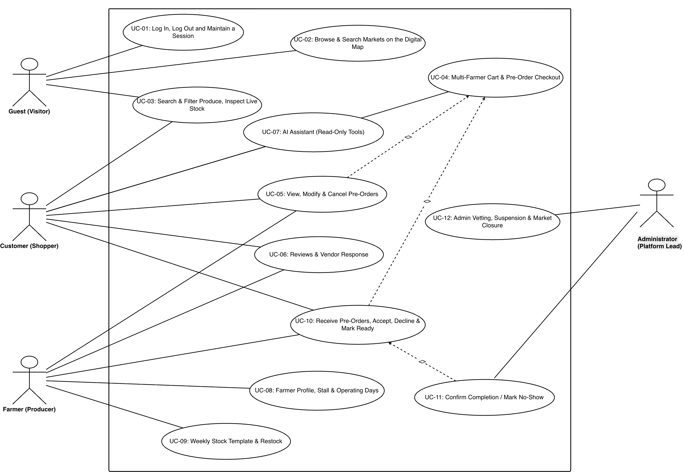
Figure 1.1: Overall Use Case Diagram - the four actors and the use cases each one reaches

1.2 Detailed Specifications of 12 Key Use Cases
The following formal specifications outline preconditions, postconditions, normal execution flows and exception paths for the twelve selected workflows. Note that the “System” role that appears on the single transition where the system expires an overdue PLACED order is not a fifth actor and not a login role: it is the lazy sweep, recorded in order_status_history as actor_role = SYSTEM with an empty actor.

UC-01: Log In, Log Out and Maintain a Session
▪ Actor: All Users (Customer, Farmer, Administrator).
▪ Purpose: Authenticate a user by email and password and open a session for their role.
▪ Prerequisites: The account exists and has not been locked.
▪ Main Flow: User enters email and password -> System checks the rate limit and verifies the password -> System opens a session and returns the profile and role -> Client redirects to the dashboard for that role.
▪ Exception Flow: Wrong credentials or a locked account show an error; repeated failed attempts are throttled per IP and per email address.
▪ Postconditions: An authenticated session exists. Logging out ends it on that device only, leaving other devices signed in.

UC-02: Browse & Search Markets on the Digital Map
▪ Actor: Guest, Customer.
▪ Purpose: Find nearby farmers' markets and see which stalls trade at each one.
▪ Prerequisites: At least one active market with an operating-day schedule exists.
▪ Main Flow: User opens the markets page -> Browser offers the visitor's location -> System returns active markets sorted by distance -> Leaflet renders the markers on OpenStreetMap -> User opens a market to see its stalls, opening hours and any closure period.
▪ Exception Flow: If location permission is refused, the map centres on the city and distance sorting is switched off.
▪ Postconditions: The user knows which markets are open, when they trade, and who sells there.

UC-03: Search & Filter Produce by Category, Price, Market and Day
▪ Actor: Guest, Customer.
▪ Purpose: Find produce and check what is actually still in stock.
▪ Prerequisites: Approved farmers have published products.
▪ Main Flow: User opens the catalog -> Applies filters for category, price, market and operating day -> System returns a paginated list with live stock levels -> User opens a product for its price, unit, quantity left and the selling farmer.
▪ Exception Flow: A product with nothing left is shown as out of stock, with the option to be alerted when it returns.
▪ Postconditions: The user has a filtered list of produce that can be added to the cart.

UC-04: Manage Cart & Place Pre-Orders for Market Pickup
▪ Actor: Customer.
▪ Purpose: Turn one multi-farmer cart into separate pre-orders for collection at the stall.
▪ Prerequisites: Customer signed in, cart not empty, and fewer than ten orders still awaiting approval.
▪ Main Flow: Customer reviews the cart grouped by farmer -> Chooses a collection date and time window for each farmer -> System checks the date is both a market day and a farmer trading day, and that stock is available -> System creates one order per farmer, all of them or none -> Each farmer is notified.
▪ Exception Flow: Insufficient stock, an invalid collection date, or exceeding the open-order limit stops the whole checkout and nothing is created.
▪ Postconditions: N separate orders exist with status PLACED. No stock is deducted at this point.

UC-05: View, Modify and Cancel Pre-Orders Before Cutoff
▪ Actor: Customer.
▪ Purpose: Let a customer change or cancel an order while there is still time to do so.
▪ Prerequisites: The order belongs to the customer and its cutoff time has not passed.
▪ Main Flow: Customer opens the order -> Edits the items or the collection window -> A placed order is updated straight away; an accepted order instead raises a change request the farmer must approve -> The farmer is notified.
▪ Exception Flow: After the cutoff, editing and cancelling are both refused. Only one change request may be open on an order at a time.
▪ Postconditions: The order is updated, or a change request is waiting for the farmer. Cancelling returns any stock that had been deducted.

UC-06: Rate & Review After Completion, including the Farmer Reply
▪ Actor: Customer (writes), Guest and Customer (read), Farmer (replies).
▪ Purpose: Collect feedback that is tied to a real, completed purchase.
▪ Prerequisites: The order is COMPLETED and belongs to the reviewer.
▪ Main Flow: Customer opens the completed order -> Rates the farmer and each purchased product from one to five stars with a comment -> System stores the review -> Farmer may publish one public reply.
▪ Exception Flow: Reviewing an order that is not completed, or reviewing the same item twice, is refused.
▪ Postconditions: The review appears on the product and stall pages. An administrator may hide it, never delete it.

UC-07: Consult the AI Assistant & Look Up Personal Data
▪ Actor: Guest, Customer, Farmer, Administrator.
▪ Purpose: Answer questions about produce, markets, farmers and collection windows in plain language, and let a signed-in user ask about their own orders, stall or platform totals.
▪ Prerequisites: The assistant is switched on (AI_CHAT_ENABLED) and the caller is inside the per-minute and per-day limits.
▪ Main Flow: User types a question in the chat widget -> System resolves the caller's role and offers the model only the read-only tools that role holds -> The model calls a tool -> System re-checks the tool against the role before running it and returns the result -> after not more than 3 tool rounds the model writes the answer -> Widget renders it as plain text.
▪ Alternative Flow: A farmer asks about their own stall or stock and the model calls get_my_stall_overview or get_my_products; an administrator asks about platform totals and the model calls get_admin_overview. A guest asking about an order reaches get_my_orders, which answers with a prompt to sign in rather than leaving the model to guess.
▪ Exception Flow: The per-minute throttle, the daily cap, a model outage and an exhausted quota all return the same neutral “busy” reply with 503 AI_UNAVAILABLE, so no probe can tell them apart; only the server log records which it was. A tool that fails returns an error value to the model, and the conversation continues.
▪ Postconditions: The user has an answer. Nothing is written to the database, no chat history is kept on the server, and the day's allowance is charged only if the model actually answered.

UC-08: Update Farmer Profile, Stall Details & Map Coordinates
▪ Actor: Farmer.
▪ Purpose: Keep the stall profile, trading days and map location current.
▪ Prerequisites: The farmer is signed in.
▪ Main Flow: Farmer opens the stall profile -> Edits stall name, contact person, address and operating days -> System resolves the coordinates from the address -> Farmer may drag the map pin to correct them -> System saves the profile.
▪ Exception Flow: Removing a trading day is refused while open orders still fall on that day. If the address cannot be resolved the coordinates stay empty and the map falls back to the market location.
▪ Postconditions: The public stall profile and map pin are updated, and collection windows on removed days are switched off.

UC-09: Configure & Apply the Weekly Stock Template
▪ Actor: Farmer.
▪ Purpose: Restock the whole catalog for the week in a single action.
▪ Prerequisites: The stall is approved and has published products.
▪ Main Flow: Farmer opens the weekly stock page -> Sets a default quantity for each product -> Clicks Apply for this week -> System counts the quantity already committed to accepted orders -> System sets the new stock to the template figure minus that amount, never below zero.
▪ Exception Flow: Overdue orders are expired before the count runs, so the committed quantity is accurate.
▪ Postconditions: Stock is refreshed for the week. Any product moving from zero to a positive quantity triggers a restock alert.

UC-10: Receive Pre-Orders - Accept, Decline, Mark Item Sold Out, Mark Ready
▪ Actor: Farmer.
▪ Purpose: Decide on incoming orders and prepare them for collection.
▪ Prerequisites: The order belongs to the farmer and is still open.
▪ Main Flow: Farmer opens the orders cockpit -> Accepts the order, which locks the product rows and deducts the stock -> Or declines it with a mandatory reason -> Or marks a single item sold out and keeps the rest of the order -> After the cutoff, marks the order ready for collection -> The customer is notified at each step.
▪ Exception Flow: Accepting is refused if the stock ran out in the meantime; the order stays placed so the farmer can restock or decline it.
▪ Postconditions: The order is ACCEPTED, DECLINED or READY_FOR_PICKUP, and the stock matches that decision.

UC-11: Confirm Order Completion / Mark Customer No-Show
▪ Actor: Farmer.
▪ Purpose: Close the order after the physical handover, or record that the customer never came.
▪ Prerequisites: The order is accepted or ready, and the collection window has been reached.
▪ Main Flow: Customer arrives at the stall -> Farmer checks the items with the customer and takes payment in cash -> Farmer confirms the handover -> System closes the order as completed and invites the customer to review it.
▪ Exception Flow: If the window closes with no customer, the farmer records a no-show and the produce returns to the online inventory.
▪ Postconditions: The order is COMPLETED or NO_SHOW. Either no-show route counts: T11 from ready-for-collection and T14 from accepted both raise the at-risk flag and both feed the automatic lock of FR-62, because the counters read orders.status = NO_SHOW and never the status the order came from.

UC-12: Admin Farmer Vetting, Suspension & Emergency Market Closure
▪ Actor: Administrator.
▪ Purpose: Govern who trades on the platform and close a market when something goes wrong.
▪ Prerequisites: Administrator signed in through the separate administrator gate.
▪ Main Flow: Administrator reviews a stall application -> Approves, rejects or suspends it -> Or locks a customer account with a recorded reason -> Or closes a market after entering a reason and typing the confirmation word -> System cascades the decision to every open order involved and returns the stock.
▪ Exception Flow: Closing a market that is already closed is refused. Every decision is written to the security audit log.
▪ Postconditions: Accounts and markets reflect the decision, affected orders are closed with a system reason, and everyone involved is notified.

2. SEQUENCE DIAGRAM SPECIFICATIONS (13 CORE WORKFLOWS)
The sequence specifications below detail message passing, validation checks, and state alterations between Actor, React 19 Frontend, API Gateway, Django Service Layer, MySQL 8.0 Database, and Redis Channels (strictly adhering to /api/ endpoints and ThreadPoolExecutor email architecture):

2.1 Sequence: User Authentication & JWT Token Issuance
Purpose. Establishes who the caller is and issues the pair of tokens every later request depends on. Triggered by any user submitting the sign-in form; the administrator portal uses a separate page but the same service.
Message flow:
▪ 1. Enter email and password
▪ 2. POST /api/auth/login/
▪ 3. Check rate limit by IP and email
▪ 4. SELECT user WHERE email = :email
▪ 5. Return the user record
▪ 6. Verify password, check not locked
▪ 7. Issue access and refresh tokens
▪ 8. Redirect to the role dashboard
▪ 9. Later: POST /api/auth/logout/
▪ 10. Blacklist that refresh token
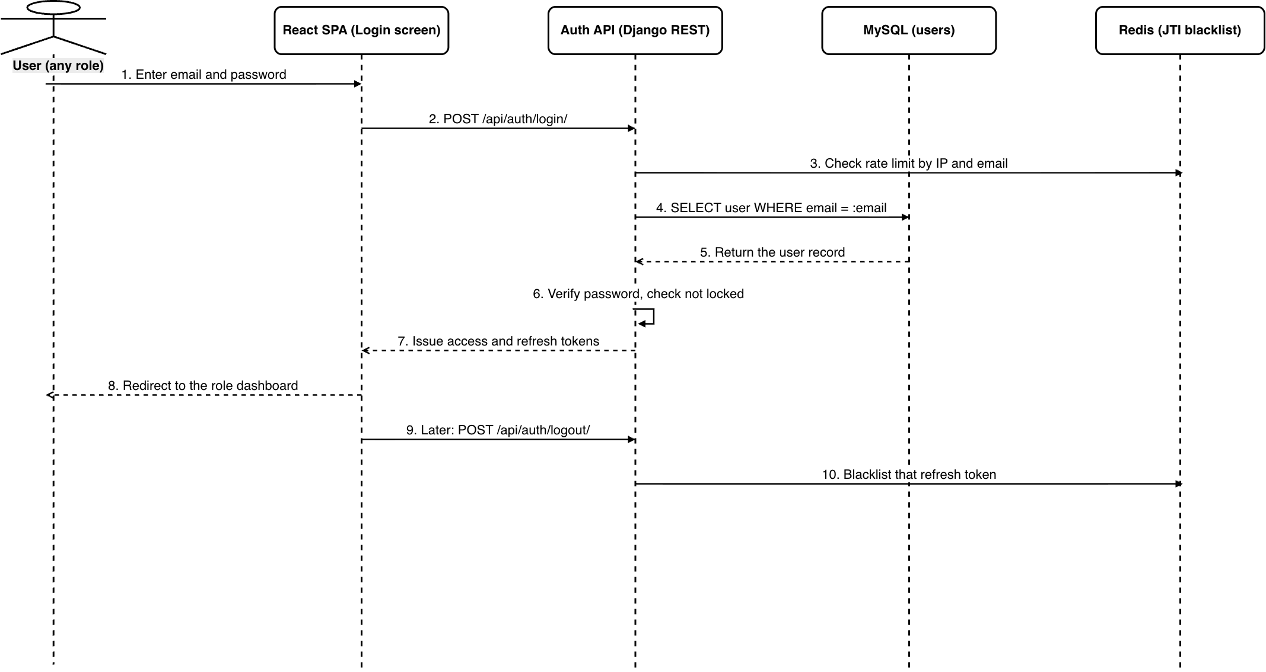
Figure 2.1: User Authentication & JWT Token Issuance
Design notes. Two limits protect this endpoint, because they stop two different attacks. The limit per IP address (5 per minute) stops one computer from trying many passwords. The limit per email address (20 per hour) stops many computers from trying the same passwords on one account, which the first limit would never see. The access token lasts 15 minutes and the refresh token lasts 7 days. A stolen access token is therefore useless very soon, but a real shopper is not asked to sign in again every few days. Logout cancels only the refresh token that was sent. This is why one account can be shared at home (FR-30): signing out on the tablet leaves the phone signed in.

2.2 Sequence: Multi-Farmer Cart Checkout & Idempotency
Purpose. Turns a basket that may span several stalls into real orders, one per farmer, without ever creating the same order twice. Triggered by the customer confirming checkout.
Message flow:
▪ 1. Review cart grouped by farmer
▪ 2. POST /api/customer/orders/
▪ 3. Idempotency-Key guards a retry
▪ 4. Count orders awaiting approval
▪ 5. Under the limit of ten
▪ 6. Market day AND farmer day?
▪ 7. Read stock, no lock, no deduction
▪ 8. INSERT one order per farmer
▪ 9. Alert each farmer
▪ 10. 201 Created: N separate orders
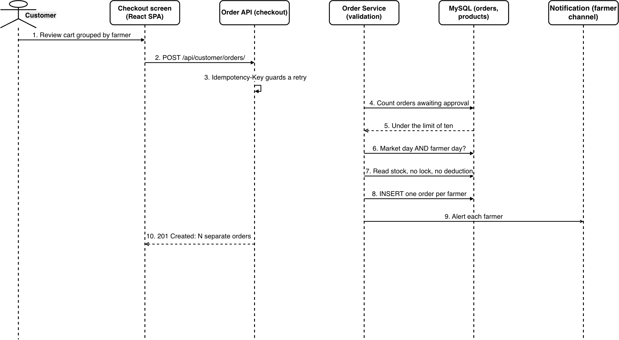
Figure 2.2: Multi-Farmer Cart Checkout & Idempotency
Design notes. The Idempotency-Key stops the same order being created twice. A shopper with a weak connection may tap Confirm twice, or the browser may resend a request that timed out. The key is stored with a hash of the request body. If the same key arrives with a different body, the system refuses it instead of silently replaying the old answer. A key that is still being processed is held for 5 minutes. A finished answer is replayed for 24 hours. Old orders are expired first, so stock held by dead orders does not make a valid cart look too expensive. All orders are saved together or none are saved. A shopper who planned one trip to the market should not end up with half of it.

2.3 Sequence: Order Modification & Change Request Flow
Purpose. Lets a customer change an order they have already placed, by two different routes depending on whether a farmer has committed to it yet. Triggered by the customer editing an order.
Message flow:
▪ 1. Edit an order already accepted
▪ 2. PATCH the order, sending If-Match
▪ 3. Cutoff not passed, no request open
▪ 4. Write orders.pending_change
▪ 5. The order itself is left untouched
▪ 6. Alert the farmer
▪ 7a. Accept: adjust stock by the delta
▪ 7b. Reject: clear it, keep the order
▪ 7c. Cancel the order: return the stock
▪ 8a. Apply new items, clear the request
▪ 9. Tell the customer the outcome
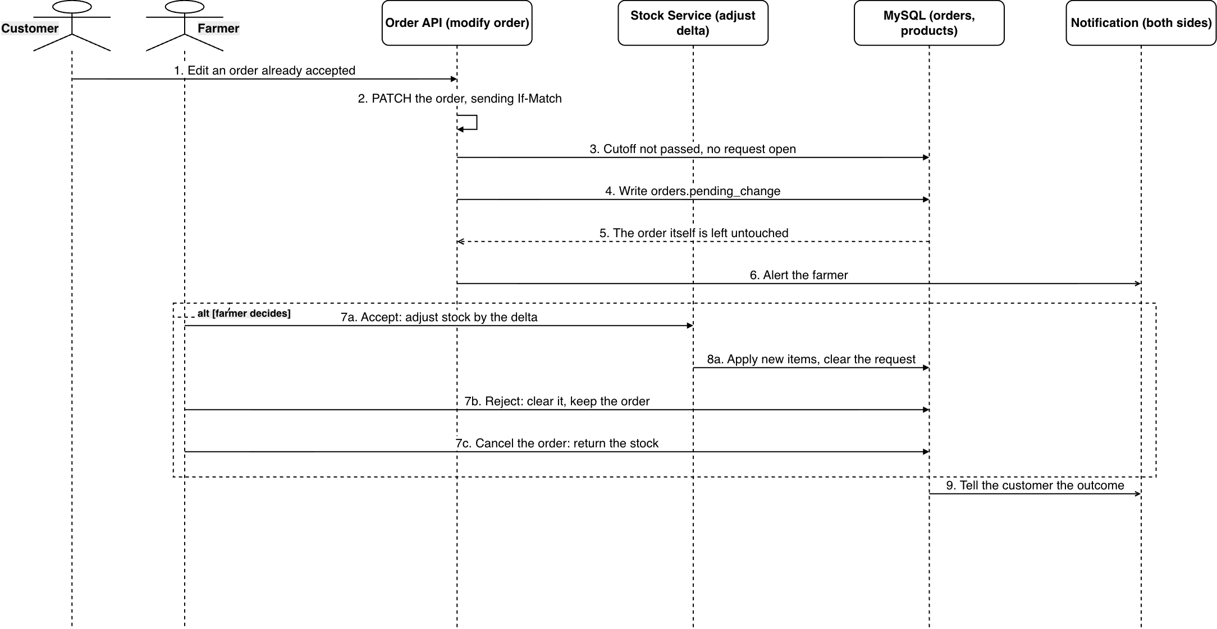
Figure 2.3: Order Modification & Change Request Flow
Design notes. The route depends on the order status, and that is the main idea here. While the order is PLACED, no one has promised anything, so the change is saved directly. After the farmer accepts, produce has been set aside, so the same change becomes a request. It waits in the pending_change field until the farmer answers. Both routes write a history row with an empty transition column, because the status did not change. That empty value is how the audit trail tells an edit apart from a status change. The cutoff applies to both routes. There is one exception: if an admin moved the market (2.13), the cutoff is switched off, because the customer is fixing a problem they did not cause.

2.4 Sequence: Farmer Order Acceptance, Item Sold Out & Stock Deduction
Purpose. The moment produce is actually committed to a shopper. Triggered by the farmer accepting a placed order, and it is the only point in the system where stock leaves the catalogue.
Message flow:
▪ 1. Click Accept on a placed order
▪ 2. POST /api/farmer/orders/{id}/accept/
▪ 3. BEGIN transaction
▪ 4. SELECT products ORDER BY id FOR UPDATE
▪ 5. Rows locked in ascending id order
▪ 6a. Deduct stock, set status ACCEPTED
▪ 6b. Not enough: 400, order stays PLACED
▪ 7a. COMMIT and release the locks
▪ 8a. Alert the customer in-app and by email
▪ 9. Move the order to the Accepted tab
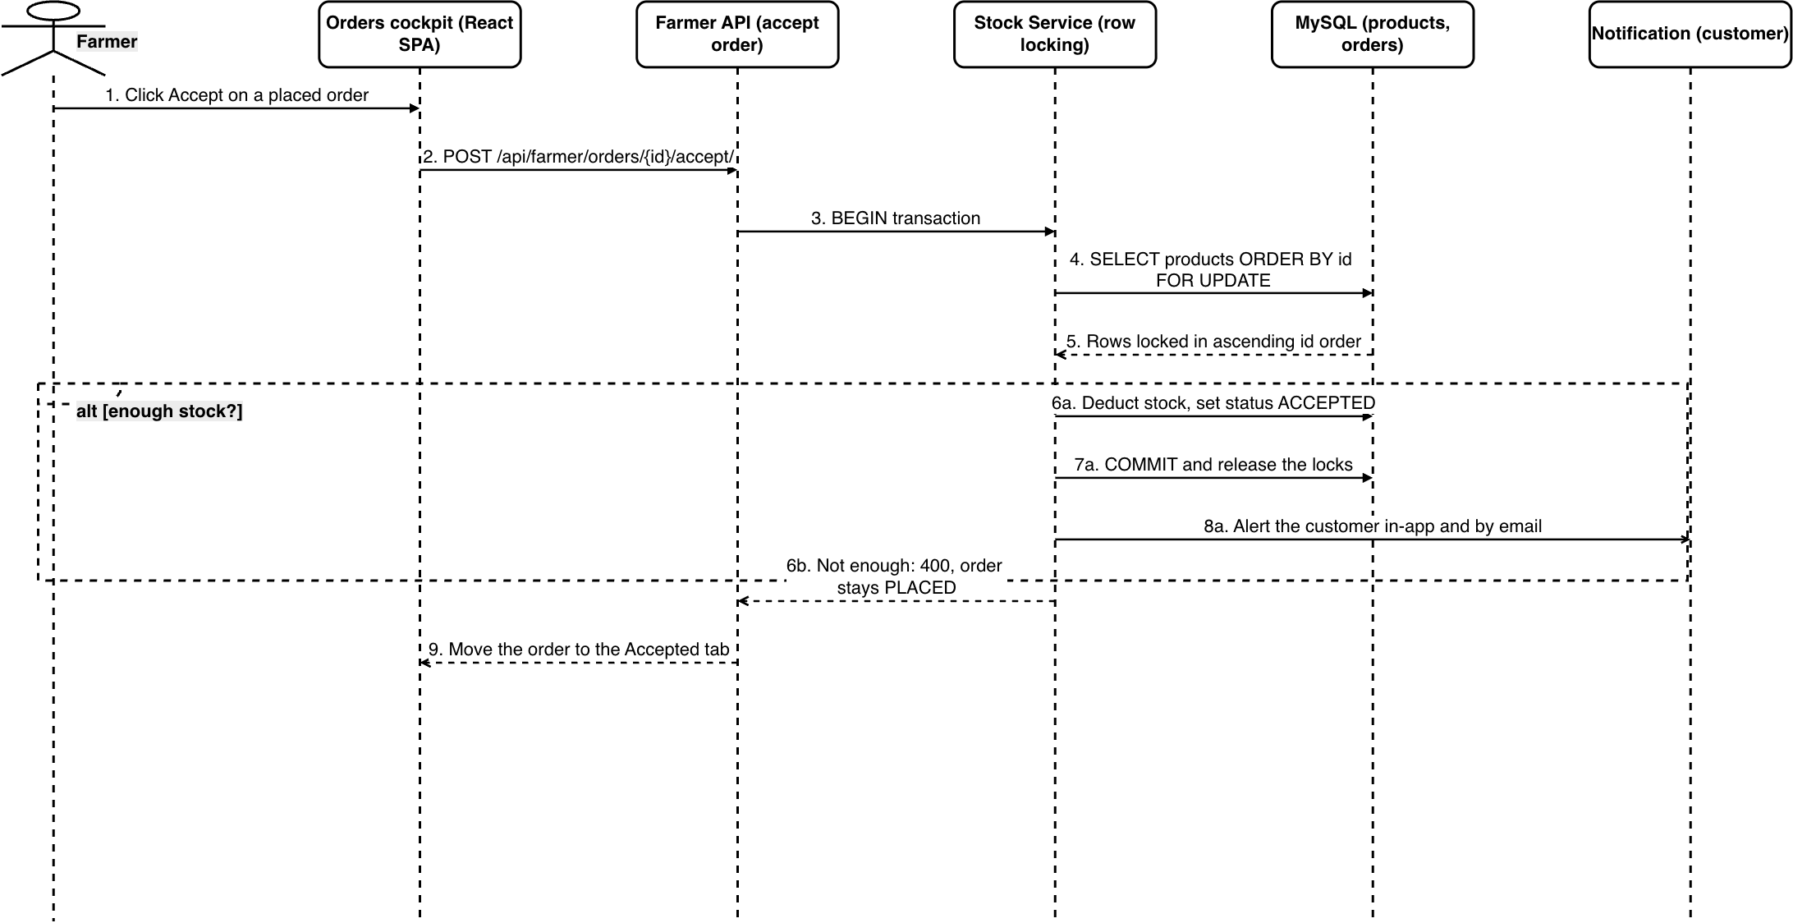
Figure 2.4: Farmer Order Acceptance, Item Sold Out & Stock Deduction
Design notes. This is where produce really leaves the catalogue, so the design is built around one risk: two farmers accepting two orders for the same produce at the same moment. The product rows are locked, and they are always locked in the same order, from the lowest id upward. This is what stops two transactions from waiting on each other forever. The check and the deduction happen inside the same lock, so nothing can change in between. If stock is short, the whole transaction is undone and the order stays PLACED. Nothing is half done. To decline an order that was already accepted, the farmer must say which items are gone, because the system needs to know what to put back on sale.

2.5 Sequence: Order Handover & No-Show Restitution
Purpose. Closes an order at the stall, either because the shopper collected it or because they did not. Triggered by the farmer at the point of handover.
Message flow:
▪ 1. Arrive and give the order number
▪ 2. Open that order in the list
▪ 3. Check the items together
▪ 4. Pay in cash at the stall
▪ 5a. Confirm handover
▪ 5b. Window closed, no one came
▪ 6a. Set status COMPLETED
▪ 6b. Set status NO_SHOW
▪ 7a. Invite the customer to review
▪ 7b. Return the produce to online stock
▪ 8. Refresh the order list
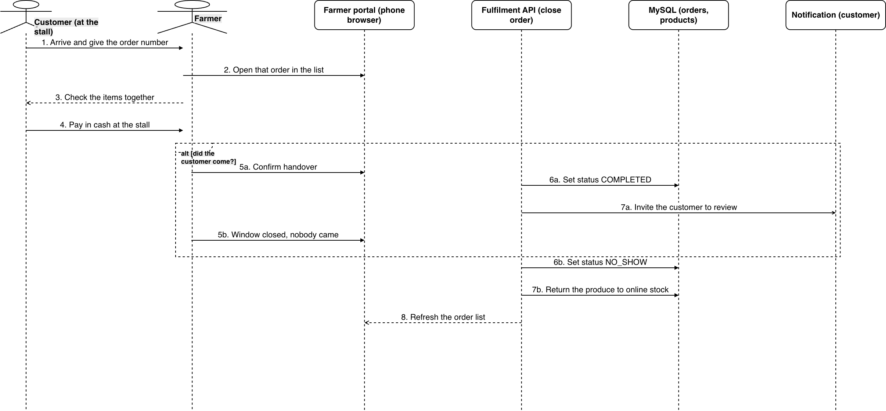
Figure 2.5: Order Handover & No-Show Restitution
Design notes. The system records that the order was completed, but not the payment. Cash is paid at the stall and there is no payment column in the database. A no-show cannot be recorded early. The system refuses it until the pickup window has closed, so a farmer cannot mark someone absent while they still have time to arrive. Recording a no-show puts the produce back on sale at once. It also starts two checks after the transaction is saved: the at-risk flag and the automatic lock (FR-62). Both count a no-show the same way, whether the order was ACCEPTED or READY_FOR_PICKUP. If either check fails, the error is written to the log and ignored, because bookkeeping must never break the farmer's handover.

2.6 Sequence: Weekly Stock Template Setup & Rollover
Purpose. Restores each product to the quantity the stall normally brings to market, without disturbing produce already promised. Triggered by the farmer applying the template, never by a timer.
Message flow:
▪ 1. Set a base weekly quantity per product
▪ 2. POST /weekly-template/ writes weekly_default_quantity
▪ 3. Apply to this week
▪ 4. POST /apply-weekly-template/
▪ 5. Expire overdue orders first
▪ 6. Read the quantity already owed
▪ 7. new = max(0, template - owed)
▪ 8. UPDATE stock_quantity
▪ 9. Which products rose above zero?
▪ 10. Alert everyone who bookmarked them
▪ 11. Return the applied figures
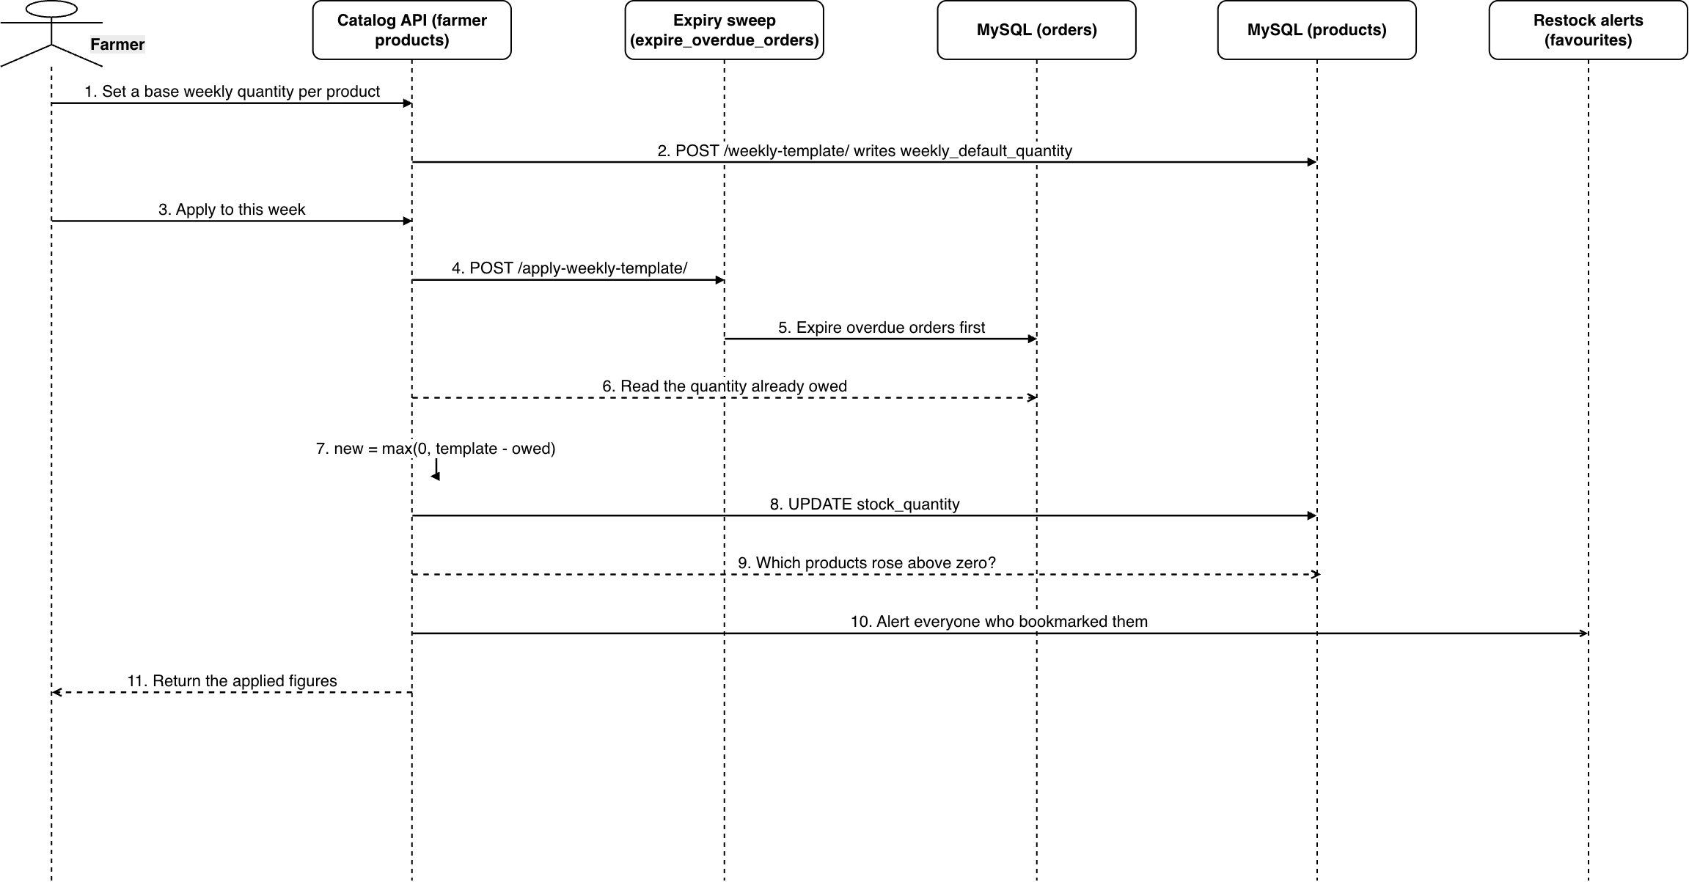
Figure 2.6: Weekly Stock Template Setup & Rollover
Design notes. The sequence of the first steps is the most important part. Old orders are expired before anything is read, so the quantity counted as owed only includes orders that are still alive. Without this, an order that died overnight would still hold produce. The new stock is then max(0, weekly quantity - owed). That zero floor keeps the template safe: it can raise stock back to the normal weekly level, but it can never go below what accepted orders are already owed. The farmer applies the template by hand, not on a timer. A template that refreshed itself every week would silently undo the corrections the farmer made. Any product that goes from zero to more than zero sends an alert to the shoppers who saved it.

2.7 Sequence: Farmer Onboarding & Admin Approval Workflow
Purpose. Takes a stall from an application to a publicly visible trader. Triggered by the applicant, completed by an administrator.
Message flow:
▪ 1. Submit the stall form and operating days
▪ 2. POST /api/auth/register/farmer/
▪ 3. Create user + profile as PENDING, one transaction
▪ 4. COMMIT
▪ 5. Geocode the address after commit
▪ 6. Coordinates, or nothing on failure
▪ 7. Review the waiting application
▪ 8. POST /api/admin/farmers/{id}/approve/
▪ 9. Status APPROVED - the stall becomes public
▪ 10. Record who decided, and why on a refusal
▪ 11. Tell the applicant
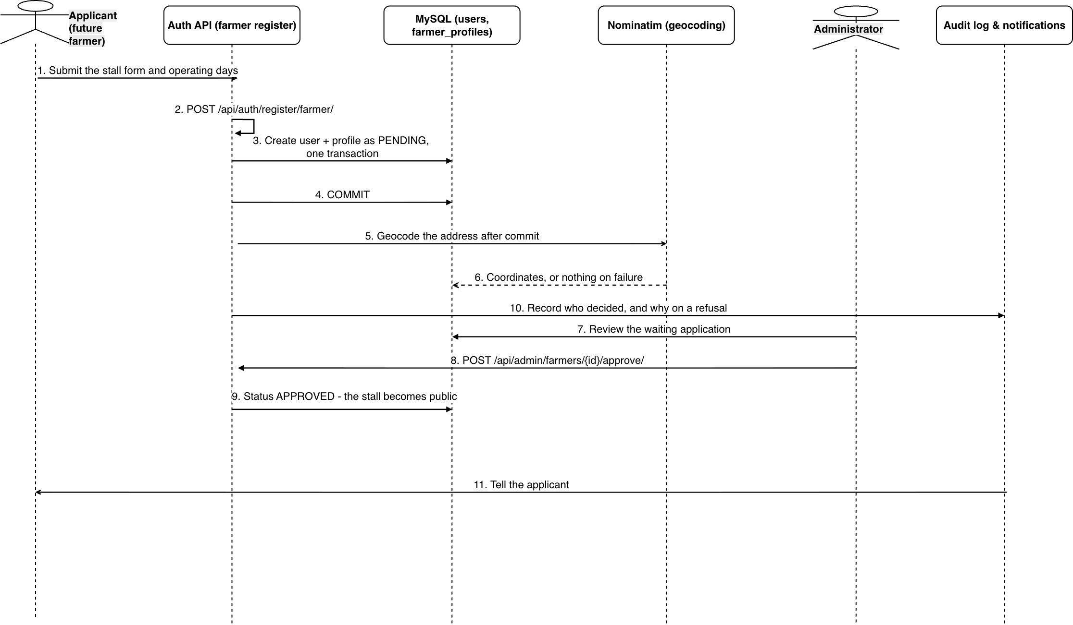
Figure 2.7: Farmer Onboarding & Admin Approval Workflow
Design notes. The stall is created with status PENDING inside one transaction, so a half-registered farmer cannot exist. The address is sent to the map service only after the data is saved. This order matters. The map service is outside our system, it has a 5 second timeout, and we send not more than one request per second. If it fails, the coordinates are simply left empty. A map pin is useful, but it is not worth losing a registration. No one should be told their sign-up failed because another company's server was slow. The stall stays invisible to shoppers until an admin approves it. Rejecting or suspending a stall needs a written reason, which is saved in the audit log, because the team may have to explain that decision later.

2.8 Sequence: Market Schedule Revision & Emergency Closure Workflow
Purpose. Withdraws a market from trading and settles everything that depended on it. Triggered by an administrator, and it is the most destructive action in the console.
Message flow:
▪ 1. Choose Close Market, type the confirmation word
▪ 2. POST /api/admin/markets/{id}/deactivate/ {reason}
▪ 3. Show how many open orders this will close
▪ 4. Confirm
▪ 5. Deactivate the market, switch off every pickup slot
▪ 6. Decline open orders: MARKET_CLOSED_BY_ADMIN
▪ 7. Void any pending change requests
▪ 8. Return the produce to stock
▪ 9. COMMIT - all of it, or none of it
▪ 10. One MARKET_CLOSED notice each, carrying the reason
▪ 11. Reactivation leaves the slots off
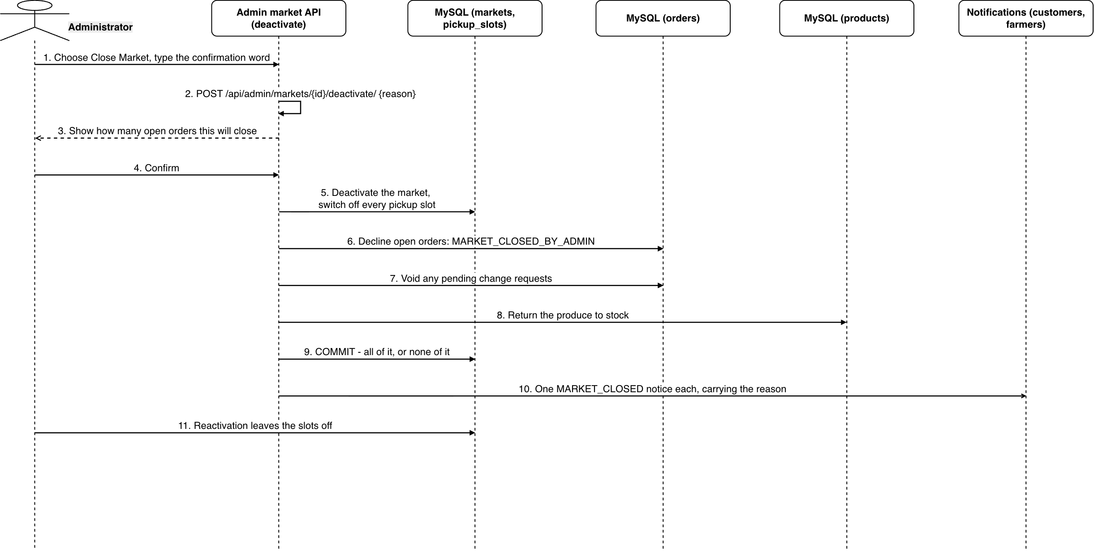
Figure 2.8: Market Schedule Revision & Emergency Closure Workflow
Design notes. This is the most destructive action in the admin console, so two things happen before anything is saved. The admin must type a confirmation word, and the screen shows how many open orders will be closed. Everything after that runs in one transaction: the market, the pickup slots, the orders, the stock and the pending changes all change together. A half-closed market would be worse than an open one, because shoppers would still be booked into times that no longer exist. Each order is closed with the reason MARKET_CLOSED_BY_ADMIN, not a normal decline, so the history shows this was the platform's decision and not the farmer's. Opening the market again does not switch the pickup slots back on. The system cannot know which stalls are ready, so each farmer turns their own back on.

2.9 Sequence: Product Review Submission & Farmer Response
Purpose. Lets a shopper rate what they actually bought, and gives the stall one public right of reply. Triggered by the customer after collection.
Message flow:
▪ 1. Rate a purchased item, 1-5 stars and a comment
▪ 2. POST /orders/{order_id}/items/{item_id}/review/
▪ 3. Is the order COMPLETED and this customer's?
▪ 4. Yes - otherwise 422 and nothing is written
▪ 5. INSERT the review
▪ 6. A unique constraint blocks a second review of the same line
▪ 7. Notify the stall
▪ 8. POST /product-reviews/{id}/reply/ - one reply only
▪ 9. Average rating is derived from the rows, never cached
▪ 10. Review and reply appear together
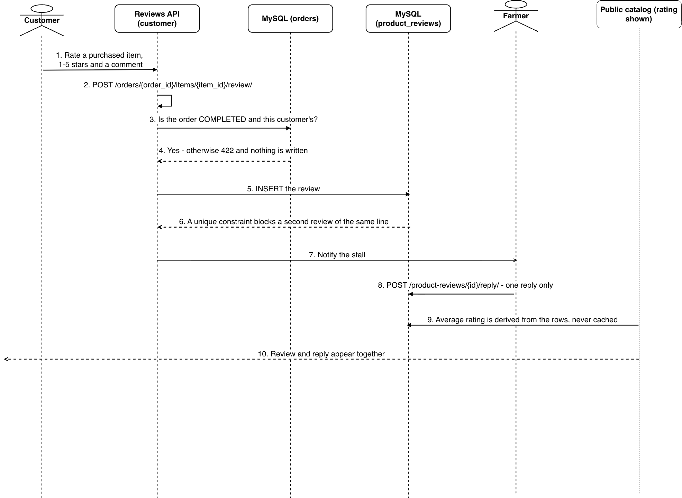
Figure 2.9: Product Review Submission & Farmer Response
Design notes. Only a completed order can be reviewed. The system checks that the order reached COMPLETED and that it belongs to the person writing the review. This is what allows the rating trustworthy. Uniqueness is enforced by the database, not by the service code: the review is linked to one order line by a one-to-one relation. Hence, even if two requests arrive at the same time, a second review of the same purchase cannot be created. Average ratings are calculated from the saved rows every time they are read. They are not cached, because a cached average can silently become wrong. The farmer may reply once to each review. The aim is a right of reply, not a discussion thread.

2.10 Sequence: Lazy Expiration & Cleanup Sweep Flow
Purpose. Closes orders the farmer never answered, so they stop appearing as if they were live. Runs as a side effect of other work rather than on a schedule.
Message flow:
▪ 1. Checkout, the weekly-stock apply and the farmer dashboard each invoke expire_overdue_orders().
▪ 2. It runs in its own transaction, so it never blocks a concurrent checkout.
▪ 3. Orders still PLACED past pickup_start_at become EXPIRED, with no stock change and no fault recorded.
▪ 4. Those customers receive ORDER_EXPIRED.
▪ 5. Change requests pending past the same moment are voided.
Design notes. There is no scheduled job and no background worker here. The sweep runs during work that is already happening: a checkout, applying the weekly template, or opening the farmer dashboard. This means the platform stays correct on free hosting, where nothing is scheduled. Each order is expired in its own transaction, so one bad row cannot undo the others, and the sweep never blocks the checkout that started it. No stock moves, because a placed order never held any. Nothing is recorded against the customer either. An order the farmer ignored is not the shopper's fault, and and this is precisely what makes EXPIRED different from NO_SHOW.

2.11 Sequence: Real-Time WebSocket Notification & Email Dispatch
Purpose. Delivers every alert the platform sends, over two channels with different reliability. Triggered from inside whichever service changed the thing worth reporting.
Message flow:
▪ 1. Order status changed (e.g. ACCEPTED)
▪ 2. INSERT INTO notifications record
▪ 3. Publish payload to user Redis channel
▪ 4. Push WebSocket frame to active browser
▪ 5. Update bell badge & toast notification
▪ 6. Register email task via on_commit()
▪ 7. COMMIT database transaction
▪ 8. Trigger on_commit hook to spawn email thread
▪ 9. Connect & dispatch via Gmail SMTP
▪ 10. Log completion (SMTP errors never rollback DB)
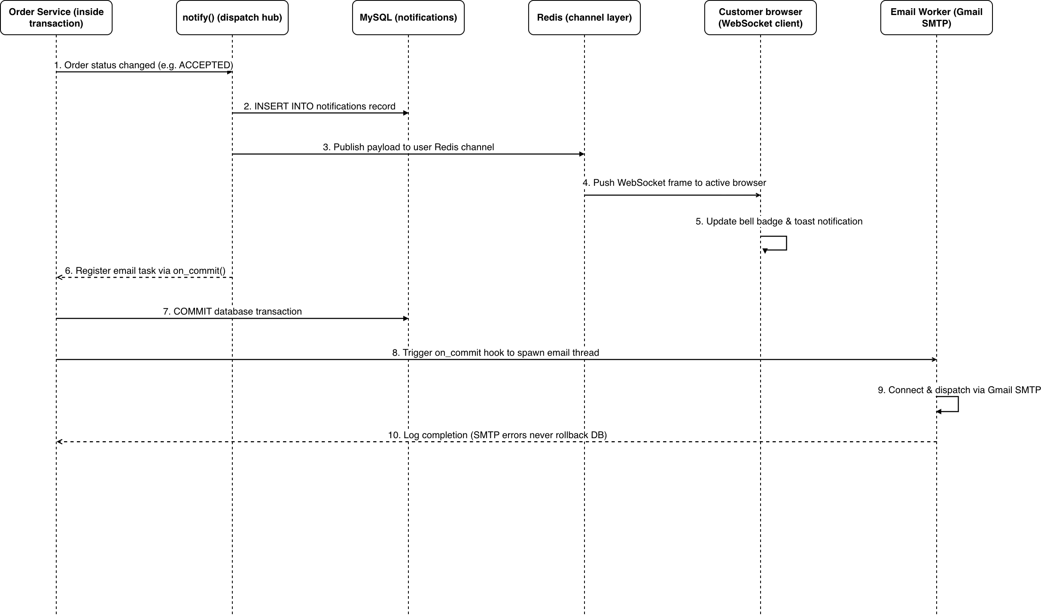
Figure 2.11: Real-Time WebSocket Notification & Email Dispatch
Design notes. Every alert goes through one function, so there is a single place to add, stop or check an alert. The in-app message is saved to the database and pushed over the WebSocket immediately. The email is added to the queue only when the transaction is saved, and then handed to a worker thread. This order is important: if the transaction is undone, no email is ever sent about an order that does not exist. The in-app message is the reliable channel and email is extra. This is why a failed email is written to the log and never retried. A retry loop against an outside mail server is the type of background job that fails silently for weeks.

2.12 Sequence: Listing Review, Automatic Approval & the Queue
Purpose. Decides whether a new or edited listing may reach the public catalogue, and does it fast enough that a stall is not left waiting. Triggered by the farmer saving a listing.
Message flow:
▪ 1. Create or edit product listing
▪ 2. Check if text, price, image or category changed
▪ 3. Save product with review_status=PENDING
▪ 4. Dispatch automated content review
▪ 5. Run heuristic checks (price band, profanity)
▪ 6. Send image & description to Gemini for audit
▪ 7. Return verdict & safety confidence scores
▪ 8a. PASS: Auto-approve & set is_on_sale=True
▪ 8b. SUSPECT / FLAG: Move to manual review queue
▪ 9a. Notify admin dashboard of auto-approval
▪ 10. Review flagged item & submit decision
▪ 11. Update review status & notify farmer
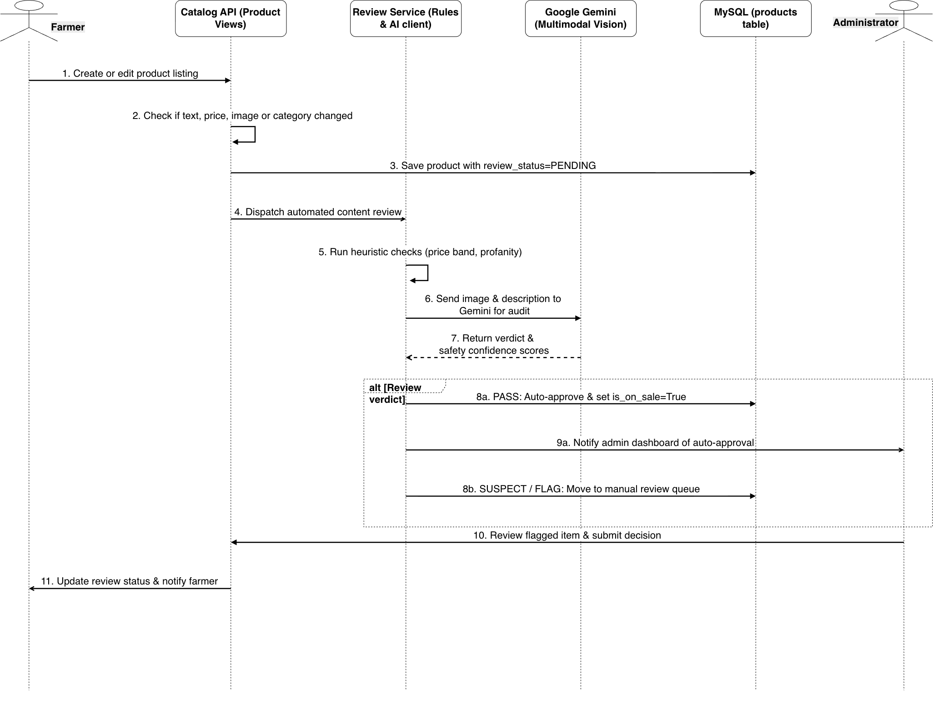
Figure 2.12: Listing Review, Automatic Approval & the Queue
Design notes. The system first asks a narrow question: did anything change that alters what the listing claims to be? The review runs away from the request, in two layers. Simple rules run first and the AI model runs second, so a listing still gets a verdict when the model is unavailable. Content that was reviewed before is recognised by its hash and is not paid for twice. A clean listing is published without waiting for a person. A suspicious one is held and sent to the queue. This difference is by design: the system may publish, and an admin can undo that, but the system may not reject, because a wrong rejection costs a stall its market day.

2.13 Sequence: Pickup Reschedule & Automatic No-Show Lock
Purpose. Two flows that share a page because they share a property: both are cases where the system acts on an order without the person whose order it is. The first repairs orders broken by a schedule change; the second closes accounts that repeatedly fail to collect.
Message flow:
▪ 1. Edit market operating days or hours
▪ 2. Calculate impact: count broken open orders
▪ 3. Return impact preview (orders_to_reschedule)
▪ 4. Confirm changes (confirm_affected=true)
▪ 5. Set orders.reschedule_requested_at = now()
▪ 6. Notify affected customers to reschedule
▪ 7a. Pick new pickup slot & date in customer portal
▪ 7b. Original pickup arrives while still unrescheduled
▪ 8a. Validate timing & clear reschedule_requested_at
▪ 8b. Cancel order, restore stock & notify customer
▪ 9. 3 no-shows within 30 days trigger account lock
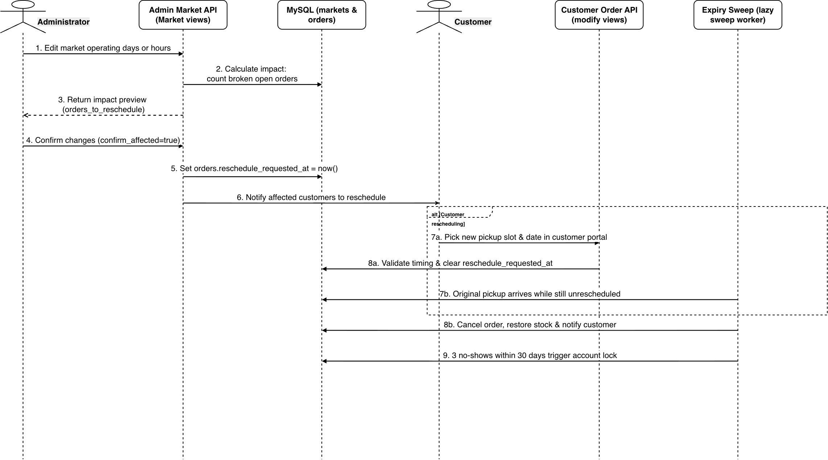
Figure 2.13: Pickup Reschedule & Automatic No-Show Lock
Design notes. These two flows are on one page because they share one property: the system acts on an order without the person who owns it. When an admin moves a market's days or hours, the affected orders are marked, not cancelled, and their cutoff is switched off. The shopper should not be blocked while fixing a problem they did not cause. Only the pickup time can change on such an order. If the old time arrives and no new time was chosen, the order is closed and the produce goes back on sale, because an order pointing at a time that has passed is not a live order. The automatic lock is the stronger action and is the decision most open to question: three no-shows in thirty days close the account and cancel its open orders, so stalls that did nothing wrong lose bookings. The count starts again after any unlock, so an admin who gives someone a fresh start is not overruled by old history, and the order numbers behind the decision are written to the audit log so it can be checked and reversed.

3. ORDER LIFECYCLE STATE MACHINE
The order is the one entity in MarketLink whose behaviour cannot be determined from its attributes: the same row means different things depending on how it got there, and several of the rules the platform rests on are rules about transitions rather than about states. This section specifies that behaviour as a state machine. The eight states are orders.status; the transition codes are the ones stored in order_status_history.transition, so every arrow below can be checked against a real row in the database.
Diagram Description: the state machine shows 8 states and 13 transitions. It reads left to right along the path an order takes when nothing goes wrong - PLACED, ACCEPTED, READY_FOR_PICKUP, COMPLETED - with the four closing states arranged above and below it: EXPIRED and CANCELLED above, DECLINED and NO_SHOW below. The numbering runs T1 to T14 with T7 absent, because T7 (customer modification of an accepted order) was superseded by the change-request mechanism and is marked deprecated in the code; that is why this document counts 13 live transitions and not fourteen.
Code | From -> To | Fired by | Guard | Effect on stock
T1 | (start) -> PLACED | Customer | Cart passes validation | Checked, none deducted
T2 | PLACED -> ACCEPTED | Farmer | Stock still sufficient | Deducted under a row lock taken in ascending product id
T3 | PLACED -> DECLINED | Farmer, Admin | Reason given (5-500 chars) | None - nothing had been deducted
T4 | ACCEPTED -> DECLINED | Farmer, Admin | Reason given; sold-out items declared | Restored
T5 | PLACED -> CANCELLED | Customer, Admin | Before the cutoff | None - nothing had been deducted
T6 | ACCEPTED -> CANCELLED | Customer, Admin | Before the cutoff | Restored
T8 | PLACED -> EXPIRED | System | Collection window has started | None; no fault recorded against the customer
T9 | ACCEPTED -> READY_FOR_PICKUP | Farmer | After the cutoff | Unchanged
T10 | READY_FOR_PICKUP -> COMPLETED | Farmer | Handover at the stall | Unchanged
T11 | READY_FOR_PICKUP -> NO_SHOW | Farmer | now >= pickup_end_at | Restored; the no-show is counted
T12 | READY_FOR_PICKUP -> DECLINED | Admin | Stall suspended | Restored
T13 | READY_FOR_PICKUP -> CANCELLED | Admin | Customer locked | Restored
T14 | ACCEPTED -> NO_SHOW | Farmer | now >= pickup_end_at | Restored; the no-show is counted
Why stock is restored on the transition and not on entering the state. DECLINED can be reached three ways and they are not consistent with each other: T3 restores nothing, because a placed order never held produce, while T4 and T12 restore the whole order. The same split runs through CANCELLED (T5 against T6 and T13). A state cannot carry an entry action that only sometimes runs, so the restoration belongs to the arrow. This is the two-stage stock model stated as behaviour: produce is committed when the farmer accepts, never when the customer checks out.
EXPIRED against NO_SHOW. Both close an order that was never collected, and keeping them separate is the intention. EXPIRED (T8) means the farmer never answered: no produce was held, and nothing is recorded against the customer, who did nothing wrong. NO_SHOW (T11, T14) means the customer did not come for an order the farmer had committed to: the produce goes back on sale and the no-show is counted. Both no-show routes count equally - the counters read orders.status = NO_SHOW and never the status the order came from - so an order abandoned at ACCEPTED carries the same weight as one abandoned at READY_FOR_PICKUP.
Transitions that change nothing. Editing a placed order and raising a change request on an accepted one are internal transitions: they write a row to order_status_history with transition left NULL, because the status did not move. They are drawn inside their states rather than as arrows, which is also the place where UML puts them.
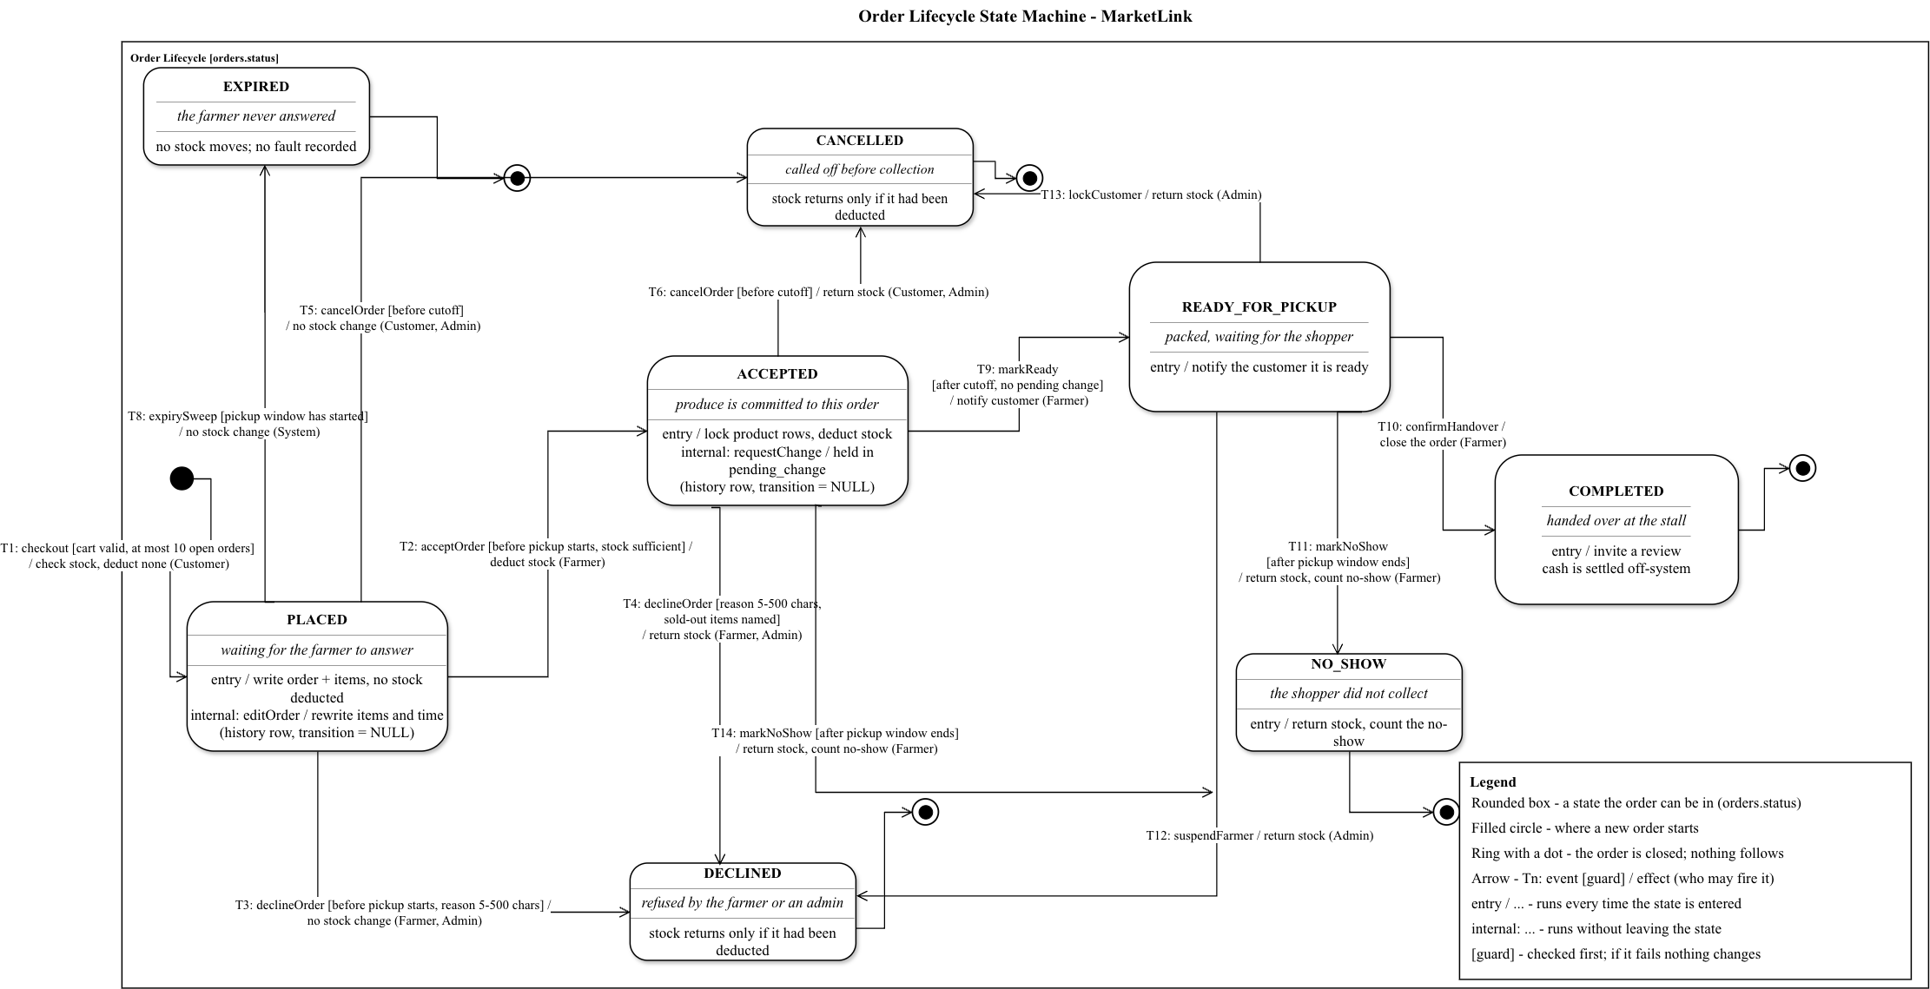
Figure 3.1: Order Lifecycle State Machine - 8 states, 13 live transitions

4. DFD (DATA FLOW DIAGRAMS)

4.1 DFD Level 0 (Context Diagram)
Figure 4.1 illustrates the contextual boundary of the MarketLink core platform, mapping bi-directional data exchanges between Customer, Farmer, Administrator, OpenStreetMap Nominatim, and External Email/AI Services.
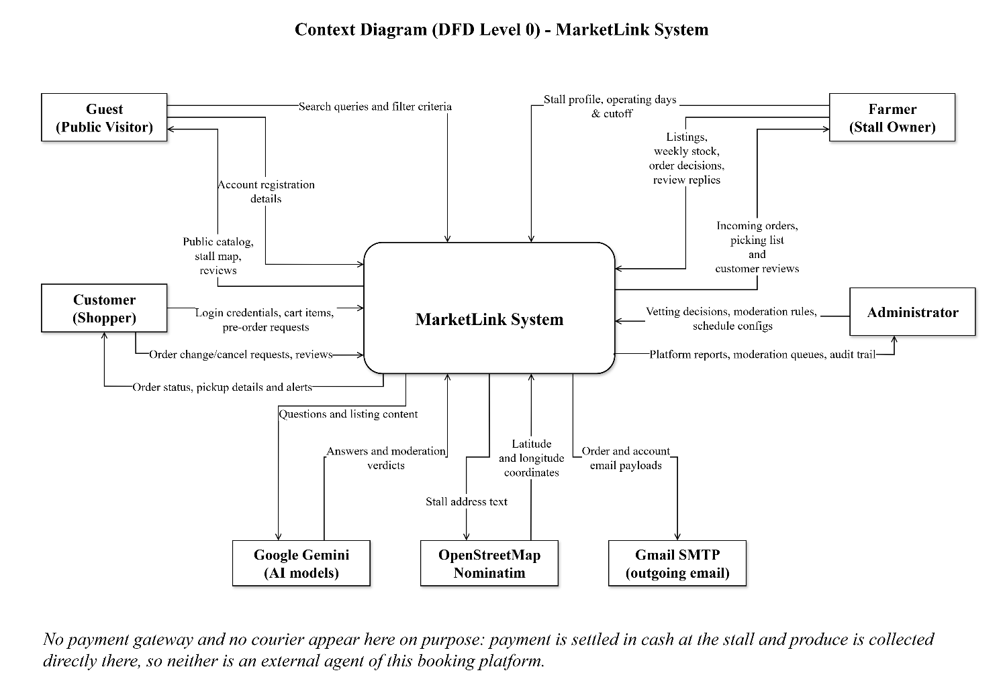

Figure 4.1: DFD Level 0 - Context Diagram

4.2 DFD Level 1 (Overall System Decomposition)
Figure 4.2 decomposes MarketLink into 4 primary processing subsystems interconnected across 8 central data store groupings (D1 to D8).
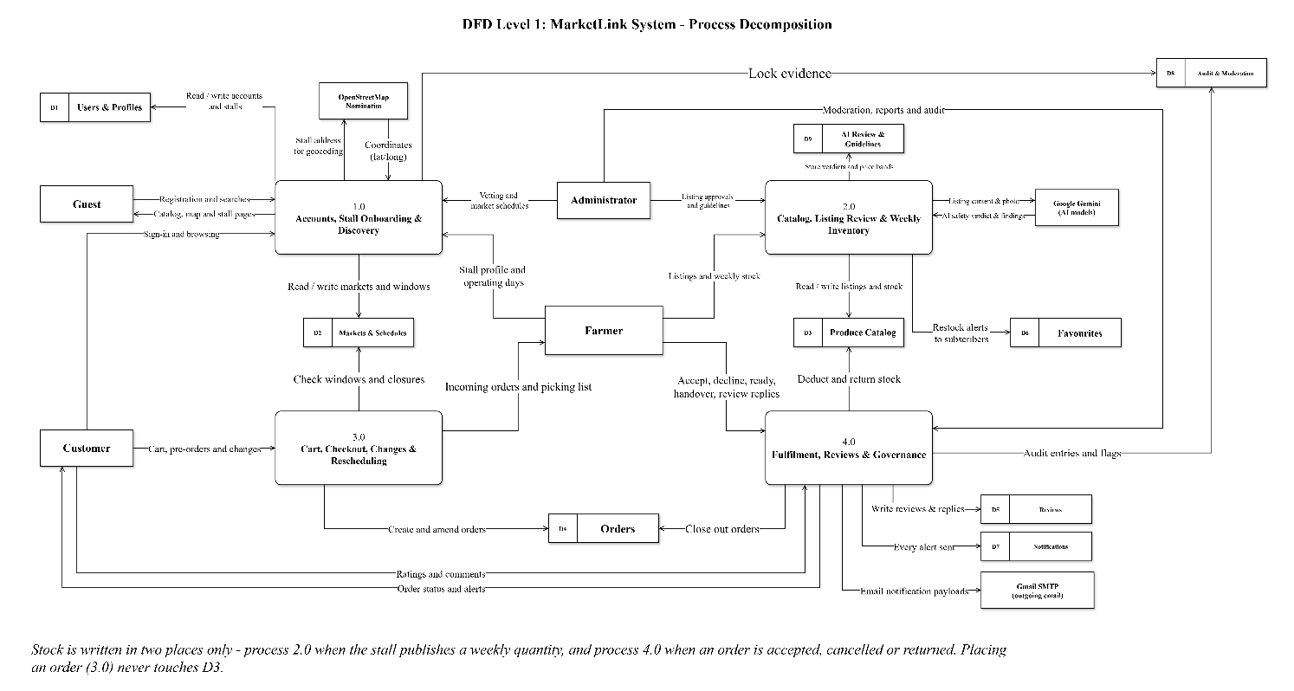
Figure 4.2: DFD Level 1 - Overall System Decomposition

5. ERD (ENTITY RELATIONSHIP DIAGRAM)

5.1 Overview Entity Relationship Architecture
The MarketLink database architecture is engineered across 8 Django applications comprising 35 relational tables: 27 core business tables plus 8 audit trail tables generated by django-simple-history (customer_profile_histories, farmer_profile_histories, farmer_market_histories, pickup_slot_histories, farmer_closure_histories, product_histories, order_histories and order_item_histories). The schema adheres strictly to Third Normal Form (3NF), runs on MySQL 8.4 LTS with the InnoDB engine and utf8mb4 / utf8mb4_0900_ai_ci collation, utilizes BIGINT auto-increment primary keys (DEFAULT_AUTO_FIELD = BigAutoField), enforces referential integrity (RESTRICT on financial and historical entities, CASCADE on subordinate child rows, SET_NULL on soft references), and maintains immutable audit histories. The chat subsystem holds no table at all: short-lived data - the JTI blacklist, the 30-second WebSocket ticket and the 24-hour Idempotency-Key - lives in Redis and is intentionally outside the relational schema.

5.2 Entity and Attribute Summary (35 Relational Tables across 8 Apps)
▪ accounts app (6 tables): roles (system roles), users (CustomUser credentials), customer_profiles (consumer info, phone unique, avatar image), farmer_profiles (stall info, operating days JSON), plus customer_profile_histories and farmer_profile_histories (audit history of account and stall changes).
▪ markets app (9 tables): markets (physical market locations & coordinates), market_operating_days (recurring days market opens), farmer_markets (a stall may now register at several markets, each approved separately) (association of stall to market), pickup_slots (recurring weekly collection windows owned by a farmer_markets pair via FK farmer_market_id, is_active flag), market_closures (start_date-end_date ranges when Admin closes a market for holidays or weather), farmer_closures (start_date-end_date ranges when a Farmer is closed for the week), farmer_market_histories (audit history of stall-to-market links), pickup_slot_histories (audit history of pickup windows), farmer_closure_histories (audit history of vacation dates).
▪ catalog app (6 tables): categories (master produce classifications), products (agricultural items, stock quantity, weekly recurring template, per-order limits, moderation status), product_histories (audit trail of product modifications), price_guidelines (accepted price band per category and unit) product_ai_reviews (one row per automated listing check, with its verdict and findings) and product_markets (which of the stall's markets a listing is actually sold at).
▪ orders app (5 tables): orders (pre-orders with pickup_start_at / pickup_end_at / cutoff_at snapshots, FSM status, OCC version, pending_change JSON), order_items (line items with product_name, unit and unit_price snapshots plus line_total), order_status_history (append-only audit log of every status change and every order edit), order_histories (audit trail of order updates), order_item_histories (audit trail of line item updates).
▪ reviews app (2 tables): product_reviews (1-5 star ratings on produce with verified purchase constraint), farmer_reviews (stall service evaluation and farmer response).
▪ favorites app (3 tables): favorite_farmers (bookmarked vendors), favorite_products (bookmarked items for restock alerts), favorite_markets (bookmarked pickup venues).
▪ notifications app (2 tables): notifications (in-app alerts with unread counter), announcements (platform-wide broadcast notices with date ranges).
▪ system app (2 tables): audit_logs (append-only record of sensitive administrative actions and exports, with endpoint, method, IP, user agent, status code and request id) and moderation_flags (the queue of reported listings and reviews awaiting an administrator).
Each table is drawn below as its own attribute diagram, in the order the entity model numbers them (25 of the base tables; the eleven django-simple-history mirror tables repeat the columns of the table they shadow and are specified in section 6 instead).
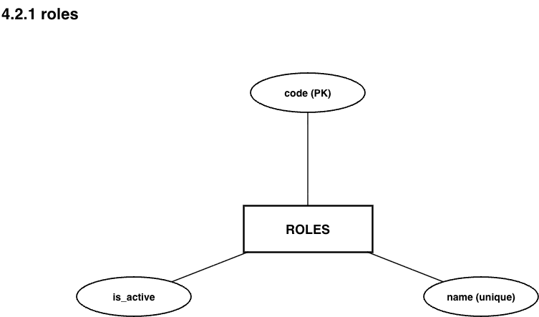
Figure 5.1: roles
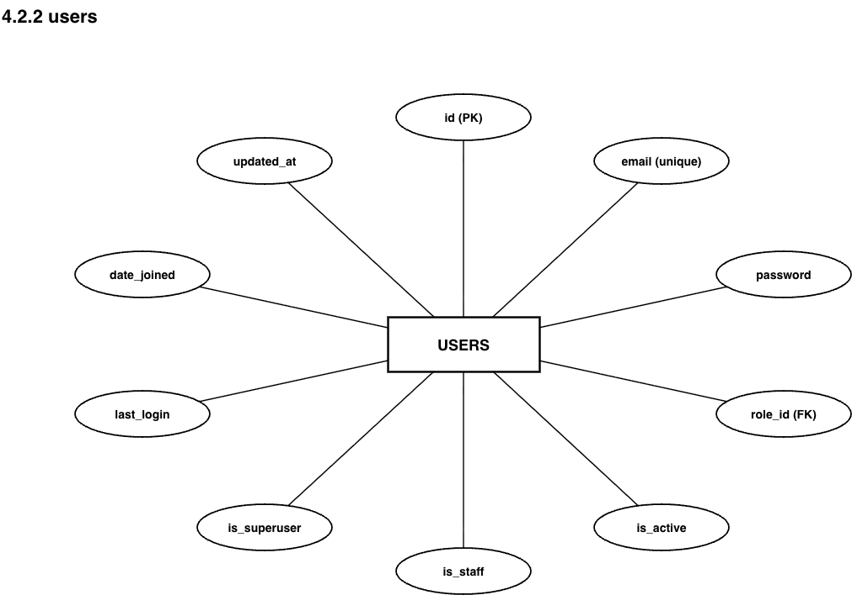
Figure 5.2: users
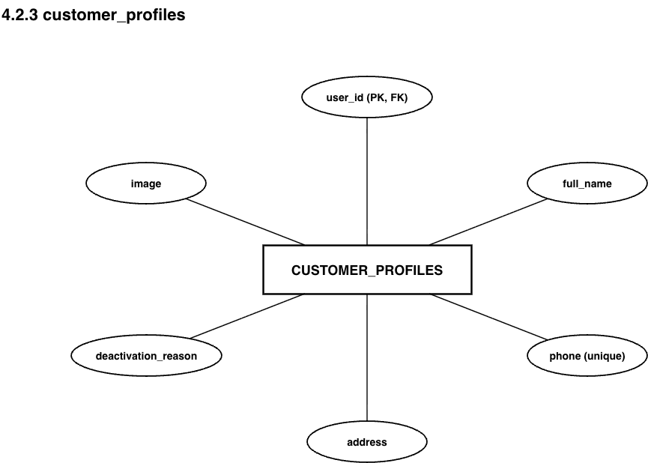
Figure 5.3: customer_profiles
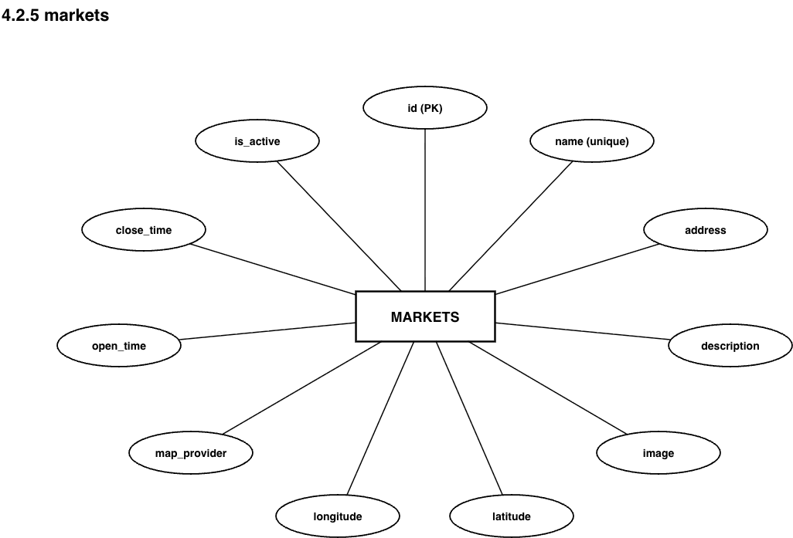
Figure 5.4: markets
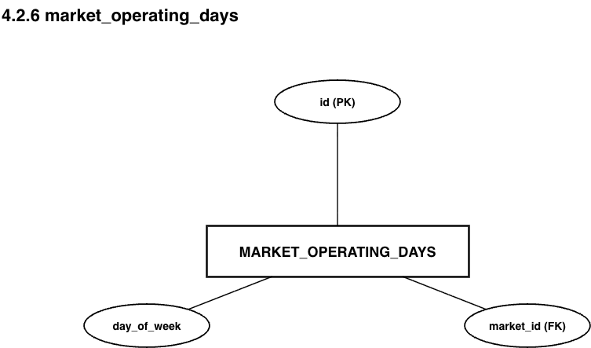
Figure 5.5: market_operating_days
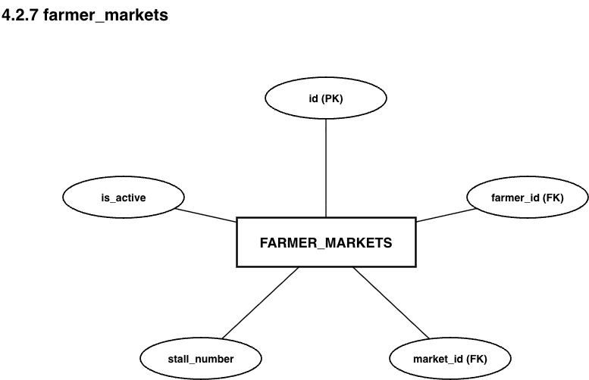
Figure 5.6: farmer_markets
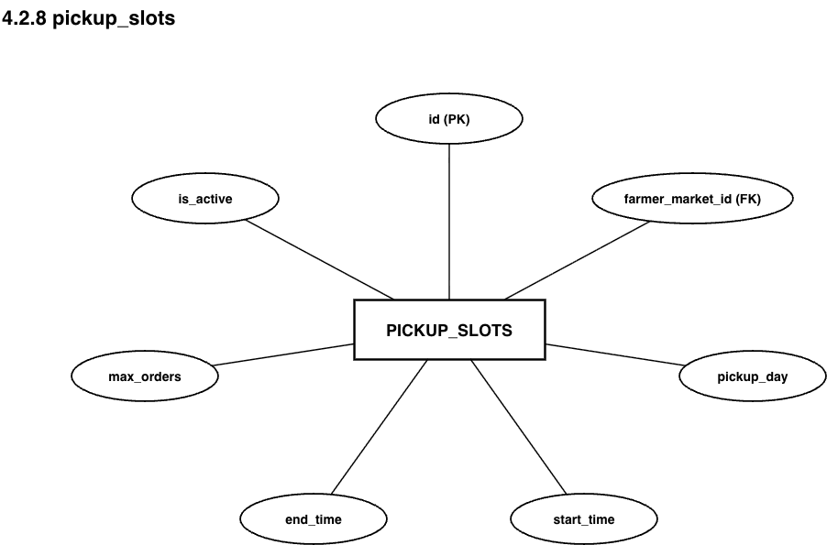
Figure 5.7: pickup_slots
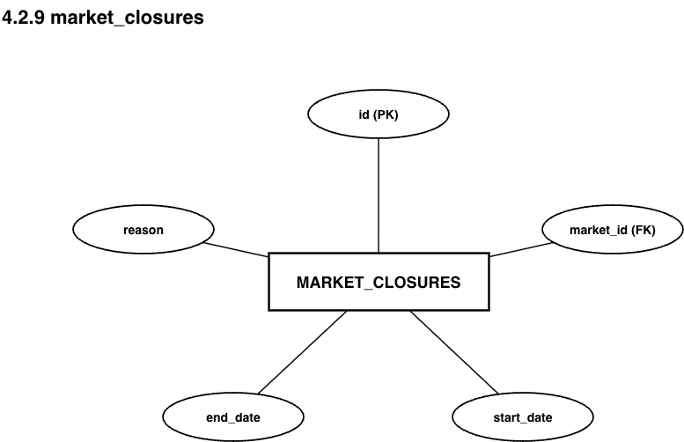
Figure 5.8: market_closures
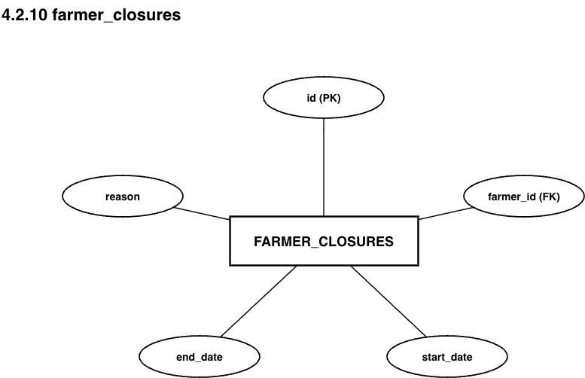
Figure 5.9: farmer_closures
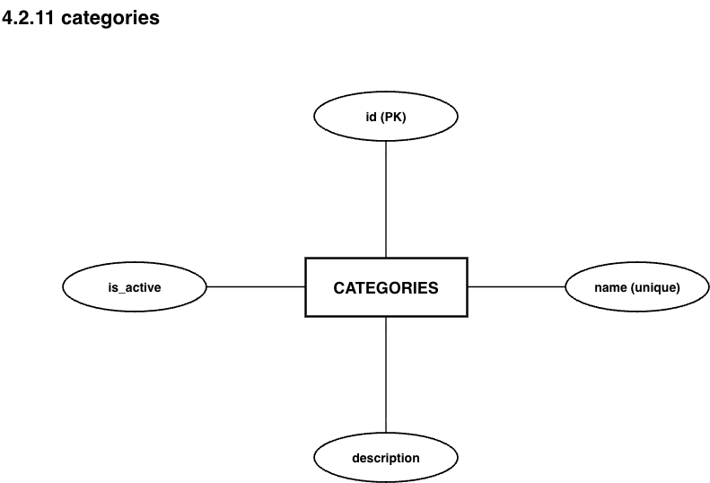
Figure 5.10: categories
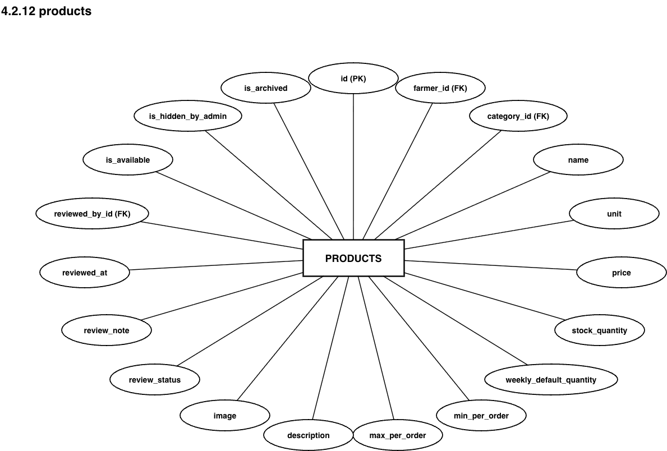
Figure 5.11: products
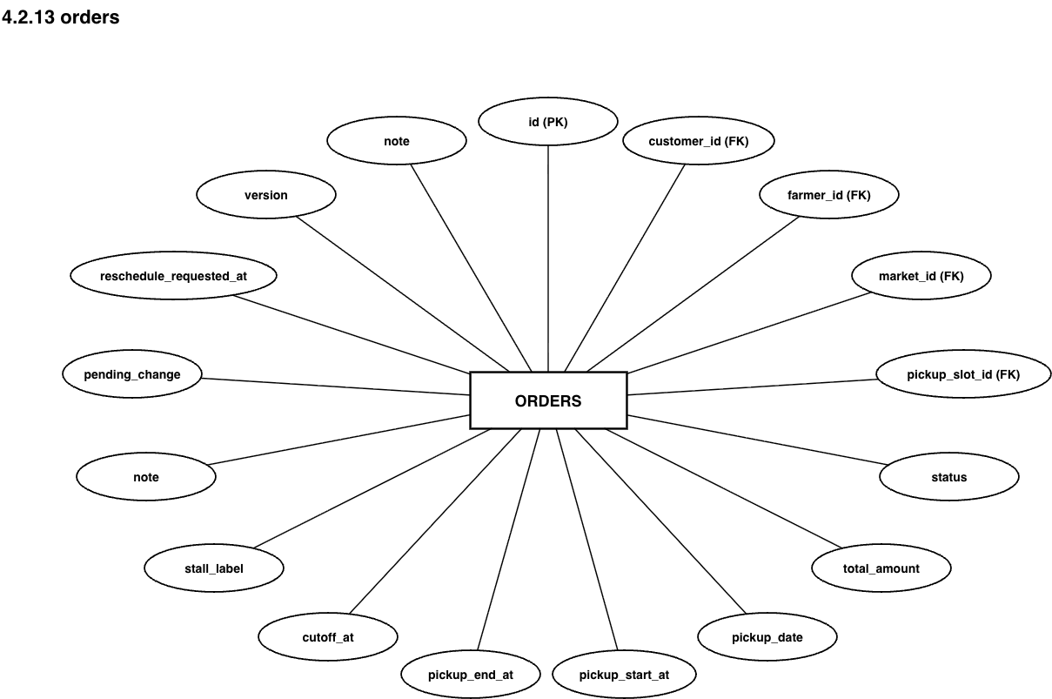
Figure 5.12: orders
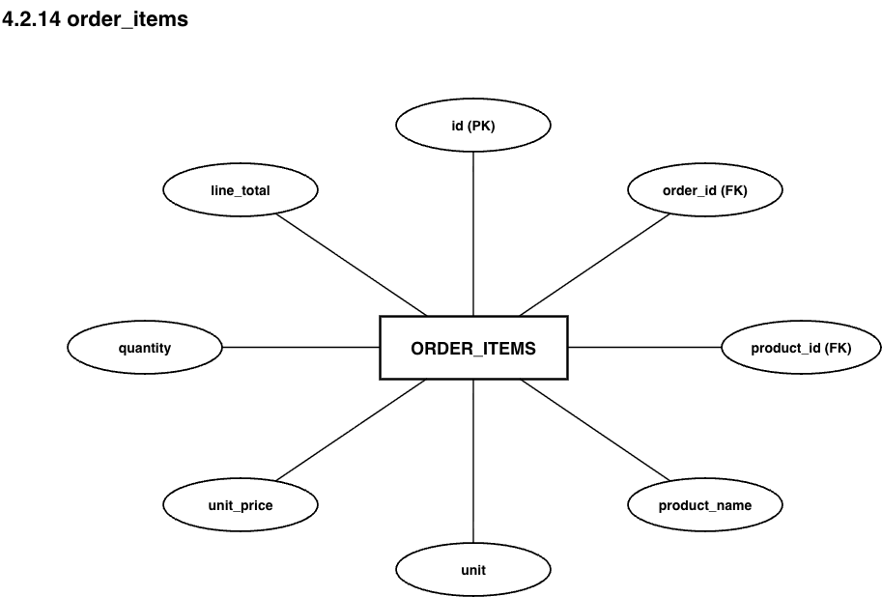
Figure 5.13: order_items
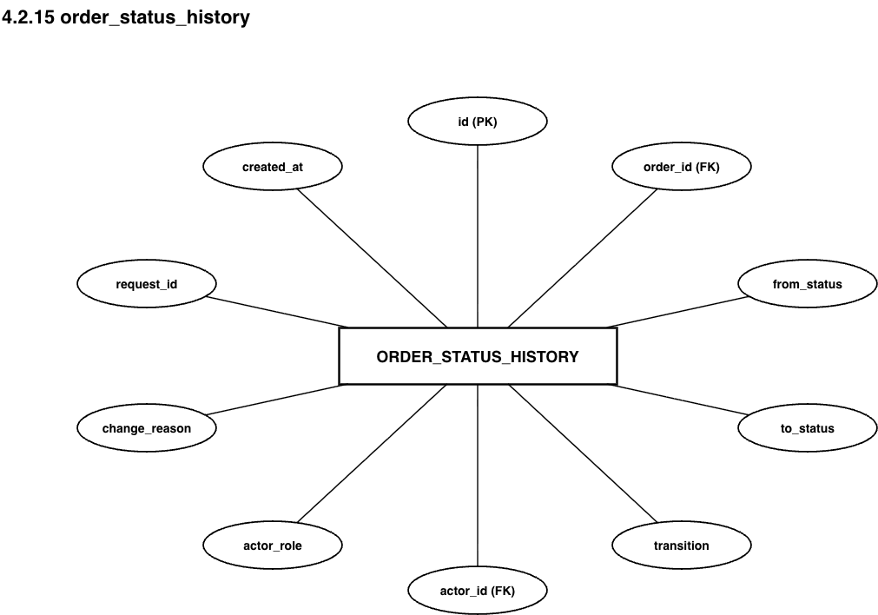
Figure 5.14: order_status_history
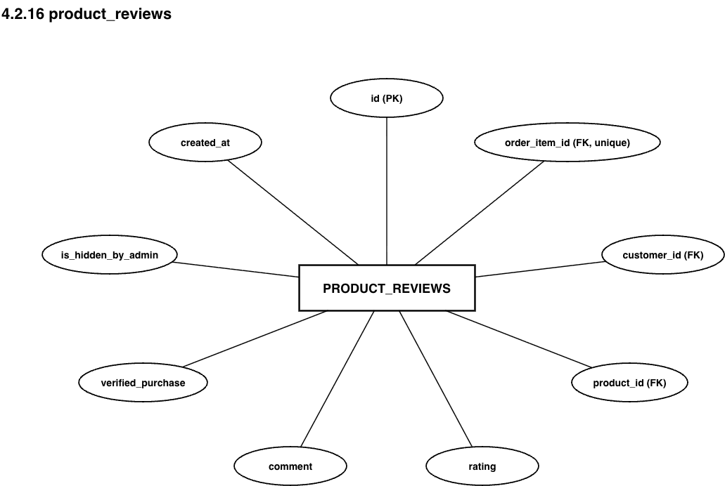
Figure 5.15: product_reviews
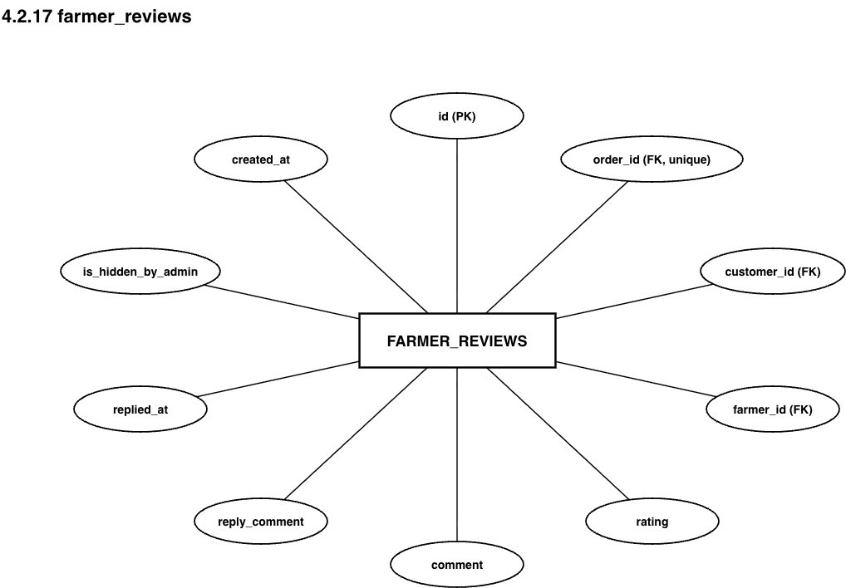
Figure 5.16: farmer_reviews
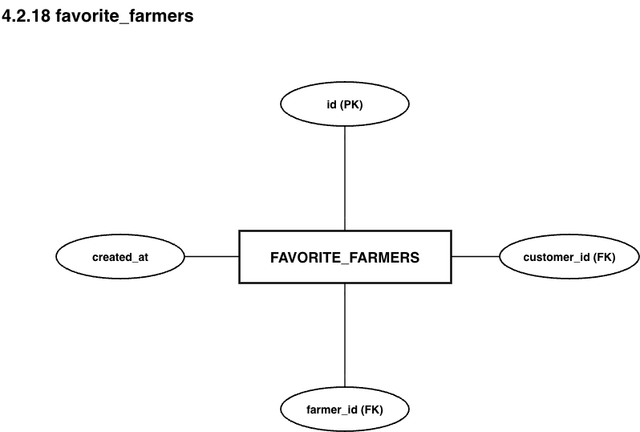
Figure 5.17: favorite_farmers
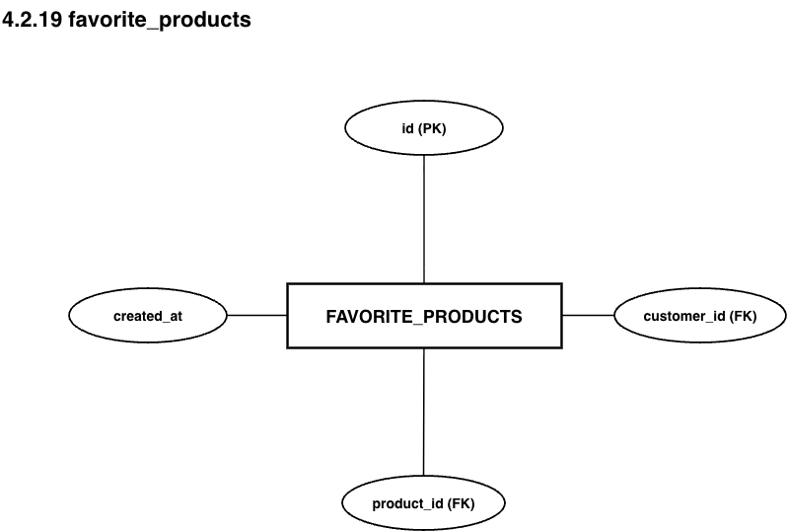
Figure 5.18: favorite_products
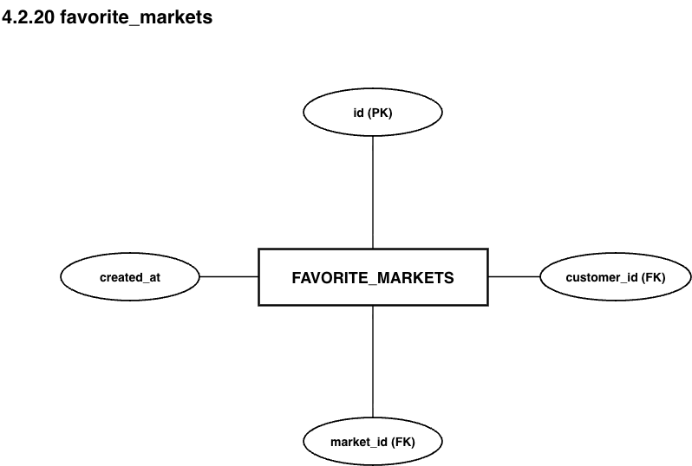
Figure 5.19: favorite_markets
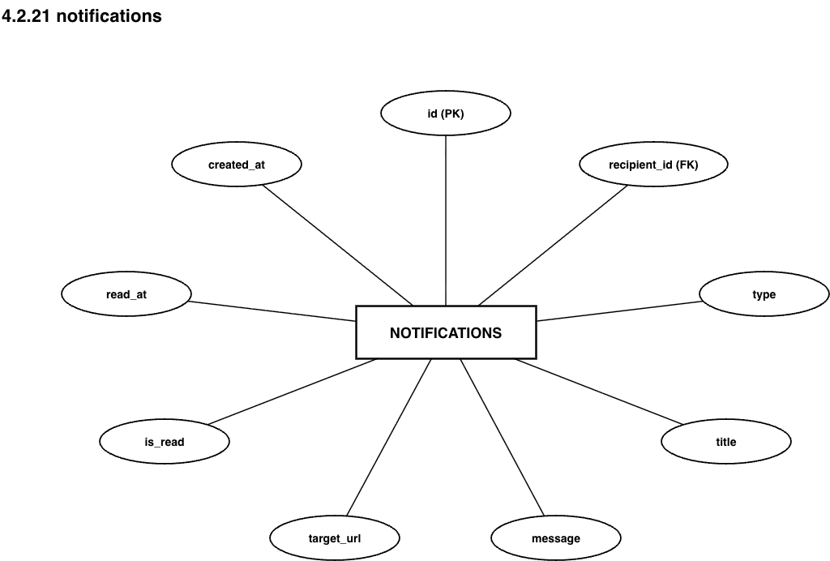
Figure 5.20: notifications
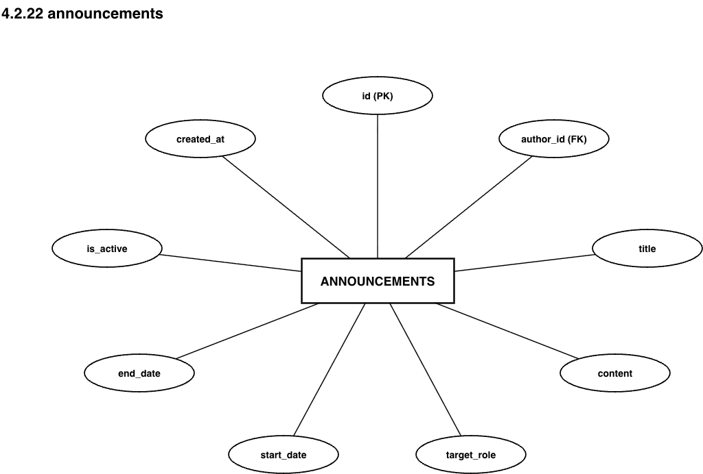
Figure 5.21: announcements
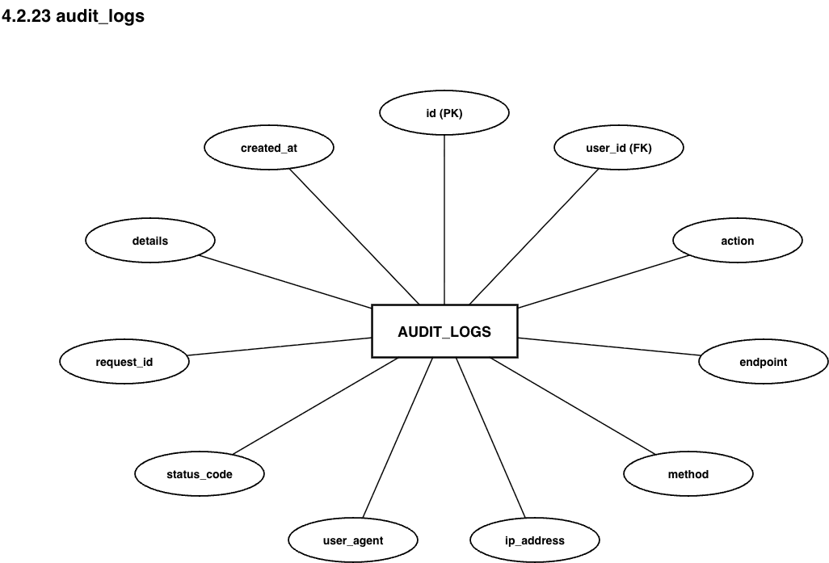
Figure 5.22: audit_logs
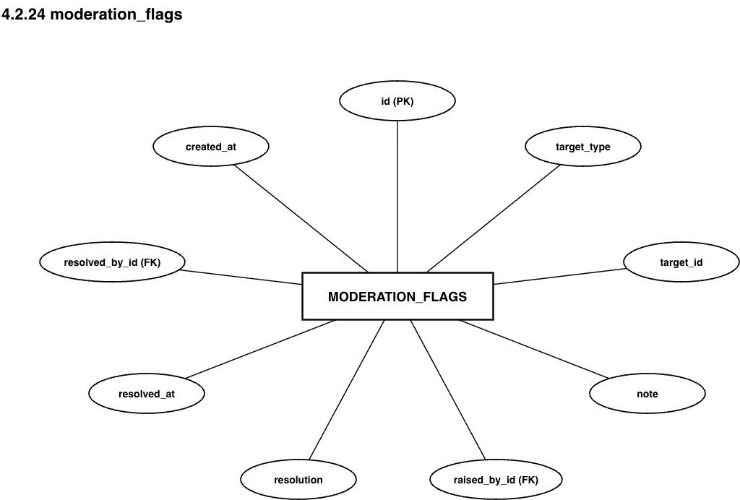
Figure 5.23: moderation_flags
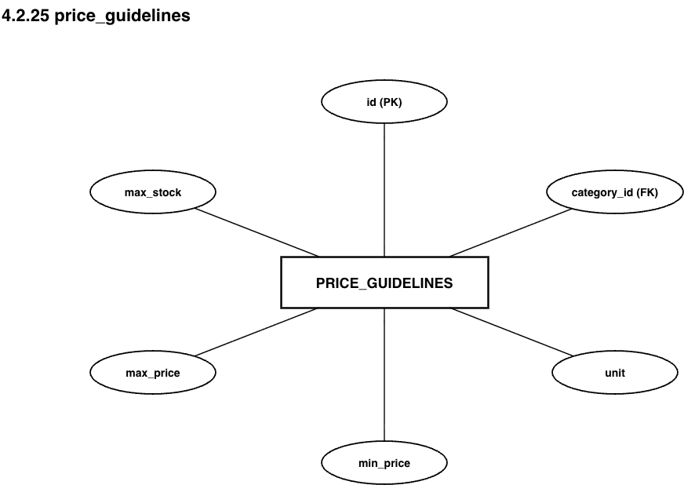
Figure 5.24: price_guidelines
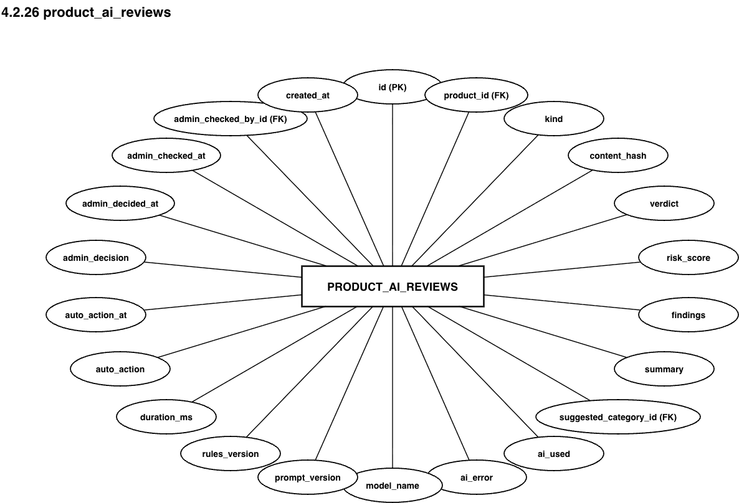
Figure 5.25: product_ai_reviews

6. DATABASE DATA DICTIONARY (35 RELATIONAL TABLES)
The following data dictionary provides exhaustive field-level schema definitions, MySQL data types, nullability, constraints, and operational business rules for all 34 database tables. Convention: the created_at and updated_at columns inherited from BaseModel are not repeated in every table and are listed only where a table deviates from that default (for example the append-only tables, which carry created_at but no updated_at). Composite indexes and table-level unique constraints are listed as a final row of each table rather than as columns:

1. roles Table (accounts app)
Column Name | MySQL Data Type | Nullable | Constraints & Key | Functional & Business Description
id | BIGINT | No | PK, AUTO_INCREMENT | Unique role identifier.
code | VARCHAR(50) | No | UNIQUE, collation utf8mb4_0900_as_ci | Role code: ADMIN, CUSTOMER, FARMER. Stored as a table so new roles need no migration.
name | VARCHAR(100) | No | None | English display title of the role.
is_active | BOOLEAN | No | DEFAULT TRUE | Role availability flag.

2. users Table (accounts app - CustomUser, USERNAME_FIELD = email)
Column Name | MySQL Data Type | Nullable | Constraints & Key | Functional & Business Description
id | BIGINT | No | PK, AUTO_INCREMENT | Unique user account identifier.
email | VARCHAR(100) | No | UNIQUE | Login identifier, normalized with strip().lower() before saving.
password | VARCHAR(128) | No | None | PBKDF2-SHA256 salted password hash (Django default).
role_id | BIGINT | No | FK -> roles.id (RESTRICT) | Assigned role driving RBAC; related_name="users".
is_active | BOOLEAN | No | DEFAULT TRUE | FALSE = the account has been locked by an administrator.
is_staff | BOOLEAN | No | DEFAULT FALSE | Django admin access for developers only.
is_superuser | BOOLEAN | No | DEFAULT FALSE | Reserved for the IT-provisioned superuser.
last_login | DATETIME(6) | Yes | None | Timestamp of last successful authentication; prerequisite for purge_stale_accounts.
date_joined | DATETIME(6) | No | None | Registration date.
updated_at | DATETIME(6) | No | None | Last modification timestamp.
INDEX (role_id, is_active) | Composite index | - | Index | Serves the Admin customer listing (A-04). Columns username, first_name and last_name are removed - names live on the profile tables.

3. customer_profiles Table (accounts app)
Column Name | MySQL Data Type | Nullable | Constraints & Key | Functional & Business Description
user_id | BIGINT | No | PK + FK -> users.id (CASCADE) | Owning user account; related_name="customer_profile".
full_name | VARCHAR(100) | No | None | Customer full name (FR-01).
phone | VARCHAR(15) | No | UNIQUE | Normalized to 0xxxxxxxxx by normalize_phone(); one Customer account per phone number.
address | VARCHAR(255) | No | None | Residential address (FR-01).
deactivation_reason | VARCHAR(500) | Yes | None | Mandatory when Admin locks the account; reset to NULL on unlock; returned inside 403 ACCOUNT_LOCKED.
image | VARCHAR(255) | Yes | None | Customer avatar path, UUIDUploadTo("customers") (migration accounts/0008).
Row lock | - | - | SELECT FOR UPDATE | The checkout service locks this row before counting the customer's open orders, which is how the open-order limit is enforced without a race.

4. customer_profile_histories Table (accounts app - django-simple-history)
Column Name | MySQL Data Type | Nullable | Constraints & Key | Functional & Business Description
(all columns of customer_profiles) | Mirrors base table | - | Snapshot copy | Full row copy on each create / update / delete, so a lock or unlock of a customer account is auditable.
history_id | BIGINT | No | PK, AUTO_INCREMENT | Unique history row identifier.
user_id | BIGINT | No | INDEX (not PK here) | Primary key of the source customer_profiles row.
history_date | DATETIME(6) | No | INDEX | Moment the change was persisted.
history_change_reason | TEXT | Yes | None | Business reason, typically the deactivation reason entered by an administrator.
history_type | VARCHAR(1) | No | None | + created, ~ changed, - deleted.
history_user_id | BIGINT | Yes | FK -> users.id (SET_NULL) | Actor; NULL = system action.

5. farmer_profiles Table (accounts app - HistoricalRecords enabled)
Column Name | MySQL Data Type | Nullable | Constraints & Key | Functional & Business Description
user_id | BIGINT | No | PK + FK -> users.id (CASCADE) | Owning user account; related_name="farmer_profile".
stall_name | VARCHAR(100) | No | None | Public stall name (FR-02).
contact_person | VARCHAR(100) | No | None | Named contact for the stall (FR-02).
phone | VARCHAR(15) | No | UNIQUE | Normalized to 0xxxxxxxxx.
address | VARCHAR(255) | No | None | Farm / stall registration address; source for geocoding.
description | TEXT | Yes | None | Free-text stall introduction.
image | VARCHAR(255) | Yes | None | Stall photo path (UUID filename).
latitude | DECIMAL(9,6) | Yes | CHECK: NULL or set together with longitude | Auto-resolved from address via Nominatim; Farmer may drag the pin to adjust.
longitude | DECIMAL(9,6) | Yes | CHECK: paired with latitude | Blank when geocoding fails - registration is never blocked.
status | VARCHAR(20) | No | DEFAULT 'PENDING', INDEX | PENDING, APPROVED, SUSPENDED, REJECTED.
status_reason | VARCHAR(500) | Yes | None | Mandatory at service level when REJECTED or SUSPENDED.
order_cutoff_hours | SMALLINT UNSIGNED | No | DEFAULT 12, CHECK 1-72 | Per-stall cutoff window; zero is not permitted.
operating_days | JSON | No | DEFAULT '[]', validated in clean()/save() + serializer | ISO weekday list of the days the stall trades, e.g. [2, 4, 6]. At least one element, integers 1-7, no duplicates, stored sorted. Validated in the model and the serializer rather than by a database CHECK.

6. farmer_profile_histories Table (accounts app - django-simple-history)
Column Name | MySQL Data Type | Nullable | Constraints & Key | Functional & Business Description
(all columns of farmer_profiles) | Mirrors base table | - | Snapshot copy | A full copy of every farmer_profiles column is written on each create / update / delete.
history_id | BIGINT | No | PK, AUTO_INCREMENT | Unique history row identifier.
user_id | BIGINT | No | INDEX (not PK here) | Primary key of the source profile row.
history_date | DATETIME(6) | No | INDEX | Moment the change was persisted.
history_change_reason | VARCHAR(100) | Yes | None | Business reason, e.g. the Admin vetting note shown on A-03.
history_type | VARCHAR(1) | No | None | + created, ~ changed, - deleted.
history_user_id | BIGINT | Yes | FK -> users.id (SET_NULL) | Actor; NULL = system action (lazy sweep, management command).
request_id | CHAR(36) | Yes | None | X-Request-ID trace correlating the change with audit_logs (NFR-04).

7. markets Table (markets app)
Column Name | MySQL Data Type | Nullable | Constraints & Key | Functional & Business Description
id | BIGINT | No | PK, AUTO_INCREMENT | Unique market identifier.
name | VARCHAR(100) | No | UNIQUE, collation utf8mb4_0900_as_ci | Market name.
address | VARCHAR(255) | No | None | Street address of the market venue.
description | TEXT | Yes | None | Free-text market introduction.
image | VARCHAR(255) | Yes | None | Market cover photo for the G-02 card (UUID filename).
latitude | DECIMAL(9,6) | No | None | Mandatory map coordinate.
longitude | DECIMAL(9,6) | No | None | Mandatory map coordinate.
map_provider | VARCHAR(30) | No | DEFAULT 'OSM' | Records which map provider a market is plotted with. OpenStreetMap is the only provider in use, so the column is a compatibility hook rather than a live switch.
open_time | TIME | No | None | One opening time shared by every operating day.
close_time | TIME | No | CHECK close_time > open_time | One closing time shared by every operating day.
is_active | BOOLEAN | No | DEFAULT TRUE, INDEX | Soft removal. Deactivating a market declines its open orders and disables every pickup slot of that market; reactivation does not re-enable slots.

8. market_operating_days Table (markets app)
Column Name | MySQL Data Type | Nullable | Constraints & Key | Functional & Business Description
id | BIGINT | No | PK, AUTO_INCREMENT | Unique row identifier.
market_id | BIGINT | No | FK -> markets.id (CASCADE) | Owning market; related_name="operating_days".
day_of_week | TINYINT UNSIGNED | No | CHECK 1-7, INDEX | ISO weekday: 1 = Monday ... 7 = Sunday. Serves the "markets open on day X" filter (FR-10).
UNIQUE (market_id, day_of_week) | Composite unique | - | Unique | A relational table rather than JSON / bitmask so the filter can use a normal index and stay in 3NF. Opening hours live on markets, not here.

9. farmer_markets Table (markets app - which markets a farmer trades at)
Column Name | MySQL Data Type | Nullable | Constraints & Key | Functional & Business Description
id | BIGINT | No | PK, AUTO_INCREMENT | Unique affiliation identifier.
farmer_id | BIGINT | No | FK -> farmer_profiles.user_id (CASCADE) | Stall owner; related_name="farmer_markets".
market_id | BIGINT | No | FK -> markets.id (RESTRICT) | Market attended; related_name="farmer_markets".
stall_label | VARCHAR(100) | No | None | Mandatory. Describes the stall position inside the market, e.g. "Row B, Stall 12, near the main gate".
status | VARCHAR(10) | No | DEFAULT 'APPROVED' | PENDING or APPROVED. A stall may register at several markets, and each registration is approved on its own; only an APPROVED row at an active market is treated as selling there.
INDEX (status) | Index | - | Index | fm_status_idx - feeds the administrator's list of market registrations still waiting.
UNIQUE (farmer_id, market_id) | Composite unique | - | Unique | Hard-deletable: orders snapshot market_id and stall_label instead of referencing this row. The service blocks deletion while open orders remain at that market (F-07).

10. farmer_market_histories Table (markets app - django-simple-history)
Column Name | MySQL Data Type | Nullable | Constraints & Key | Functional & Business Description
(all columns of farmer_markets) | Mirrors base table | - | Snapshot copy | Full row copy on each create / update / delete.
history_id | BIGINT | No | PK, AUTO_INCREMENT | Unique history row identifier.
id | BIGINT | No | INDEX (not PK here) | Primary key of the source farmer_markets row.
history_date | DATETIME(6) | No | INDEX | Moment the change was persisted.
history_change_reason | VARCHAR(100) | Yes | None | Business reason for the change.
history_type | VARCHAR(1) | No | None | + created, ~ changed, - deleted.
history_user_id | BIGINT | Yes | FK -> users.id (SET_NULL) | Actor; NULL = system action.
request_id | CHAR(36) | Yes | None | X-Request-ID trace.

11. pickup_slots Table (markets app -)
Column Name | MySQL Data Type | Nullable | Constraints & Key | Functional & Business Description
id | BIGINT | No | PK, AUTO_INCREMENT | Unique slot identifier.
farmer_market_id | BIGINT | No | FK -> farmer_markets.id (CASCADE) | The farmer-market pair this recurring window belongs to; related_name="pickup_slots".
day_of_week | TINYINT UNSIGNED | No | CHECK 1-7 | Must be both a market operating day and a farmer operating day (service, U-04 /).
start_time | TIME | No | None | Must fall inside the market opening hours (service).
end_time | TIME | No | CHECK end_time > start_time | Closing edge of the collection window.
is_active | BOOLEAN | No | DEFAULT TRUE | Lets the Farmer pause a window without deleting it; inactive windows are hidden on Checkout (C-02).
UNIQUE (farmer_market_id, day_of_week, start_time) | Composite unique | - | Unique | Editing or deleting a slot never alters placed orders, which snapshot their own times. When an Admin revises a market schedule, the service sets is_active = false for any slot falling outside the new schedule.

12. pickup_slot_histories Table (markets app - django-simple-history)
Column Name | MySQL Data Type | Nullable | Constraints & Key | Functional & Business Description
(all columns of pickup_slots) | Mirrors base table | - | Snapshot copy | Full row copy on each create / update / delete; the stall-profile service disables slots row by row to preserve this trail.
history_id | BIGINT | No | PK, AUTO_INCREMENT | Unique history row identifier.
id | BIGINT | No | INDEX (not PK here) | Primary key of the source pickup_slots row.
history_date | DATETIME(6) | No | INDEX | Moment the change was persisted.
history_change_reason | VARCHAR(100) | Yes | None | Business reason, e.g. MARKET_SCHEDULE_CHANGED.
history_type | VARCHAR(1) | No | None | + created, ~ changed, - deleted.
history_user_id | BIGINT | Yes | FK -> users.id (SET_NULL) | Actor; NULL = system action.
request_id | CHAR(36) | Yes | None | X-Request-ID trace.

13. market_closures Table (markets app - Admin-declared temporary closure)
Column Name | MySQL Data Type | Nullable | Constraints & Key | Functional & Business Description
id | BIGINT | No | PK, AUTO_INCREMENT | Unique closure period identifier.
market_id | BIGINT | No | FK -> markets.id (CASCADE) | Affected market; related_name="closures" (pure child row).
start_date | DATE | No | None | First closed day, Vietnam time.
end_date | DATE | No | CHECK end_date >= start_date | Last closed day - a closure is a date RANGE, not a single day.
reason | VARCHAR(200) | Yes | None | Shown publicly, e.g. "Lunar New Year closure".
INDEX (market_id, end_date) | Composite index | - | Index | Finds closure periods still in force. Service rules: start_date >= today, no overlap with another period of the same market, and 422 RESOURCE_IN_USE while open orders have a pickup_date inside the range.

14. farmer_closures Table (markets app - farmer-declared closure period)
Column Name | MySQL Data Type | Nullable | Constraints & Key | Functional & Business Description
id | BIGINT | No | PK, AUTO_INCREMENT | Unique vacation period identifier.
farmer_id | BIGINT | No | FK -> farmer_profiles.user_id (CASCADE) | Stall owner; related_name="closures" (pure child row).
start_date | DATE | No | None | First day off, Vietnam time.
end_date | DATE | No | CHECK end_date >= start_date | Last day off.
reason | VARCHAR(200) | Yes | None | Shown publicly, e.g. "Harvest break".
INDEX (farmer_id, end_date) | Composite index | - | Index | Applies to every market of the Farmer. Pickup dates are valid only when: market open, farmer operating day, no market closure, no farmer closure, slot and market active, inside BOOKING_HORIZON_DAYS - otherwise SLOT_NOT_AVAILABLE.

15. farmer_closure_histories Table (markets app - django-simple-history)
Column Name | MySQL Data Type | Nullable | Constraints & Key | Functional & Business Description
(all columns of farmer_closures) | Mirrors base table | - | Snapshot copy | Full row copy on each create / update / delete.
history_id | BIGINT | No | PK, AUTO_INCREMENT | Unique history row identifier.
id | BIGINT | No | INDEX (not PK here) | Primary key of the source farmer_closures row.
history_date | DATETIME(6) | No | INDEX | Moment the change was persisted.
history_change_reason | VARCHAR(100) | Yes | None | Business reason for the change.
history_type | VARCHAR(1) | No | None | + created, ~ changed, - deleted.
history_user_id | BIGINT | Yes | FK -> users.id (SET_NULL) | Actor; NULL = system action.
request_id | CHAR(36) | Yes | None | X-Request-ID trace.

16. categories Table (catalog app)
Column Name | MySQL Data Type | Nullable | Constraints & Key | Functional & Business Description
id | BIGINT | No | PK, AUTO_INCREMENT | Unique master category identifier.
name | VARCHAR(50) | No | UNIQUE, collation utf8mb4_0900_as_ci | Category name managed by Admin (A-07).
icon | VARCHAR(50) | Yes | None | Lucide icon name for the UI.
display_order | SMALLINT UNSIGNED | No | DEFAULT 0 | Manual sort order in menus and filters.
is_active | BOOLEAN | No | DEFAULT TRUE | Hidden instead of deleted once products reference it (A-07).

17. products Table (catalog app - no HistoricalRecords on the base model)
Column Name | MySQL Data Type | Nullable | Constraints & Key | Functional & Business Description
id | BIGINT | No | PK, AUTO_INCREMENT | Unique produce identifier.
farmer_id | BIGINT | No | FK -> farmer_profiles.user_id (RESTRICT) | Owning stall; related_name="products".
category_id | BIGINT | No | FK -> categories.id (RESTRICT) | Master category; related_name="products".
name | VARCHAR(100) | No | None | Produce name.
description | TEXT | Yes | None | Produce description.
image | VARCHAR(255) | Yes | None | Produce photo path (UUID filename; the image is re-encoded on upload, which strips EXIF and GPS metadata).
price | DECIMAL(10,2) | No | CHECK 0.01 <= price <= 10000.00 | Current USD price; orders keep their own snapshot.
unit | VARCHAR(10) | No | None | TextChoices: KG, BUNCH, EACH, BAG, BOX, PACK.
stock_quantity | INT UNSIGNED | No | DEFAULT 0 | AVAILABLE stock: already net of farmer-accepted orders. PLACED orders are not deducted.
weekly_default_quantity | INT UNSIGNED | Yes | None | Weekly stock template. NULL = product excluded from the template. "Apply to this week" computes max(template - held, 0).
is_available | BOOLEAN | No | DEFAULT TRUE | FALSE = temporarily not for sale (FR-43).
is_archived | BOOLEAN | No | DEFAULT FALSE | The Farmer's "delete" - soft removal.
is_hidden_by_admin | BOOLEAN | No | DEFAULT FALSE | Admin takedown for policy violation (FR-54).
hidden_reason | VARCHAR(500) | Yes | None | Admin rationale for the takedown.
hidden_at | DATETIME(6) | Yes | None | Takedown timestamp.
hidden_by_id | BIGINT | Yes | FK -> users.id (SET_NULL) | Acting Admin; related_name="hidden_products".
min_per_order | INT UNSIGNED | Yes | None | Smallest quantity a customer may order; NULL means no minimum.
max_per_order | INT UNSIGNED | Yes | None | Largest quantity per order, so one customer cannot take a whole stall's stock.
review_status | VARCHAR(10) | No | DEFAULT 'PENDING' | PENDING, APPROVED or REJECTED. A listing is only publicly on sale while APPROVED (FR-61). Editing name, description, image or category_id sends it back to PENDING; editing price or stock_quantity intentionally does not.
review_note | VARCHAR(500) | Yes | None | Explanation attached to that status.
reviewed_at | DATETIME(6) | Yes | None | When the listing was last reviewed.
reviewed_by_id | BIGINT | Yes | FK -> users.id (SET_NULL) | The administrator who reviewed it; NULL when the automated check did.
moderation_action | VARCHAR(20) | Yes | None | The action taken on the listing as a result.
Indexes | - | - | Index | (farmer_id, is_archived) - (category_id, is_archived, is_hidden_by_admin) - (price) - (created_at) - (review_status, created_at) for the approval queue, which is read far more often than written and always as "everything still waiting, oldest first". "Publicly on sale" = is_available=1 AND is_archived=0 AND is_hidden_by_admin=0 AND review_status='APPROVED' AND farmer.status='APPROVED'.

18. product_histories Table (catalog app - django-simple-history)
Column Name | MySQL Data Type | Nullable | Constraints & Key | Functional & Business Description
(all columns of products) | Mirrors base table | - | Snapshot copy | Full row copy on each create / update / delete, so every stock and price movement is auditable.
history_id | BIGINT | No | PK, AUTO_INCREMENT | Unique history row identifier.
id | BIGINT | No | INDEX (not PK here) | Primary key of the source products row.
history_date | DATETIME(6) | No | INDEX | Moment the change was persisted.
history_change_reason | VARCHAR(100) | Yes | None | Every stock movement records its cause, e.g. "Order #12: PLACED -> ACCEPTED".
history_type | VARCHAR(1) | No | None | + created, ~ changed, - deleted.
history_user_id | BIGINT | Yes | FK -> users.id (SET_NULL) | Actor; NULL = system action (lazy sweep).
request_id | CHAR(36) | Yes | None | X-Request-ID trace. Writes must go through save()/delete() row by row or marketlink_core/history.py - never QuerySet.update() or plain bulk_create.

19. price_guidelines Table (catalog app)
Column Name | MySQL Data Type | Nullable | Constraints & Key | Functional & Business Description
id | BIGINT | No | PK, AUTO_INCREMENT | Unique guideline identifier.
category_id | BIGINT | No | FK -> categories.id | The produce category the band applies to.
unit | VARCHAR(10) | No | None | Unit the band is expressed in: KG, BUNCH, EACH, BAG, BOX or PACK.
min_price | DECIMAL(10,2) | No | None | Lower end of the accepted price band for that category and unit.
max_price | DECIMAL(10,2) | No | None | Upper end of the band. A listing outside the band is flagged for review rather than blocked.
max_stock | INT UNSIGNED | Yes | None | Plausible ceiling on the quantity a single stall can offer; NULL means no ceiling.
created_at / updated_at | DATETIME(6) | No | None | Administrators maintain these bands, which give the automated listing check something to measure against.

20. product_markets Table (catalog app - which of a stall's markets a listing is sold at)
Column Name | MySQL Data Type | Nullable | Constraints & Key | Functional & Business Description
id | BIGINT | No | PK, AUTO_INCREMENT | Unique link identifier.
product_id | BIGINT | No | FK -> products.id (CASCADE) | The listing; related_name="market_links".
farmer_market_id | BIGINT | No | FK -> farmer_markets.id (CASCADE) | One of that farmer's market registrations; related_name="product_links".
created_at | DATETIME(6) | No | None | When the listing was offered at this market.
UNIQUE (product_id, farmer_market_id) | Composite unique | - | Unique | pm_uniq_product_stall - a listing is linked to one of the stall's markets at most once. The table exists because a farmer may now trade at several markets, so a listing has to say which of them it is sold at.

21. product_ai_reviews Table (catalog app)
Column Name | MySQL Data Type | Nullable | Constraints & Key | Functional & Business Description
id | BIGINT | No | PK, AUTO_INCREMENT | Unique review-run identifier.
product_id | BIGINT | No | FK -> products.id | The listing that was checked.
kind | VARCHAR(15) | No | None | Which part of the listing was checked, for example its text or its image.
content_hash | VARCHAR(64) | No | None | Hash of the checked content, so unchanged content is not re-checked.
verdict | VARCHAR(20) | No | None | Outcome of the run: approved, flagged for a human, or rejected.
risk_score | SMALLINT UNSIGNED | No | None | How strongly the run objected; drives the ordering of the moderation queue.
findings | JSON | No | None | The individual objections, each with its rule and evidence.
summary | VARCHAR(500) | No | None | One-line explanation shown to the administrator.
suggested_category_id | BIGINT | Yes | FK -> categories.id | Category the check believes fits better, when it disagrees with the farmer.
ai_used | BOOLEAN | No | None | FALSE when only the deterministic rules ran, so a rule-only verdict is never mistaken for a model verdict.
ai_error | VARCHAR(300) | Yes | None | Why the model could not be reached; the rules still produce a verdict.
model_name / prompt_version / rules_version | VARCHAR | No | None | Recorded so an old verdict can be explained after the rules or the model change.
duration_ms | INT UNSIGNED | Yes | None | How long the run took.
admin_decision | VARCHAR(10) | Yes | None | What the administrator did with the verdict; NULL while it waits.
admin_decided_at | DATETIME(6) | Yes | None | When that decision was taken.
auto_action | VARCHAR(10) | Yes | None | What the check did on its own, without an administrator: APPROVED (a clear listing went on sale) or HELD (kept off sale and queued). NULL when the run only advised.
auto_action_at | DATETIME(6) | Yes | None | When the automatic action was taken.
admin_checked_at | DATETIME(6) | Yes | None | When an administrator reviewed that automatic action. NULL means no person has looked at it yet, which is what the AI Decisions page lists.
admin_checked_by_id | BIGINT | Yes | FK -> users.id (SET_NULL) | The administrator who reviewed the automatic action.
Indexes | - | - | Index | (product_id, kind, -created_at) for the latest run on a listing - (verdict, created_at) for the queue ordering. Rows are never updated except to record what the administrator then decided, so the table doubles as the record of how advice and decisions compare.

22. orders Table (orders app - status changes recorded in order_status_history)
Column Name | MySQL Data Type | Nullable | Constraints & Key | Functional & Business Description
id | BIGINT | No | PK, AUTO_INCREMENT | Order number, displayed as #id.
customer_id | BIGINT | No | FK -> users.id (RESTRICT) | Buyer with role CUSTOMER; related_name="orders".
farmer_id | BIGINT | No | FK -> farmer_profiles.user_id (RESTRICT) | Exactly one Farmer per order; related_name="orders".
market_id | BIGINT | No | FK -> markets.id (RESTRICT) | SNAPSHOT of the collection venue; drives per-market revenue reporting (FR-55).
pickup_slot_id | BIGINT | Yes | FK -> pickup_slots.id (SET_NULL) | Soft reference: if the Farmer deletes the window, the order keeps every detail it needs.
stall_label | VARCHAR(100) | Yes | None | SNAPSHOT of the stall position at ordering time; always populated on new orders, kept nullable for safety.
pickup_date | DATE | No | None | Collection date in Vietnam time.
pickup_start_at | DATETIME(6) | No | None | SNAPSHOT = pickup_date + slot start_time, converted VN -> UTC. Drives the automatic expiry of orders the Farmer never approved.
pickup_end_at | DATETIME(6) | No | CHECK pickup_end_at > pickup_start_at | SNAPSHOT closing edge; the Farmer may only flag NO_SHOW once now >= pickup_end_at.
cutoff_at | DATETIME(6) | No | CHECK cutoff_at <= pickup_start_at | Hard-stored = pickup_start_at - order_cutoff_hours at placement / modification. The UI shows this instant, never the hour count.
status | VARCHAR(20) | No | DEFAULT 'PLACED' | The 8 FSM states: PLACED, ACCEPTED, READY_FOR_PICKUP, COMPLETED, CANCELLED, DECLINED, NO_SHOW, EXPIRED.
note | VARCHAR(300) | Yes | None | Customer note to the Farmer, not more than 300 characters.
total_amount | DECIMAL(10,2) | No | CHECK total_amount >= 0 | Sum of line_total, recomputed on every modification.
version | INT UNSIGNED | No | DEFAULT 1 | Optimistic concurrency control paired with If-Match; incremented on every write, including automatic expiry, Admin-driven closures and change-request events.
reschedule_requested_at | DATETIME(6) | Yes | None | Set when an Admin change to the market schedule leaves this order without a valid collection time (FR-64). While it is set, the original cutoff no longer blocks the customer and only the pickup time may be changed; clearing it means a new time was accepted. An order still carrying it when pickup_start_at passes is closed and the stock returned.
pending_change | JSON | Yes | None | The change request awaiting the Farmer's decision, NULL when none. Shape { items, pickup_slot_id, pickup_date, note, requested_at } where each item carries product_id, quantity and unit_price (the price the customer saw when submitting). Malformed payload -> the change-request endpoint returns 422 FAILED_PRECONDITION, never 500.
Indexes | - | - | Index | (farmer_id, status, pickup_start_at) - (customer_id, status) - (customer_id, farmer_id, status) - (status, pickup_start_at) - (market_id, status, pickup_date) - (created_at). There is intentionally no cancelled_by or decline_reason column: reasons live in order_status_history.change_reason.

23. order_items Table (orders app)
Column Name | MySQL Data Type | Nullable | Constraints & Key | Functional & Business Description
id | BIGINT | No | PK, AUTO_INCREMENT | Unique line identifier.
order_id | BIGINT | No | FK -> orders.id (CASCADE) | Parent order; related_name="items" (pure child row).
product_id | BIGINT | No | FK -> products.id (RESTRICT) | Produce ordered; related_name="order_items".
product_name | VARCHAR(100) | No | None | SNAPSHOT of the product name at ordering time.
unit | VARCHAR(10) | No | None | SNAPSHOT of the unit of measure at ordering time.
unit_price | DECIMAL(10,2) | No | CHECK unit_price >= 0 | SNAPSHOT taken from the DATABASE, never from the client payload.
quantity | INT UNSIGNED | No | CHECK quantity >= 1 | Ordered quantity.
line_total | DECIMAL(10,2) | No | None | = unit_price x quantity.
UNIQUE (order_id, product_id) | Composite unique | - | Unique | One row per product per order; quantity changes edit that row. INDEX (product_id) computes held_quantity and best sellers. On modification, kept items retain their old unit_price while newly added items take the current price.

24. order_status_history Table (orders app - FSM audit trail, append-only)
Column Name | MySQL Data Type | Nullable | Constraints & Key | Functional & Business Description
id | BIGINT | No | PK, AUTO_INCREMENT | Unique trail row identifier.
order_id | BIGINT | No | FK -> orders.id (CASCADE) | Parent order; related_name="status_history" (pure child row).
from_status | VARCHAR(20) | Yes | None | NULL on order creation, which has no previous status.
to_status | VARCHAR(20) | No | None | Equal to from_status when a PLACED order is edited without a state change.
transition | VARCHAR(10) | Yes | None | Identifies which of the 13 live status transitions occurred. NULL for edits to a PLACED order and for change-request events, since neither changes the status.
actor_id | BIGINT | Yes | FK -> users.id (SET_NULL) | related_name="order_status_actions"; NULL when actor_role = SYSTEM.
actor_role | VARCHAR(20) | No | None | CUSTOMER, FARMER, ADMIN or SYSTEM.
change_reason | TEXT | Yes | None | Mandatory at service level when a Farmer declines an order (Farmer rationale, 5-500 characters), on edits to a PLACED order and on change-request events (e.g. "Customer modified: Tomato 5->8 kg"), SYSTEM_EXPIRED on automatic expiry, and the Admin-driven codes FARMER_SUSPENDED_BY_ADMIN / CUSTOMER_LOCKED_BY_ADMIN / MARKET_CLOSED_BY_ADMIN.
request_id | CHAR(36) | Yes | None | X-Request-ID trace (NFR-04); NULL when written by the expire_orders command.
created_at | DATETIME(6) | No | None | Append timestamp; there is no updated_at and no edit / delete API.
INDEX (order_id, created_at) | Composite index | - | Index | Feeds the C-05 / F-03 timeline. Exactly one row is written inside the same transaction.atomic() as the orders update.

25. order_histories Table (orders app - django-simple-history)
Column Name | MySQL Data Type | Nullable | Constraints & Key | Functional & Business Description
(all columns of orders) | Mirrors base table | - | Snapshot copy | Full row copy on each create / update / delete, complementing the FSM trail.
history_id | BIGINT | No | PK, AUTO_INCREMENT | Unique history row identifier.
id | BIGINT | No | INDEX (not PK here) | Primary key of the source orders row.
history_date | DATETIME(6) | No | INDEX | Moment the change was persisted.
history_change_reason | VARCHAR(100) | Yes | None | Business reason for the change.
history_type | VARCHAR(1) | No | None | + created, ~ changed, - deleted.
history_user_id | BIGINT | Yes | FK -> users.id (SET_NULL) | Actor; NULL = system action.
request_id | CHAR(36) | Yes | None | X-Request-ID trace.

26. order_item_histories Table (orders app - django-simple-history)
Column Name | MySQL Data Type | Nullable | Constraints & Key | Functional & Business Description
(all columns of order_items) | Mirrors base table | - | Snapshot copy | Full row copy; the change-request service deletes and recreates lines row by row (never bulk_create) so the pre-change content survives.
history_id | BIGINT | No | PK, AUTO_INCREMENT | Unique history row identifier.
id | BIGINT | No | INDEX (not PK here) | Primary key of the source order_items row.
history_date | DATETIME(6) | No | INDEX | Moment the change was persisted.
history_change_reason | VARCHAR(100) | Yes | None | Business reason for the change.
history_type | VARCHAR(1) | No | None | + created, ~ changed, - deleted.
history_user_id | BIGINT | Yes | FK -> users.id (SET_NULL) | Actor; NULL = system action.
request_id | CHAR(36) | Yes | None | X-Request-ID trace.

27. product_reviews Table (reviews app -)
Column Name | MySQL Data Type | Nullable | Constraints & Key | Functional & Business Description
id | BIGINT | No | PK, AUTO_INCREMENT | Unique review identifier.
order_item_id | BIGINT | No | UNIQUE FK -> order_items.id (RESTRICT) | One review per ordered line; related_name="product_review". Product and customer are DERIVED via order_item -> product and order_item -> order -> customer, so nothing is duplicated (3NF).
rating | TINYINT UNSIGNED | No | CHECK 1-5 | Star rating.
comment | VARCHAR(1000) | Yes | None | Customer commentary.
reply | VARCHAR(500) | Yes | None | Farmer public response, allowed once.
replied_at | DATETIME(6) | Yes | None | Response timestamp.
is_hidden_by_admin | BOOLEAN | No | DEFAULT FALSE | Admin moderation flag - reviews are hidden, never hard-deleted.
hidden_reason | VARCHAR(500) | Yes | None | Admin rationale; never exposed to the Farmer.
hidden_at | DATETIME(6) | Yes | None | Moderation timestamp.
hidden_by_id | BIGINT | Yes | FK -> users.id (SET_NULL) | Acting Admin; related_name="hidden_product_reviews".
INDEX (is_hidden_by_admin, created_at) | Composite index | - | Index | Per-product lookups reuse the order_items(product_id) index. Creation requires order.status = COMPLETED.

28. farmer_reviews Table (reviews app -)
Column Name | MySQL Data Type | Nullable | Constraints & Key | Functional & Business Description
id | BIGINT | No | PK, AUTO_INCREMENT | Unique review identifier.
order_id | BIGINT | No | UNIQUE FK -> orders.id (RESTRICT) | One stall review per completed order; related_name="farmer_review". The Farmer is DERIVED via order -> farmer.
rating | TINYINT UNSIGNED | No | CHECK 1-5 | Star rating of the stall service.
comment | VARCHAR(1000) | Yes | None | Customer commentary.
reply | VARCHAR(500) | Yes | None | Farmer public response, allowed once.
replied_at | DATETIME(6) | Yes | None | Response timestamp.
is_hidden_by_admin | BOOLEAN | No | DEFAULT FALSE | Admin moderation flag.
hidden_reason | VARCHAR(500) | Yes | None | Admin rationale.
hidden_at | DATETIME(6) | Yes | None | Moderation timestamp.
hidden_by_id | BIGINT | Yes | FK -> users.id (SET_NULL) | Acting Admin; related_name="hidden_farmer_reviews".
Service precondition | - | - | Business rule | order.status = COMPLETED AND order.customer = request.user.

29. favorite_farmers Table (favorites app -)
Column Name | MySQL Data Type | Nullable | Constraints & Key | Functional & Business Description
id | BIGINT | No | PK, AUTO_INCREMENT | Unique bookmark identifier.
customer_id | BIGINT | No | FK -> users.id (CASCADE) | Owning customer; related_name="favorite_farmers".
farmer_id | BIGINT | No | FK -> farmer_profiles.user_id (RESTRICT) | Bookmarked stall; related_name="favorited_by".
created_at | DATETIME(6) | No | None | Bookmark timestamp. There is no updated_at - rows are only added or removed.
UNIQUE (customer_id, farmer_id) | Composite unique | - | Unique | Prevents duplicate bookmarks.

30. favorite_products Table (favorites app -)
Column Name | MySQL Data Type | Nullable | Constraints & Key | Functional & Business Description
id | BIGINT | No | PK, AUTO_INCREMENT | Unique bookmark identifier.
customer_id | BIGINT | No | FK -> users.id (CASCADE) | Owning customer; related_name="favorite_products".
product_id | BIGINT | No | FK -> products.id (RESTRICT) | Bookmarked produce; related_name="favorited_by".
created_at | DATETIME(6) | No | None | Bookmark timestamp; no updated_at.
UNIQUE (customer_id, product_id) | Composite unique | - | Unique | INDEX (product_id) resolves who receives a RESTOCK alert.

31. favorite_markets Table (favorites app -)
Column Name | MySQL Data Type | Nullable | Constraints & Key | Functional & Business Description
id | BIGINT | No | PK, AUTO_INCREMENT | Unique bookmark identifier.
customer_id | BIGINT | No | FK -> users.id (CASCADE) | Owning customer; related_name="favorite_markets".
market_id | BIGINT | No | FK -> markets.id (RESTRICT) | Saved market; related_name="favorited_by".
created_at | DATETIME(6) | No | None | Bookmark timestamp; no updated_at.
UNIQUE (customer_id, market_id) | Composite unique | - | Unique | Powers the saved-market shortcuts with directions (FR-25).

32. notifications Table (notifications app -)
Column Name | MySQL Data Type | Nullable | Constraints & Key | Functional & Business Description
id | BIGINT | No | PK, AUTO_INCREMENT | Unique notification identifier.
recipient_id | BIGINT | No | FK -> users.id (CASCADE) | Recipient; related_name="notifications".
type | VARCHAR(40) | No | None | Event type enum covering orders to the customer (ORDER_ACCEPTED, ORDER_READY, ORDER_DECLINED, ORDER_EXPIRED, ORDER_CHANGE_APPROVED, ORDER_CHANGE_REJECTED, ORDER_ITEM_SOLD_OUT, ORDER_RESCHEDULE_MISSED for FR-64), orders to the farmer (ORDER_PLACED, ORDER_MODIFIED, ORDER_CANCELLED), the catalogue (RESTOCK, PRODUCT_APPROVED, PRODUCT_REJECTED, PRODUCT_BLOCKED, AI_LISTING_FLAGGED, and AI_AUTO_APPROVED which tells administrators what the check published by itself), markets (MARKET_CLOSED, MARKET_UPDATED, MARKET_SCHEDULE_CHANGED) accounts (ACCOUNT_STATUS_CHANGED, ACCOUNT_LOCKED_NO_SHOW for the automatic lock of FR-62) and market registrations (STALL_MARKET_APPROVED, STALL_MARKET_REJECTED, telling a stall whether it may trade at a market it applied to).
title | VARCHAR(150) | No | None | Short headline, English.
message | VARCHAR(500) | No | None | Notification body, English.
target_url | VARCHAR(255) | Yes | None | Frontend route to open, e.g. /customer/orders/1024.
is_read | BOOLEAN | No | DEFAULT FALSE | Read flag driving the unread badge.
read_at | DATETIME(6) | Yes | None | First read timestamp; preserved when the mark-as-read endpoint is called again.
created_at | DATETIME(6) | No | None | Dispatch timestamp; no updated_at.
INDEX (recipient_id, is_read, created_at) | Composite index | - | Index | Serves the bell dropdown and the unread count.

33. announcements Table (notifications app -)
Column Name | MySQL Data Type | Nullable | Constraints & Key | Functional & Business Description
id | BIGINT | No | PK, AUTO_INCREMENT | Unique announcement identifier.
title | VARCHAR(150) | No | None | Announcement headline.
content | VARCHAR(1000) | No | None | Plain text body (no HTML, so nothing can be injected).
audience | VARCHAR(20) | No | DEFAULT 'ALL' | ALL, CUSTOMER or FARMER.
starts_at | DATETIME(6) | No | None | Publication start.
ends_at | DATETIME(6) | Yes | CHECK NULL or ends_at > starts_at | Publication end; NULL = open-ended.
is_active | BOOLEAN | No | DEFAULT TRUE | Lets Admin retract a banner without deleting it.
created_by_id | BIGINT | Yes | FK -> users.id (SET_NULL) | Publishing Admin; related_name="announcements".
INDEX (is_active, audience, starts_at) | Composite index | - | Index | Resolves the banner currently in force for a given role (N-04).

34. audit_logs Table (system app - append-only, no edit / delete API)
Column Name | MySQL Data Type | Nullable | Constraints & Key | Functional & Business Description
id | BIGINT | No | PK, AUTO_INCREMENT | Unique audit entry identifier.
user_id | BIGINT | Yes | FK -> users.id (SET_NULL) | Acting user; NULL when a login attempt used a non-existent email.
action | VARCHAR(40) | No | None | Action enum covering sign-in and access (LOGIN, LOGIN_FAILED, LOGOUT, ACCOUNT_REGISTERED, PASSWORD_CHANGED, ACCESS_DENIED), people (FARMER_APPROVED / REJECTED / SUSPENDED / REINSTATED, CUSTOMER_DEACTIVATED / ACTIVATED, CUSTOMER_AUTO_LOCKED for the automatic no-show lock of FR-62, FARMER_UPDATED, CUSTOMER_UPDATED), listings (PRODUCT_APPROVED / REJECTED for the approval queue of FR-61, PRODUCT_HIDDEN / RESTORED / BLOCKED / UNBLOCKED), reviews (REVIEW_HIDDEN / RESTORED), markets (MARKET_CREATED / UPDATED / DEACTIVATED / ACTIVATED), market registrations (STALL_MARKET_APPROVED, STALL_MARKET_REJECTED, for approving a stall at one particular market), the follow-up queue (CONTENT_FLAGGED, CONTENT_FLAG_RESOLVED) and operations (EXPORT_DATA, ACCOUNT_PURGED).
endpoint | VARCHAR(255) | Yes | None | Request path.
method | VARCHAR(10) | Yes | None | HTTP verb.
ip_address | VARCHAR(45) | Yes | None | GenericIPAddressField (IPv4 / IPv6); resolved from X-Forwarded-For per NUM_PROXIES.
user_agent | VARCHAR(255) | Yes | None | Client user agent, truncated.
status_code | SMALLINT UNSIGNED | Yes | None | HTTP response status returned.
request_id | CHAR(36) | Yes | None | X-Request-ID trace (NFR-04).
details | JSON | No | DEFAULT '{}' | Structured context via DjangoJSONEncoder; never stores passwords or tokens.
created_at | DATETIME(6) | No | None | Immutable audit timestamp.
Indexes | - | - | Index | (action, created_at) - (user_id, created_at) - (created_at). Written OUTSIDE the business transaction (ATOMIC_REQUESTS = False) so a rollback cannot erase the security trail. Reports are computed on demand from order data, so the platform stores no separate reports table; each export is recorded here instead.

35. moderation_flags Table (system app)
Column Name | MySQL Data Type | Nullable | Constraints & Key | Functional & Business Description
id | BIGINT | No | PK, AUTO_INCREMENT | Unique flag identifier.
target_type | VARCHAR(20) | No | None | What was reported: a product listing or a review.
target_id | BIGINT UNSIGNED | No | None | Primary key of that record. The pair target_type + target_id is a intentional generic reference, so one queue serves every reportable object.
note | VARCHAR(500) | No | None | Why it was raised.
raised_by_id | BIGINT | Yes | FK -> users.id | Who raised it; NULL when the automated check did.
resolved_at | DATETIME(6) | Yes | None | NULL while the flag is still open, which is how the queue is filtered.
resolved_by_id | BIGINT | Yes | FK -> users.id | The administrator who closed it.
resolution | VARCHAR(500) | Yes | None | What was decided and why.
created_at / updated_at | DATETIME(6) | No | None | Raised and last-touched timestamps.

7. SOFTWARE ARCHITECTURE

7.1 Overall Multi-Tier System Architecture
MarketLink is structured upon a modern, distributed Multi-Tier Client-Server architecture designed to isolate concerns, ensure high transaction throughput, and provide horizontal scalability:
▪ 1. Presentation Tier (Client): React 19 Single Page Application (SPA) executed on client web browsers. Renders accessible UI components with pure CSS3, CSS Modules, CSS Custom Properties (Design Tokens), and Radix UI headless primitives. Zero dependency on Tailwind CSS. Interacts via REST JSON APIs (/api/) and WebSockets.
▪ 2. Managed Edge & Proxy Tier: TLS termination and reverse proxying are provided by the managed hosting edge rather than a self-hosted Nginx instance. The application trusts only the X-Forwarded-For entry appended by that proxy, governed by NUM_PROXIES (1 in hosting, 0 locally), and the same rule resolves the IP written to audit_logs.
▪ 3. Application Core Tier: Django 5.2 with Django REST Framework 3.17 running atop the Daphne ASGI server, which is mandatory because REST and WebSocket traffic share one process. Business logic is encapsulated in decoupled service layers; there is no Celery worker and no Docker Compose stack.
▪ 4. Caching & Channel Tier: A managed Upstash Redis instance reached over rediss:// TLS serves as the JWT JTI revocation blacklist, the single-use ws-ticket store (TTL 30s, read with the atomic GETDEL that sets the Redis 6.2 floor), the Idempotency-Key store (TTL 24h) and the Channels layer broker. Zero Celery dependency.
▪ 5. Persistent Relational Database Tier: MySQL 8.4 LTS Community Server on the InnoDB engine with utf8mb4 / utf8mb4_0900_ai_ci. Enforces ACID guarantees, row-level locking via SELECT FOR UPDATE ordered by ascending id to prevent deadlocks, and transactional integrity across all 35 relational tables.
▪ 6. Asynchronous Email Dispatch Subsystem: Python concurrent.futures ThreadPoolExecutor(max_workers=2) dispatches HTML emails asynchronously via Gmail SMTP upon transaction.on_commit().

7.2 Frontend Architecture (React 19 Framework)
The frontend is a React 19 single-page application built with Vite in plain JavaScript (JSX) - the project uses no TypeScript - and styled with CSS Modules plus CSS Custom Property design tokens:
▪ State Management: Zustand client store manages authentication tokens, user identity, and persistent multi-farmer shopping carts stored in localStorage.
▪ Data Fetching: TanStack React Query handles server-state caching, automatic background invalidation, and optimistic UI mutations.
▪ GIS Mapping: Leaflet.js wrapped in React Leaflet coordinates interactive mapping, marker clustering, and geographic coordinate geocoding.
▪ Component Architecture: Component hierarchy divided into pages/ (branched per role: guest, customer, farmer, admin), features/ for the shared cross-role UI, components/, hooks/ and api/, styled with CSS Modules and design tokens. There is intentionally no shared/ page directory: each role owns its own profile, password and notifications pages. Radix UI primitives provide the WAI-ARIA behaviour required by NFR-02.

7.3 Backend Architecture (Django REST Framework)
The backend follows the Service Layer Architecture Pattern, preventing fat models and congested viewsets:
▪ API Layer: Views & ViewSets: Purely handle HTTP request parsing, authentication checks, and standard JSON serialization.
▪ Service Layer: Dedicated business logic classes (CheckoutService, OrderFulfillmentService, InventoryService) handle transactional orchestration, row-level locking, and validation.
▪ Data Access Layer: Django ORM models define schema constraints, custom queryset managers, and historical audit trail records.

7.4 Real-time WebSockets & AI Subsystem (ASGI & Redis)
Real-time bi-directional messaging is powered by Django Channels over ASGI Daphne. Connected clients maintain persistent WebSocket connections grouped by user ID ('user_{id}'). Each connection validates a short-lived ticket carrying a session identifier sid. When user logs out, only that device's socket closes; when an account is locked by Admin, all sockets terminate immediately with code 4401.
The AI subsystem connects to Google Gemini via the google-genai SDK and serves two independent features that share one client: the assistant (FR-29) and the listing review (FR-60). Both call models through a chain - a configured model followed by named fallbacks - because the free tier counts requests per model, so a model that is out of quota for the day hands over to the next rather than failing the request. A per-day quota exhaustion moves to the next model, a per-minute one waits as long as the API asks and retries the same model, and an unusable model name is skipped; none of this reaches the user as anything other than a normal answer or a single neutral apology.
The assistant answers through Function Calling over read-only tools, and which tools exist depends on who is asking. Everyone gets the three public ones - search_products (not more than 5 items with name, price, unit, stock, stall and market), get_market_info (operating days, opening hours, address) and get_farmer_availability (trading days, markets, pickup windows, cutoff). A guest and a customer additionally get get_my_orders, which a guest intentionally still has so the assistant can answer “where is my order” with “please sign in” from the tool rather than by guessing. A farmer gets get_my_stall_overview and get_my_products instead; an administrator gets get_admin_overview. A tool the caller’s role does not hold is refused inside run_tool even if the model asks for it, so the role boundary is enforced at the point of execution rather than only in the prompt.
There is no write tool at all, which is the primary defence against destructive prompt injection: the worst a successful injection achieves is a badly worded answer about public produce data. There is no direct database access and no text-to-SQL generation, and no chat history is persisted on the server - the widget resends the recent turns each time, so there is no stored conversation to poison or to leak. A tool that fails is caught and returned to the model as an error value, because a lookup failure must not end the conversation. Guardrails: a 12-second per-call timeout inside an overall 15-second deadline, not more than 3 tool rounds with not more than 4 calls per round, replies capped at 2,000 characters, the dedicated chat: 20/min burst throttle, daily caps of 30 answers per guest IP address and 100 per signed-in account (counted in the shared cache, expiring at local midnight, and charged only once the model has actually answered so an outage never uses up someone’s day), and the AI_CHAT_ENABLED kill switch. Every refusal - burst throttle, daily cap, model outage, quota exhaustion, kill switch - returns the same neutral “busy” reply and 503 AI_UNAVAILABLE; only the server log records which it was, so the limits cannot be discovered by probing them.
The listing review (FR-60) uses the same model chain with a 20-second timeout and a intentional pause between calls in the batch commands to stay inside the per-minute quota. It runs two layers - deterministic rules and a vision-capable model reading the wording and the photograph - and its verdict may approve a listing automatically (AI_AUTO_APPROVE) or hold it for the follow-up queue. It never rejects: rejection stays with an administrator.

7.5 Security Hardening & Maintenance Operations
Backend security posture is reinforced through strict configuration defaults and defensive runtime controls: missing DEBUG environment variable defaults strictly to False; if DEBUG=False, a missing or empty SECRET_KEY halts application startup immediately; ALLOWED_HOSTS defaults strictly to localhost. Production environments enforce SECURE_SSL_REDIRECT, SECURE_HSTS_SECONDS=31536000, and cookie hardening (SESSION_COOKIE_SECURE, CSRF_COOKIE_SECURE, HttpOnly, SameSite='Lax'). Client IP addresses are resolved via NUM_PROXIES (0 local, 1 Render) ensuring spoof-proof rate limiting and audit logging. Brute-force attacks are thwarted via global email throttle (login_email: 20/hr failed attempts across all portals). Uploaded images (max 2MB, <=36MP) are mandatory re-encoded before persistence, stripping EXIF/GPS metadata while preserving rotation. Excel export routines force raw string types to prevent formula injection.
Automated account lifecycle maintenance is executed via the CLI command 'python manage.py purge_stale_accounts [--months=3] [--apply]'. The command identifies inactive customer accounts and unapproved vendor stalls (PENDING, REJECTED) with zero login activity for >= 3 months and zero order history. Approved/suspended farmers and administrators are permanently excluded. Operates in dry-run mode by default; passing --apply commits deletion and records an ACCOUNT_PURGED entry in audit_logs. The command strictly requires successful authentication endpoints to update users.last_login as an operational prerequisite.

8. TASKSHEET 2 (PHASE 2 WORK ALLOCATION: 26/09/2026 – 27/09/2026)
Phase 2 delivers behavioral system modeling, 3NF relational database architecture across 35 tables, core FSM transition logic, backend APIs, and primary frontend portals over 2 days (26/09/2026 – 27/09/2026).
• 26/09/2026: Nghi (Specified 12 Use Cases UC-01..12, 13 Sequence Workflows, and 8-State Order FSM with 14 transitions); Danh (Implemented 15 Public & Guest screens G-01..15 and 3 Authentication screens G-09, G-10, G-11); Long (Implemented Order FSM Engine fsm.py, pessimistic row locking select_for_update, and stock deduction); Tú (Implemented Customer APIs: Multi-Vendor Checkout CU-04, Order Modification CU-07, JWT Auth Service); Minh Anh (Implemented Admin APIs AD-01..17: stall vetting, customer suspension, and market timetable management).
• 27/09/2026: Nghi (Authored DFD Level 0, Level 1, 4 DFD Level 2; compiled 35-Table Data Dictionary and Tasksheet 2); Danh (Implemented 12 Customer Portal screens C-00..11: Zustand cart, pickup slot checkout, timeline, and reviews); Long (Executed 35-table MySQL migrations; implemented Farmer APIs FA-01..35 and weekly template synchronization); Tú (Engineered Gemini AI Chatbot service chat_bot/ and real-time WebSocket notification consumers); Minh Anh (Developed financial Excel export module openpyxl; deployed Staging platform on Render & Upstash Redis).
No. | Member Name | Assigned Role | Key Assigned Tasks (26/09 – 27/09/2026) | Timeline | Core Deliverables | Status
1 | Nguyễn Đức Long | Lead Backend | Build Order FSM Engine; pessimistic locks; execute 35-table migrations; Farmer APIs | 26/09 – 27/09 | Order FSM Engine; 35 Tables; Farmer APIs | 100% Completed
2 | Trần Lê Minh Anh | Admin/DevOps | Build Admin APIs; financial Excel export; deploy Staging Platform on Render Cloud | 26/09 – 27/09 | Admin APIs; Excel Engine; Cloud Staging | 100% Completed
3 | Tăng Huỳnh Tuấn Tú | Customer/AI | Build Checkout & Modify APIs; integrate Gemini AI Chatbot; WebSocket consumers | 26/09 – 27/09 | Customer APIs; Gemini Bot; WebSockets | 100% Completed
4 | Nguyễn Khánh Danh | Lead Frontend | Build 15 Guest screens, 3 Auth screens, 12 Customer screens; Zustand Cart integration | 26/09 – 27/09 | 27 UI Screens (Guest & Customer Portals) | 100% Completed
5 | Phạm Kim Nghi | Lead Technical Writer | Specify 12 Use Cases, 13 Sequences, Order FSM, DFD Level 0–2, 35-Table Data Dictionary | 26/09 – 27/09 | Phase 2 Report (§1–§7); Tasksheet 2 | 100% Completed

PHASE 3: UI SCREEN PREVIEW & FINALIZATION

1. SNAPSHOT SCREEN SPECIFICATIONS
This section details the layout, functional elements, data bindings and interaction mechanics of all 60 routed screens of the MarketLink system - 15 public/guest, 12 customer, 11 farmer and 22 administrator - followed by the 3 embedded components that appear inside other screens and therefore carry no route of their own. Screen codes and route paths match the shipped React router, so every entry here can be checked directly against the code.

1.1 Public & Guest Screen Specifications (G-01 to G-15)
Public routes carry no /guest/ prefix: an authenticated Customer, Farmer or Admin browses exactly the same pages, so the URLs stay short and shareable. "Guest" names the actor and the pages/guest/ source folder, never a route segment.

G-01 · Public Landing Page (Home) (Route: /)
▪ Hero banner featuring the project slogan 'Farm Fresh Just a Click Away' with fresh-produce imagery and a primary call to action into the catalog.
▪ Quick search bar with autocomplete for produce items, local farmers, or market names.
▪ Value proposition cards: Direct from Farm, Zero Morning Rush, 100% Pre-Inspected Quality.
▪ Nearest markets strip, master category icon grid, and a 'New this week' row of 8 recently updated product cards.
▪ Platform-wide announcement banner (N-04) rendered at the top when an announcement is in force for the viewer.
▪ Floating AI Assistant launch widget docked in the bottom-right viewport corner.
[UI Mockup Preview: G-Screen layout rendered with Pure CSS3 / CSS Modules & responsive design tokens]

G-02 · Explore Farmers' Markets & Digital Map (Route: /markets)
▪ Full-width interactive Leaflet OpenStreetMap centered on active farmers' markets with produce pin clusters.
▪ Filter sidebar: Days of week (Mon-Sun), market open hours, and district proximity.
▪ Clickable market cards beneath the map synchronizing viewport focus upon selection.
▪ Badge indicators displaying total participating stalls and upcoming market days.
[UI Mockup Preview: G-Screen layout rendered with Pure CSS3 / CSS Modules & responsive design tokens]

G-03 · Market Details & Participating Stalls (Route: /markets/:id)
▪ Market header with high-resolution facility photo, street address, and operating timetable.
▪ Notice box displaying upcoming holiday closures (market_closures) if applicable.
▪ Grid of participating farmer stalls (farmer_markets) showing the stall_label position text, farmer bio and average rating.
▪ List of available pickup time windows supported at this venue.
[UI Mockup Preview: G-Screen layout rendered with Pure CSS3 / CSS Modules & responsive design tokens]

G-04 · Master Produce Catalog, Search & Filter (Route: /products)
▪ Category pills driven by the master categories table for instant filtering.
▪ Multi-faceted filters: keyword, master category, price range slider ($0.01 - $10,000.00 per the price CHECK constraint), market and operating day, with sorting by price, rating or recency. Search is debounced at 400ms and results paginate 20 per page (NFR-05).
▪ Product card grid displaying image, name, price/unit ($/KG, $/BUNCH), stall name, and available stock.
▪ Direct 'Add to Cart' button with optimistic counter update.
[UI Mockup Preview: G-Screen layout rendered with Pure CSS3 / CSS Modules & responsive design tokens]

G-05 · Product Details & Harvest Provenance (Route: /products/:id)
▪ High-resolution produce gallery with zoom capability.
▪ Detailed pricing block, available harvest inventory indicator, and measurement unit.
▪ Harvest background and farm notes provided by the grower.
▪ Farmer profile snapshot card with shortcut to view stall and bookmarked favorite button.
▪ Customer reviews section showing verified purchase ratings, review comments, and vendor replies.
[UI Mockup Preview: G-Screen layout rendered with Pure CSS3 / CSS Modules & responsive design tokens]

G-06 · Public Farmer Stall Profile (Route: /farmers/:id)
▪ Stall header displaying farm banner, logo, farm story, and overall verified review stars.
▪ Operating days chip tags (Monday through Sunday) reflecting declared active schedules.
▪ Mini-map pinpointing the farmer's registered farm or cooperative location.
▪ Full catalog of agricultural goods currently offered by this specific farmer.
▪ Customer favorite bookmark toggle button.
[UI Mockup Preview: G-Screen layout rendered with Pure CSS3 / CSS Modules & responsive design tokens]

G-07 · About MarketLink & FAQ (Route: /about)
▪ Mission statement outlining eGreen Basket agricultural sustainability goals.
▪ Exploration of the pre-order and market pickup mechanism, clarifying why shipping is excluded.
▪ Family account sharing guidelines explaining multi-session JWT access from multiple devices.
▪ Zero food waste impact calculator.
[UI Mockup Preview: G-Screen layout rendered with Pure CSS3 / CSS Modules & responsive design tokens]

G-08 · Contact Us & Inquiries (Route: /contact)
▪ Interactive contact form for platform support, partnership inquiries, and farmer onboarding questions.
▪ Aptech / FPT center address, hotline, and operating hours.
[UI Mockup Preview: G-Screen layout rendered with Pure CSS3 / CSS Modules & responsive design tokens]

G-09 · User Login (Customer, Farmer, Admin) (Route: /login)
▪ Clean authentication modal/page with email and password input fields.
▪ Automatic email normalization and client-side format validation.
▪ Role redirection logic: automatically routes to Customer, Farmer, or Admin portal upon JWT receipt.
▪ Password visibility toggle and 'Forgot Password?' recovery link.
[UI Mockup Preview: G-Screen layout rendered with Pure CSS3 / CSS Modules & responsive design tokens]

G-10 · Customer Account Registration (Route: /register)
▪ Registration form requesting Full Name, Normalized Mobile Phone (0xxxxxxxxx), Address, Email, and Password.
▪ Real-time client-side password strength meter.
▪ Terms of service acceptance checkbox ensuring agreement with pickup and no-show policies.
[UI Mockup Preview: G-Screen layout rendered with Pure CSS3 / CSS Modules & responsive design tokens]

G-11 · Farmer / Stall Owner Registration (Route: /register/farmer)
▪ Vendor registration form: Contact Name, Stall Commercial Name, Mobile Phone, Farm Address.
▪ Mandatory Operating Days selection: checkboxes Monday to Sunday, at least one day required.
▪ Automatic geocoding feedback indicator informing user that GPS coordinates are resolved from address.
▪ Notice of administrative review informing applicant that account requires Admin verification.
[UI Mockup Preview: G-Screen layout rendered with Pure CSS3 / CSS Modules & responsive design tokens]

G-12 · Access Denied & Page Not Found (Route: /403 and * (catch-all))
▪ /403 ForbiddenPage: shown when an authenticated user opens a branch belonging to another role, with a clear explanation and a button back to their own dashboard (FR-04).
▪ * NotFoundPage: catch-all 404 for unknown URLs, offering search and links to the markets and catalog pages.
▪ Note on account recovery: the platform intentionally has no forgot-password or email-reset flow. Password change requires the current password and is a voluntary action available to every signed-in role at C-11, F-11 and A-12. The Admin login page carries no registration or recovery link at all, because Admin accounts are provisioned by IT via createsuperuser.
[UI Mockup Preview: G-Screen layout rendered with Pure CSS3 / CSS Modules & responsive design tokens]

G-13 · Public Farmers Directory (Route: /farmers)
▪ Directory of every approved farmer on the platform.
▪ Search by vendor name, produce specialty, or market association.
▪ Quick overview of operating days and customer reputation rating.
[UI Mockup Preview: G-Screen layout rendered with Pure CSS3 / CSS Modules & responsive design tokens]

G-14 · Privacy Policy (Route: /privacy)
▪ Twelve plain-language sections - who we are, information we collect, what is stored in your browser, how we use it, who can see it, services we rely on, how long we keep it, how we protect it, your choices, children, changes to this policy, contact us.
▪ Carries a visible 'Last updated' date and an 'On this page' index that deep-links to each section; arriving on a #fragment scrolls to it.
▪ Written to be read rather than to be complied with: it states what is stored in the browser, which is where this application keeps the cart (FR-17) and the per-device session (FR-30).
[UI Mockup Preview: G-Screen layout rendered with Pure CSS3 / CSS Modules & responsive design tokens]

G-15 · Sitemap (Route: /sitemap)
▪ Every page on MarketLink in one place, grouped as Shop, Your account and Sell on MarketLink, each entry with a one-line description of what it is for.
▪ Serves two audiences: a shopper who cannot find a page, and a reviewer who wants the whole surface of the application on one screen rather than by exploring the menus.
[UI Mockup Preview: G-Screen layout rendered with Pure CSS3 / CSS Modules & responsive design tokens]

1.2 Customer Portal Screen Specifications (C-00 to C-11)

C-00 · Customer Dashboard & Overview (Route: /customer)
▪ Summary banner with upcoming market pickup reminders (next scheduled date, time window, stall name).
▪ Active pre-orders summary cards with current status badges (PLACED, ACCEPTED, READY).
▪ Quick access shortcuts to bookmarked Favorite Farmers, Products, and Markets.
▪ Recent purchase history and pending review invitations.
[UI Mockup Preview: C-Screen layout rendered with customer-centric action flow]

C-01 · Multi-Farmer Shopping Cart (Route: /customer/cart)
▪ Zustand-powered persistent cart automatically partitioning items by vendor stall.
▪ Quantity steppers with real-time total price calculation in USD ($).
▪ Stall-specific checkout readiness indicators verifying items are currently in stock.
▪ Empty cart call-to-action redirecting to produce catalog.
[UI Mockup Preview: C-Screen layout rendered with customer-centric action flow]

C-02 · Multi-Farmer Pre-Order Checkout (Route: /customer/checkout)
▪ Accordion panel per farmer stall in cart.
▪ Mandatory pickup configuration: Select Market Location, Select Pickup Date (within 7 days), Select Pickup Slot.
▪ System validation rules: Date must match market operating days AND farmer operating days.
▪ Optional note to the farmer, not more than 300 characters (orders.note VARCHAR(300)).
▪ Notice: 'Inventory is held upon farmer acceptance; physical payment collected at stall.'
▪ Place Pre-Order button with UUIDv4 Idempotency-Key submission.
[UI Mockup Preview: C-Screen layout rendered with customer-centric action flow]

C-03 · Pre-Order Confirmation & Summary (Route: /customer/checkout/success)
▪ Success banner reading 'N orders placed successfully', listing each new order by its numeric id displayed as #id - the system intentionally has no separate human-readable order-number scheme.
▪ Per-order pickup instructions: market address, stall_label, pickup date and time window, plus the note 'Farmers will confirm your orders. You will be notified when each order is accepted and when it is ready for pickup.'
▪ Primary actions 'View my orders' and 'Continue shopping'; the cart is cleared once creation succeeds. No file is generated here - under NFR-01 the Admin Excel report is the single downloadable artifact in the entire platform.
[UI Mockup Preview: C-Screen layout rendered with customer-centric action flow]

C-04 · My Orders & Pre-Order History (Route: /customer/orders)
▪ Tabbed order list: Active Pre-Orders (PLACED, ACCEPTED, READY) and Completed History (COMPLETED, CANCELLED, NO_SHOW).
▪ Order cards displaying vendor name, market, pickup time, total sum ($), and live status badge.
▪ Direct action buttons: 'View Details', 'Modify Order' (if allowed), 'Cancel Order' (prior to cutoff), 'Reorder'.
[UI Mockup Preview: C-Screen layout rendered with customer-centric action flow]

C-05 · Customer Order Details & FSM Tracker (Route: /customer/orders/:id)
▪ Visual step tracker illustrating progress: Placed -> Accepted -> Ready for Pickup -> Completed.
▪ Detailed line items table with snapshotted prices, ordered quantities, and subtotals.
▪ Change Request Box: Displays pending change status (if submitted) and farmer response.
▪ Directions to market stall with integrated mini-map.
▪ Farmer contact phone number for pickup coordination.
[UI Mockup Preview: C-Screen layout rendered with customer-centric action flow]

C-06 · Order Modification & Change Request (Route: /customer/orders/:id/edit)
▪ If PLACED: Direct item quantity editor with available stock ceiling validation.
▪ If ACCEPTED: 'Submit Change Request' modal; allows adjusting items or selecting new pickup slot.
▪ Clear indicator explaining that original order remains active until vendor reviews change request.
[UI Mockup Preview: C-Screen layout rendered with customer-centric action flow]

C-07 · Order Review & Feedback Submission (Route: /customer/orders/:id/review)
▪ Form enabled strictly upon order reaching COMPLETED state.
▪ 1 to 5 interactive star rating for each purchased produce line item with written comment.
▪ Overall farmer stall service rating (1 to 5 stars) with comments on packaging and punctuality.
▪ Verified Purchase badge automatically applied.
[UI Mockup Preview: C-Screen layout rendered with customer-centric action flow]

C-08 · Customer Favorites & Restock Alerts (Route: /customer/favorites)
▪ Tab 1: Favorite Farmers with stall links and current operating days.
▪ Tab 2: Favorite Products with instant 'Add to Cart' button and restock alert badge.
▪ Tab 3: Favorite Markets with links to upcoming weekend trading schedules.
[UI Mockup Preview: C-Screen layout rendered with customer-centric action flow]

C-09 · Customer Notifications Centre (Route: /customer/notifications)
▪ Full notification history rendered by the shared features/notifications/NotificationList.jsx component, paginated 20 per page.
▪ Filter tabs All / Unread; each row shows a type icon, title, two-line message, relative time and an unread dot.
▪ Clicking a row marks it read and navigates to its target_url; a 'Mark all as read' action clears the badge in one call.
▪ Live updates arrive over the WebSocket channel; on reconnect the unread count is re-fetched. Platform-wide announcements are not listed here; they render as the N-04 banner.
[UI Mockup Preview: C-Screen layout rendered with customer-centric action flow]

C-10 · Customer Profile (Route: /customer/profile)
▪ Editable fields: full name (required), phone (required, normalized and unique across customer accounts), address (required).
▪ Email is displayed read-only because it is the USERNAME_FIELD used for login.
▪ Single 'Save' call to the profile endpoint; a duplicate phone number returns 400 with the error rendered inline under the phone input.
▪ Farmers use F-08 for the equivalent screen; Admin has no extended profile.
[UI Mockup Preview: C-Screen layout rendered with customer-centric action flow]

C-11 · Change Password (Customer) (Route: /customer/password)
▪ Shared features/auth/ChangePasswordForm.jsx component, mounted on a route inside each role branch.
▪ Fields: current password (required), new password (required, must meet the password strength rules), confirm new password (required).
▪ A wrong current password returns 400 VALIDATION_ERROR under that field; success shows a toast.
▪ Other devices intentionally keep their sessions so a shared family account is not logged out everywhere.
[UI Mockup Preview: C-Screen layout rendered with customer-centric action flow]

1.3 Farmer Portal Screen Specifications (F-01 to F-11)

F-01 · Farmer Dashboard & KPI Cockpit (Route: /farmer)
▪ Key operational counters: Pending Orders Awaiting Review, Today's Scheduled Pickups, Ready for Handover.
▪ Weekly sales and volume trend charts formatted in USD ($).
▪ Quick restock warnings highlighting products nearing zero inventory.
▪ Alert banner notifying farmer if stall account has pending status change.
[UI Mockup Preview: F-Screen layout optimized for vendor agricultural operations]

F-02 · Pre-Orders Management Cockpit (Route: /farmer/orders)
▪ Tabbed queue: 'Pending Approval' (sorted oldest first), 'Confirmed Pickups' (sorted nearest slot first), 'History'.
▪ Filter toggle for orders possessing active customer Change Requests.
▪ Quick-action buttons: 'Accept Order' (triggers stock deduction) and 'Decline' (mandatory reason modal).
▪ Visual warning badge if requested item exceeds current warehouse inventory.
[UI Mockup Preview: F-Screen layout optimized for vendor agricultural operations]

F-03 · Farmer Order Details & Fulfillment Handover (Route: /farmer/orders/:id)
▪ Full order details with customer contact phone for direct voice coordination.
▪ Change Request Box: Review customer requested items vs original; 3 Action Buttons: 'Accept Change' (updates stock), 'Decline Change' (retains original), 'Cancel Order'.
▪ Line-item action: 'Mark Item Sold Out' button on pending orders allowing vendor to drop a single exhausted crop while keeping remaining order active.
▪ Decline Dialog: Prompts vendor to call customer and mandates selecting which items are out of stock (remaining items returned to stock).
▪ Fulfillment actions: 'Mark Ready for Pickup' (notifies customer produce is packed) and 'Confirm Handover' (finalizes order).
▪ Exception action: 'Mark No-Show' (active after pickup window expiration; returns produce to online stock; the no-show counts towards the customer At-risk flag and the automatic lock whether it is recorded from READY_FOR_PICKUP or from ACCEPTED).
[UI Mockup Preview: F-Screen layout optimized for vendor agricultural operations]

F-04 · My Products Catalog (Route: /farmer/products)
▪ Table of farm goods with thumbnail, category, price ($), unit, and stock status.
▪ Columns displaying: Current Available Stock, Quantity Held in Accepted Orders, and Pending Unapproved Orders.
▪ Quick toggles for 'In Stock / Out of Stock' and seasonal flags.
▪ Action buttons: 'Edit Product', 'Soft Archive' (preserves order history), and 'Update Weekly Template'.
[UI Mockup Preview: F-Screen layout optimized for vendor agricultural operations]

F-05 · Product Form (Create / Edit) (Route: /farmer/products/new)
▪ Form inputs: Product Name, Master Category dropdown, Price ($), Measurement Unit (KG, BUNCH, EACH, BAG, BOX, PACK).
▪ Initial stock quantity and recurring weekly template quantity.
▪ Image uploader with automatic image compression and preview.
▪ Detailed culinary description and seasonal availability toggle.
[UI Mockup Preview: F-Screen layout optimized for vendor agricultural operations]

F-06 · Weekly Stock Template Manager (Route: /farmer/weekly-stock)
▪ Weekly recurring harvest planner: define standard weekly harvest output per item.
▪ Dynamic stock reconciliation view: Available Stock = Template Volume - Quantity Held in Accepted Orders.
▪ 'Restock to Template' batch button updating all product inventories for the upcoming market cycle.
▪ Triggers automated restock notifications to customers tracking out-of-stock items.
[UI Mockup Preview: F-Screen layout optimized for vendor agricultural operations]

F-07 · Markets & Pickup Slots Configuration (Route: /farmer/pickup-settings)
▪ Select participating farmers' markets from the approved master list.
▪ Create recurring Pickup Windows: Day of Week, Start Time, End Time, and Order Cutoff Lead Time (hours).
▪ Validation rule: Pickup day must fall within both Market operating days and Farmer declared operating days.
▪ Temporary Stall Closure tab: Declare vacation dates (farmer_closures) automatically blocking orders.
[UI Mockup Preview: F-Screen layout optimized for vendor agricultural operations]

F-08 · Stall Profile & Operating Days (Route: /farmer/profile)
▪ Edit commercial stall name, contact person, phone number, farm biography, and promotional banner.
▪ Mandatory Operating Days checkboxes, Monday through Sunday, with a minimum of one day required.
▪ Interactive farm geolocation map: displays auto-geocoded coordinates with drag-and-drop pin adjustment.
▪ Notification banner if address cannot be auto-geocoded via Nominatim.
[UI Mockup Preview: F-Screen layout optimized for vendor agricultural operations]

F-09 · Customer Reviews & Vendor Replies (Route: /farmer/reviews)
▪ List of verified customer reviews received for stall and individual produce items.
▪ 1 to 5 star rating indicators and customer written commentary.
▪ Official Vendor Response form allowing farmer to post one public acknowledgement per review.
[UI Mockup Preview: F-Screen layout optimized for vendor agricultural operations]

F-10 · Farmer Notifications Centre (Route: /farmer/notifications)
▪ Same shared NotificationList.jsx component as C-09, mounted on the farmer branch route.
▪ Surfaces the farmer-facing events of FR-48: new order placed, customer modified an order, customer cancelled, and order cancelled because the customer was locked by an Admin.
▪ Filter tabs All / Unread, pagination 20 per page, click-through to the order detail via target_url.
▪ Bell component (N-01) in the header mirrors the unread count in real time.
[UI Mockup Preview: F-Screen layout optimized for vendor agricultural operations]

F-11 · Change Password (Farmer) (Route: /farmer/password)
▪ Identical shared ChangePasswordForm.jsx as C-11, on the farmer branch route.
▪ Available to a Farmer in any status, including PENDING and SUSPENDED, since it is an account-security action rather than a trading action.
▪ Current password, new password and confirmation are all required; other devices keep their sessions.
[UI Mockup Preview: F-Screen layout optimized for vendor agricultural operations]

1.4 Administrator Console Screen Specifications (A-00 to A-21)

A-00 · Administrator Login (Route: /admin/login)
▪ Dedicated administrative gateway with hardened credentials validation.
▪ Restricted strictly to users with role code 'ADMIN'; logs all authentication attempts to audit_logs.
[UI Mockup Preview: A-Screen layout structured for enterprise administrative governance]

A-01 · Master Platform KPI Dashboard (Route: /admin)
▪ Platform metrics: Total Gross Merchandise Volume ($), Completed Orders, Active Farmers, Registered Customers.
▪ System health indicators: Database connection pool, Redis cache latency, WebSocket active ticket sessions, and ThreadPoolExecutor background tasks.
▪ Pending administrative queue: Unapproved Farmer Applications, Pending Moderation Flags, At-Risk Accounts.
[UI Mockup Preview: A-Screen layout structured for enterprise administrative governance]

A-02 · Farmer Applications & Stall Moderation (Route: /admin/farmers)
▪ Tabbed table: Pending Applications, Approved Vendors, Suspended Stalls.
▪ Inspection modal displaying farm address, contact credentials, and declared operating days.
▪ Administrative actions: 'Approve Vendor' (sends welcome email) and 'Reject / Suspend' (mandatory internal reason).
▪ Cascade logic: Suspending a farmer automatically voids open pre-orders and restores stock.
[UI Mockup Preview: A-Screen layout structured for enterprise administrative governance]

A-03 · Farmer Stall Detailed Review (Route: /admin/farmers/:id)
▪ In-depth dossier of farmer performance: Total sales volume, fulfillment rate, customer review average.
▪ Audit trail of vendor profile modifications (farmer_profile_histories).
▪ List of affiliated market venues and active pickup windows.
[UI Mockup Preview: A-Screen layout structured for enterprise administrative governance]

A-04 · Customer Moderation & Anti-Spam Shield (Route: /admin/customers)
▪ Directory of registered customers with search by name, phone, or email.
▪ Visual 'At-Risk' spam badge: flagged if customer has >= 3 No-Show records in the past 30 days.
▪ Action: 'Deactivate / Lock Account' requiring mandatory internal reason.
▪ Cascade logic: Locking customer automatically cancels their open orders and returns reserved produce to inventory.
[UI Mockup Preview: A-Screen layout structured for enterprise administrative governance]

A-05 · Farmers' Markets Master Directory (Route: /admin/markets)
▪ Table of physical market locations with GPS coordinates, address, and operating hours.
▪ Total affiliated farmer count and active pickup slot indicators.
▪ Emergency Close Market Action: Admin can shut down an active market immediately even with pending orders; modal mandates entering reason (5-500 chars) and typing confirmation keyword 'Confirm'. Automatically cancels all open market orders with system code MARKET_CLOSED_BY_ADMIN, returns all stock, and sends unified broadcast notice.
[UI Mockup Preview: A-Screen layout structured for enterprise administrative governance]

A-06 · Market Form (Create / Edit Schedule) (Route: /admin/markets/new)
▪ Inputs: Market Name, Street Address, GPS Latitude/Longitude coordinates (with interactive map picker).
▪ Standard Operating Hours: open_time (e.g. 06:00) and close_time (e.g. 12:00).
▪ Operating Days selection: Checkboxes Monday through Sunday.
▪ Market Holiday Closures tab (market_closures): Define holiday shutdowns that block pre-order slots.
[UI Mockup Preview: A-Screen layout structured for enterprise administrative governance]

A-07 · Master Produce Categories (Route: /admin/categories)
▪ Manage platform agricultural classifications (Vegetables, Fruits, Herbs, Organic).
▪ Category title, SEO slug, description, and iconography/image upload.
▪ Soft-deletion toggle protecting categorized products from referential integrity loss.
[UI Mockup Preview: A-Screen layout structured for enterprise administrative governance]

A-08 · Content Moderation Cockpit (Route: /admin/moderation)
▪ Moderation queue for user-submitted reviews and vendor product listings.
▪ Action: 'Hide Review' (sets is_hidden_by_admin = True) preserving record for legal audit.
▪ Action: 'Takedown Product' removing inappropriate or unauthorized agricultural goods from public view.
[UI Mockup Preview: A-Screen layout structured for enterprise administrative governance]

A-09 · Financial & Operational Reports (Excel Export) (Route: /admin/reports)
▪ Interactive date range selector (Weekly, Monthly, Custom Range).
▪ Tabular breakdown: Gross sales by market venue, top grossing farmer cooperatives, most popular produce items.
▪ Export button: Generates formatted Excel spreadsheet (.xlsx via openpyxl) and records event in audit_logs.
[UI Mockup Preview: A-Screen layout structured for enterprise administrative governance]

A-10 · Broadcast System Announcements (Route: /admin/announcements)
▪ Create platform-wide public broadcast banners (announcements table, FR-57).
▪ Target specific audiences: ALL users, CUSTOMER, or FARMER portals.
▪ Define active validity windows: starts_at and optional ends_at schedules.
▪ Publish notices regarding severe weather disruptions, seasonal market festivals, or holiday schedules.
[UI Mockup Preview: A-Screen layout structured for enterprise administrative governance]

A-11 · System Security Audit Trail & Model Histories (Route: /admin/audit-logs)
▪ Immutable append-only log of sensitive platform events (audit_logs table, FR-58).
▪ Full audit row: id, user_id, action, endpoint, method, ip_address, user_agent, status_code, request_id, details and created_at.
▪ Model Audit Trail viewer: Inspect temporal changes across 7 entity history tables (farmer_profile_histories, product_histories, order_histories, order_item_histories, farmer_market_histories, pickup_slot_histories, farmer_closure_histories).
▪ Search and filter by actor, action code, HTTP status, or date range.
[UI Mockup Preview: A-Screen layout structured for enterprise administrative governance]

A-12 · Change Password (Administrator) (Route: /admin/password)
▪ Identical shared ChangePasswordForm.jsx as C-11 and F-11, on the admin branch route.
▪ This is the only account-management screen an Admin has: there is intentionally no screen and no API for creating an Admin account, which IT provisions with manage.py createsuperuser or a seed command.
▪ There is likewise no forced first-login password change - the must_change_password column was removed from the design.
[UI Mockup Preview: A-Screen layout structured for enterprise administrative governance]

A-13 · Approval Queue (Stalls & Listings) (Route: /admin/approvals)
▪ Two waiting queues on one screen: stall applications not yet approved, and produce listings held at review_status PENDING before they may reach the public catalog (FR-61).
▪ The listing queue can be filtered by what the AI check concluded - 'Likely violation', 'Worth a look', 'Not reviewed' - and sorted by 'Highest AI risk', so the riskiest listings surface first instead of the oldest.
▪ Sorting for the stall queue is 'Waiting longest' by default, which is the order that keeps an applicant from being forgotten.
▪ Approve, or Refuse with a written reason that the stall reads; both write PRODUCT_APPROVED / PRODUCT_REJECTED (or the farmer equivalents) to audit_logs and notify the stall.
▪ Empty states are explicit - 'No stalls waiting', 'No listings waiting' - so an empty queue is never confused with a failed load.
[UI Mockup Preview: A-Screen layout structured for enterprise administrative governance]

A-14 · AI Decisions Review (Route: /admin/ai-decisions)
▪ Lists every decision the AI listing check made on its own (FR-60): APPROVED, meaning the listing went on sale unattended, and HELD, meaning it was kept off sale and queued.
▪ Filter by decision ('Approved and held', 'Approved by AI', held), and search by product or stall.
▪ Each row can be marked Checked, which stamps admin_checked_at and admin_checked_by: the page exists so that no automatic decision stays permanently unexamined, and 'Nothing to check' is the goal state rather than the default one.
▪ An automatic approval can be overridden with 'Take off sale', which requires a reason of at least five characters - 'What is wrong with it? The stall reads this.'
▪ This screen is the accountability counterpart to automatic approval: it is what allows AI_AUTO_APPROVE defensible, because every unattended decision remains attributable and reversible.
[UI Mockup Preview: A-Screen layout structured for enterprise administrative governance]

A-15 · Follow-up Queue (Route: /admin/queue)
▪ One queue for everything awaiting a human decision, whoever raised it: an administrator, or the system itself (FR-63).
▪ Targets are typed - Product, Stall review, Product review, Stall, Customer - so unrelated concerns share one workflow without being confused for each other.
▪ System-raised entries are prefixed 'Auto:' in the note, so the queue always shows whether a person or a rule asked for the look.
▪ Resolution requires answering 'What did you do about it?', which is stored as the resolution and written to audit_logs as CONTENT_FLAG_RESOLVED; a confirmation step ('Mark this as dealt with?') stands in front of it.
▪ One open flag per subject: a repeat occurrence on something already queued adds nothing, so a recurring problem cannot bury the queue.
[UI Mockup Preview: A-Screen layout structured for enterprise administrative governance]

A-16 · Produce Listings Oversight (Route: /admin/products)
▪ Platform-wide listing table across every stall, which A-13 is not: this is the whole catalog, not only what is waiting.
▪ Filters for review state (pending, approved, rejected), visibility ('Shown to shoppers', 'Hidden or taken down'), category and a stall-or-product search.
▪ Sorting by name, stall, highest price, highest rated, lowest rated and oldest first - 'Lowest rated' being the one an administrator uses to find listings shoppers are unhappy with.
▪ Take down or restore a listing from here (FR-54), which is the after-publication lever, distinct from the before-publication decision on A-13.
[UI Mockup Preview: A-Screen layout structured for enterprise administrative governance]

A-17 · Platform Orders (Route: /admin/orders)
▪ Read-only view of every order on the platform, for answering a dispute rather than for intervening in one.
▪ Search by order number, shopper name, phone or stall; filter by status and by a pickup date range ('Pickup from' / 'Pickup to').
▪ The administrator has no transition control here: order states belong to the customer and the farmer (FR-20, FR-44), and the intentional absence of an admin override is what keeps the order history evidential.
[UI Mockup Preview: A-Screen layout structured for enterprise administrative governance]

A-18 · Price Guidelines (Route: /admin/price-guidelines)
▪ Maintains the accepted price band per category and unit - 'Lowest usual price ($)', 'Highest usual price ($)', 'Highest usual stock' - which is the tunable input to the deterministic layer of the AI listing check (FR-60).
▪ A category with no guideline is shown as such: 'No guideline, only the peer-price check runs', so the administrator can see exactly where the rules have nothing to compare against.
▪ 'Highest usual stock' may be left as 'No limit'; removing a guideline is confirmed first.
▪ This screen is why the listing check is tunable by the team rather than fixed by the model: the rules layer argues from numbers an administrator owns.
[UI Mockup Preview: A-Screen layout structured for enterprise administrative governance]

A-19 · Platform Limits (Route: /admin/limits)
▪ The operational thresholds the platform enforces, editable without a deployment: how far ahead a shopper may book, how many orders one shopper may have awaiting approval, how many no-shows before a shopper is flagged, the period those no-shows are counted over, and the largest image a stall may upload.
▪ The no-show threshold and window shown here are the same pair that drives both the at-risk flag and the automatic account lock (FR-62), so the two can never drift apart.
▪ Load failure is explicit ('Settings could not be loaded' with Try again) rather than silently falling back to defaults, because a limit silently reverting to a default is a security-relevant event.
[UI Mockup Preview: A-Screen layout structured for enterprise administrative governance]

A-20 · Customer Detail & No-Show Evidence (Route: /admin/customers/:id)
▪ One customer: profile (full name, phone validated as a Vietnamese mobile number, address), account state (Active / Locked) and an 'At risk' marker.
▪ Counters for total orders, open orders and no-shows, with the recent orders listed beneath them.
▪ When an account was locked by the system rather than by a person, the page says 'Locked automatically' and shows the specific orders the lock relied on (FR-62), so the decision can be reviewed and reversed rather than merely observed.
▪ Locking or unlocking from here requires a reason and previews how many open orders will be cancelled.
[UI Mockup Preview: A-Screen layout structured for enterprise administrative governance]

A-21 · Market Detail & Impact Preview (Route: /admin/markets/:id)
▪ One market at a glance: market days, opening hours, stall count, open order count, description and upcoming closures ('None planned.' when there are none).
▪ The open-order count is the purpose of the screen: it is the number that tells an administrator what a schedule change is about to cost before they make it.
▪ Editing continues on A-06, where a change to the days or hours triggers the impact preview and, once saved, marks the affected orders for rescheduling (FR-64).
[UI Mockup Preview: A-Screen layout structured for enterprise administrative governance]

1.5 Embedded Components Without a Route (N-01, N-03, N-04)
These three components have no URL of their own: they are mounted inside other screens. They are specified here because they carry real functional requirements and are graded as part of the interface.

N-01 · Notification Bell (Header) (features/notifications/NotificationBell.jsx - Customer and Farmer)
▪ Bell icon with an unread counter, hidden at zero and rendered as '9+' above nine.
▪ Dropdown of the 10 most recent notifications: type icon, title, two-line body, relative time, unread dot. Clicking marks it read and navigates to target_url.
▪ 'Mark all as read' action plus a 'View all' link into C-09 for a Customer or F-10 for a Farmer.
▪ Updates live over the WebSocket channel; the unread count is re-fetched on reconnect.
▪ Admin intentionally has no bell: Admins receive no personal notifications.
[UI Mockup Preview: embedded component rendered inside its host screen]

N-03 · Floating AI Assistant Widget (components/common/chat/AIChatWidget.jsx - all four roles)
▪ Circular launcher docked bottom-right, expanding to a chat panel and going full-screen on mobile.
▪ The greeting and the suggestion chips change with who is signed in, because the assistant's tools do (FR-29). A guest is offered 'Markets, produce, stalls and how pickup works' with chips such as 'Which markets open on Sunday morning?' and 'How does pickup work?'; a customer gets 'Markets, produce and your orders' with 'Where is my order?'; a farmer gets 'Your stall, orders and products' with 'What needs my attention today?' and 'Which products are running low?'; an administrator gets 'The work queue and how to use the admin screens' with 'What is waiting for me today?'.
▪ Messages render as plain text and never as HTML, which removes the injection surface entirely. A typing state shows while awaiting the model.
▪ Input is capped at 1,000 characters with a live counter appearing in the last hundred.
▪ History lives only in the client store and is never persisted server-side; the recent turns are resent as context on each question.
▪ An order question from a signed-out visitor returns a prompt to sign in - the tool itself answers that way, rather than the model guessing.
▪ Every refusal the backend makes - burst throttle, daily cap, model outage - reaches the widget as the same neutral busy message, so the widget cannot be used to probe which limit was hit.
▪ The whole widget is hidden when AI_CHAT_ENABLED is false, read from the public configuration endpoint.
[UI Mockup Preview: embedded component rendered inside its host screen]

N-04 · Platform-Wide Announcement Banner (features/announcements/AnnouncementBanner.jsx - audience-dependent)
▪ Renders the announcement currently in force for the viewer, resolved by audience (ALL, CUSTOMER, FARMER) against starts_at, ends_at and is_active (FR-57).
▪ Appears at the top of the viewport on G-01 and inside each role layout; dismissible per viewer without affecting other users.
▪ Content is plain text only, matching the announcements.content column.
[UI Mockup Preview: embedded component rendered inside its host screen]

2. TASKSHEET 3 (PHASE 3 WORK ALLOCATION: 28/09/2026 – 29/09/2026)

No. | Member Name | Assigned Role | Key Assigned Tasks (28/09 – 29/09/2026) | Timeline | Core Deliverables | Status
1 | Nguyễn Đức Long | Lead Backend | Finalize Daphne ASGI; CLI purge script; code freeze; lead Test Scenarios 2 & 4 | 28/09 – 29/09 | WebSocket engine; Test Scenarios 2 & 4 | 100% Completed
2 | Trần Lê Minh Anh | Admin/DevOps | Deploy Production Cloud; execute OWASP security audit; lead Test Scenario 3 | 28/09 – 29/09 | Production Cloud; Test Scenario 3 Sign-off | 100% Completed
3 | Tăng Huỳnh Tuấn Tú | Customer/AI | Optimize Customer APIs; fine-tune Gemini AI Chatbot; lead Test Scenario 1  Optimize Customer APIs; fine-tune Gemini AI Chatbot; lead Test Scenario 1; record full web demo video with English voiceover presentation | 28/09 – 29/09 | Tuned Chatbot; Test Scenario 1 Sign-off | 100% Completed
4 | Nguyễn Khánh Danh | Lead Frontend | Build 11 Farmer screens, 22 Admin screens, 3 Widgets; mobile responsive QA | 28/09 – 29/09 | 33 UI Screens + 3 Embedded Widgets | 100% Completed
5 | Phạm Kim Nghi | Lead Technical Writer | Screen Specs for 63 screens; AI Usage Disclosure; final document audit & Tasksheet 3 | 28/09 – 29/09 | Final Review Document & Defense Deck | 100% Completed

2.3 Overall Project Workload & Contribution Summary (24/09/2026 – 29/09/2026)
No. | Member Name | Core Project Specialization | Phase 1 | Phase 2 | Phase 3 | Sprint Duration | Contribution
1 | Nguyễn Đức Long | Team Leader, Lead Backend Architect - & AI Specialist | 24/09 – 25/09 | 26/09 – 27/09 | 28/09 – 29/09 | 5-Day Sprint | 20.0%
2 | Trần Lê Minh Anh | Backend Administrator, DevOps & QA Lead | 24/09 – 25/09 | 26/09 – 27/09 | 28/09 – 29/09 | 5-Day Sprint | 20.0%
3 | Tăng Huỳnh Tuấn Tú | Backend Customer | 24/09 – 25/09 | 26/09 – 27/09 | 28/09 – 29/09 | 5-Day Sprint | 20.0%
4 | Nguyễn Khánh Danh | Frontend Engineer (Complete 63 UI UX Screens) | 24/09 – 25/09 | 26/09 – 27/09 | 28/09 – 29/09 | 5-Day Sprint | 20.0%
5 | Phạm Kim Nghi | Technical Writer & Documentation Specialist | 24/09 – 25/09 | 26/09 – 27/09 | 28/09 – 29/09 | 5-Day Sprint | 20.0%
— | OVERALL TOTAL | MarketLink Engineering Team (FPT BitForge) | Phase 1 | Phase 2 | Phase 3 | 5 Days Intensive | 100.0%

